**Name : Treesa Joseph Roll No : KCTYCS(75) Date :**

# Practical 1A : Implementation of CALCULATOR SOAP WEB SERVICES with NetBeans java

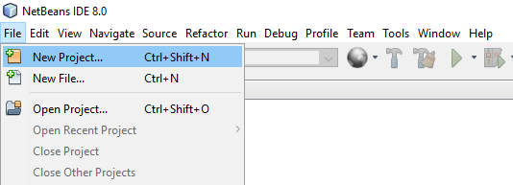

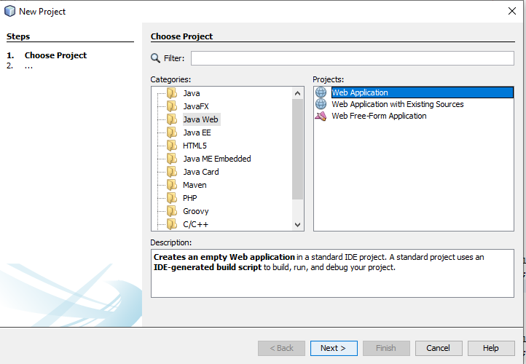

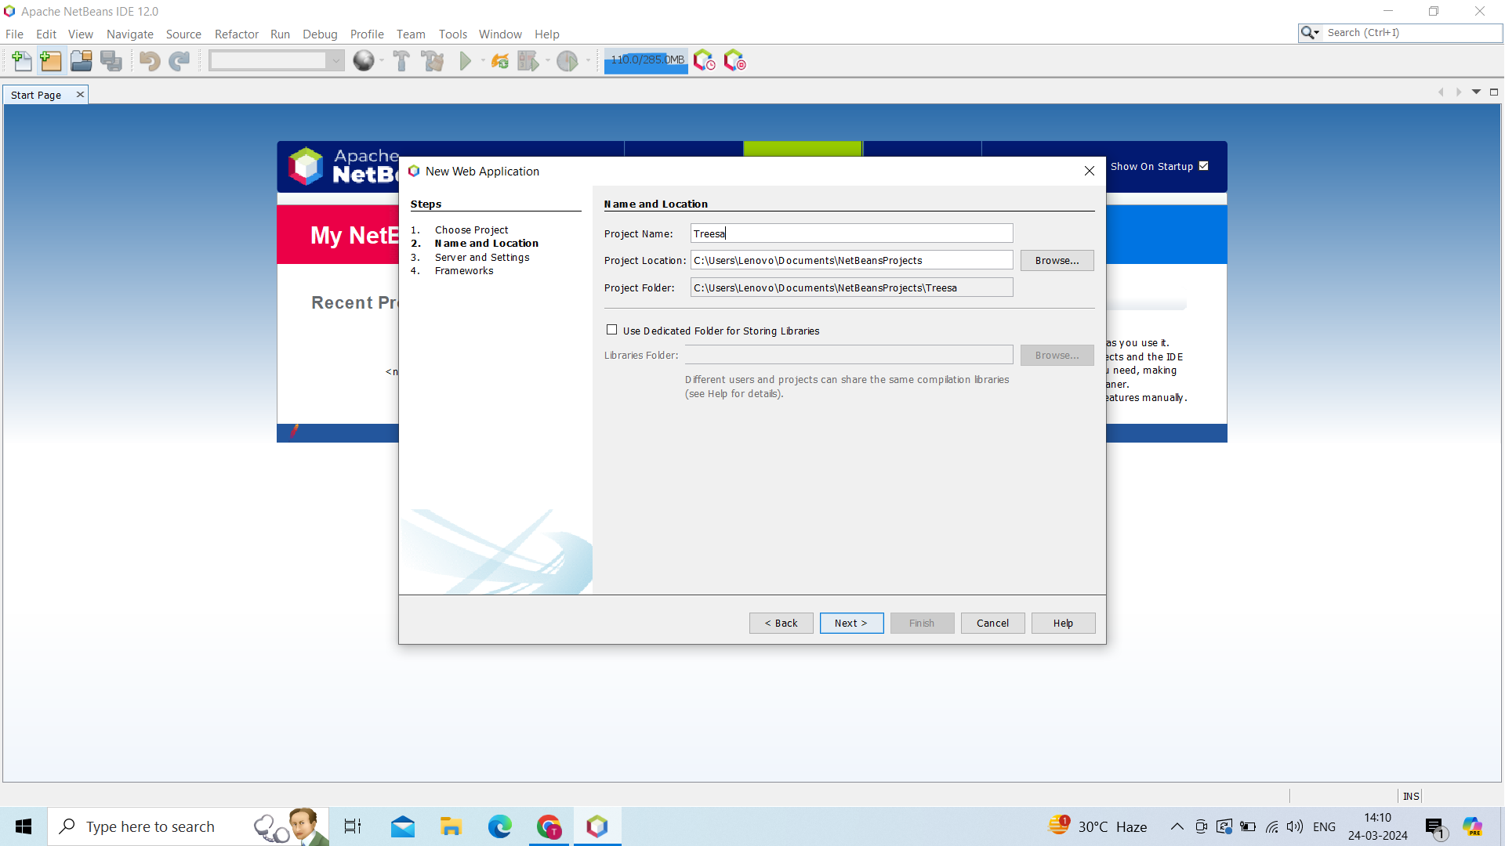

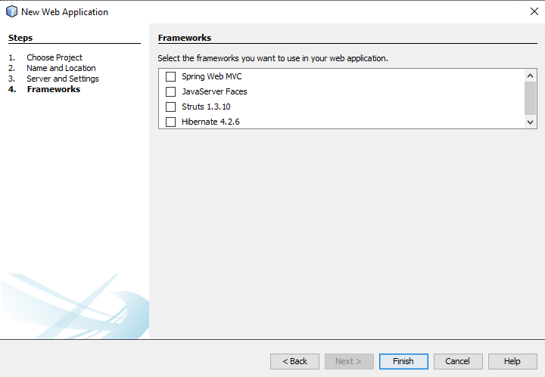

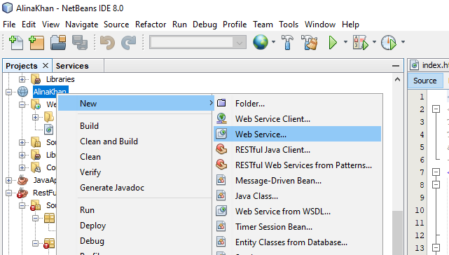

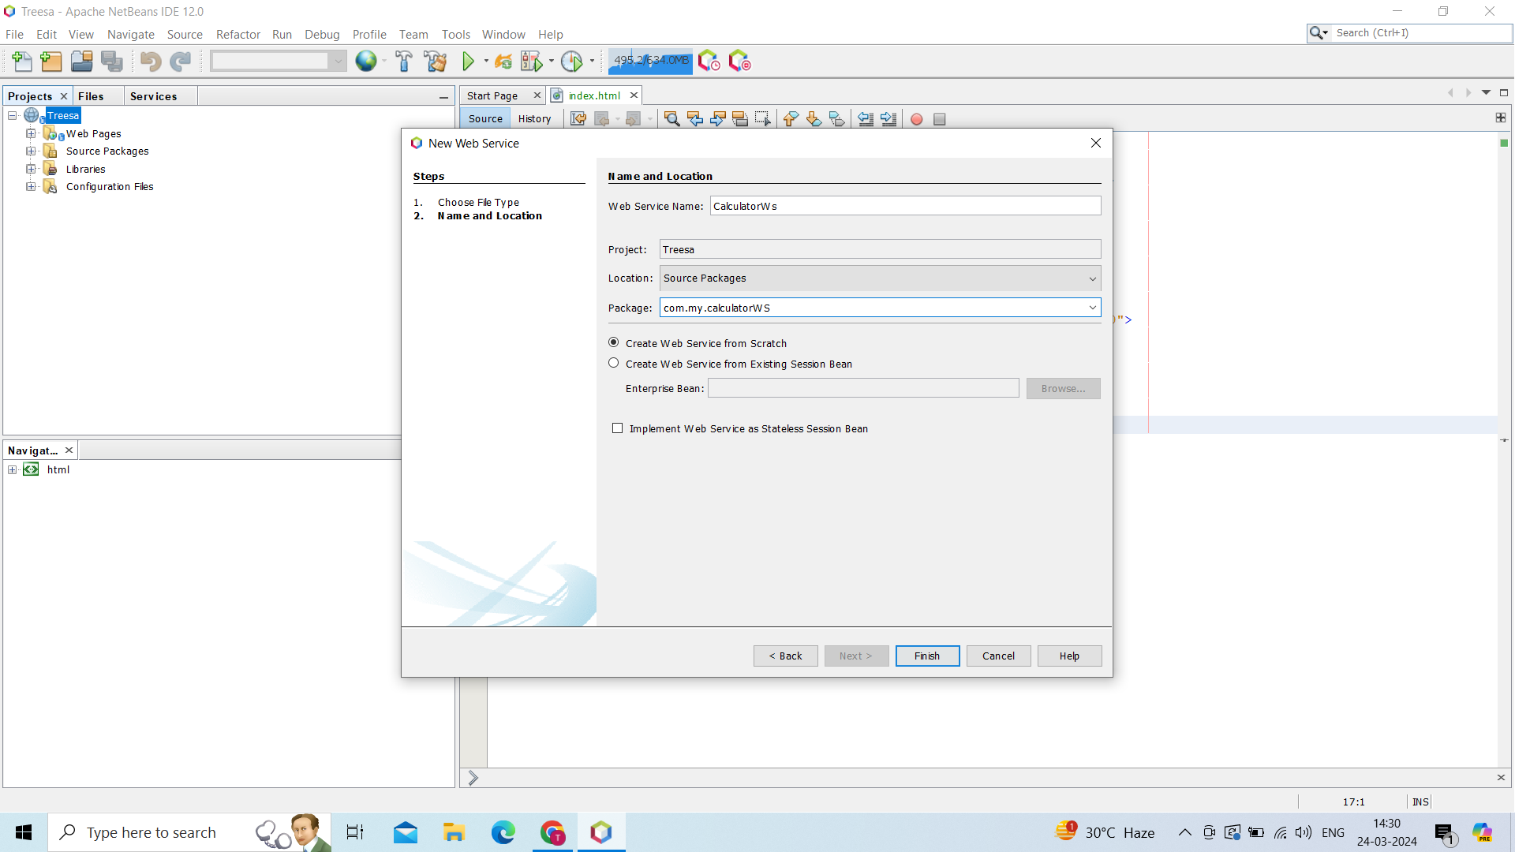

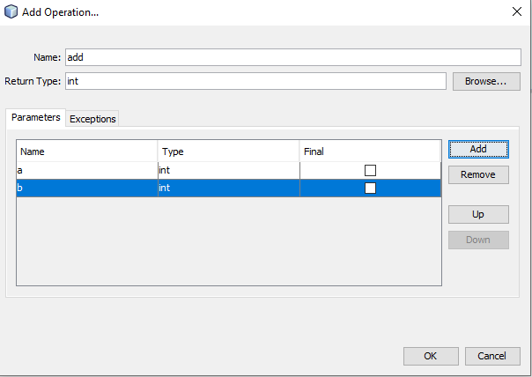

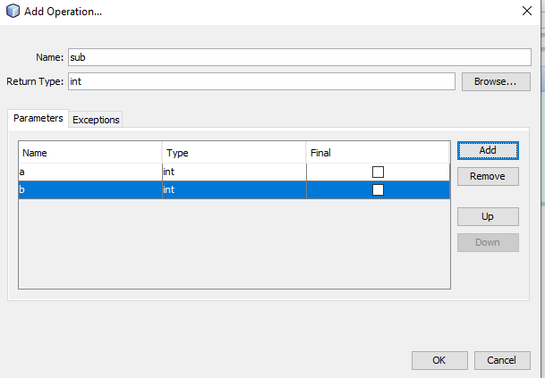

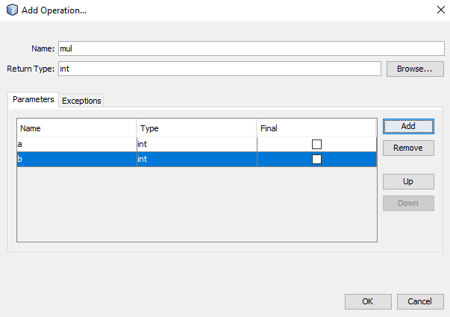

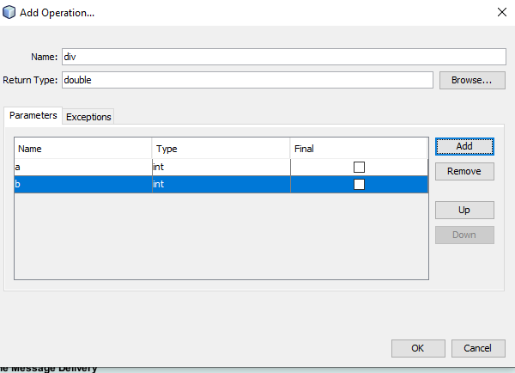

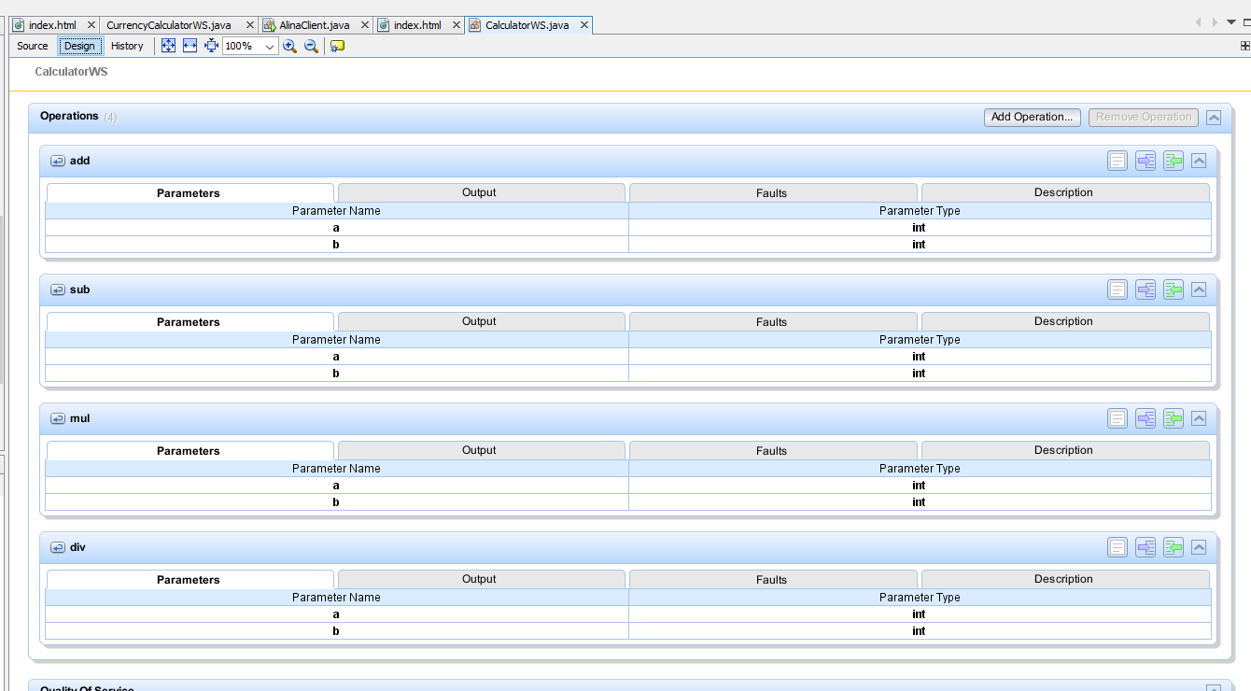

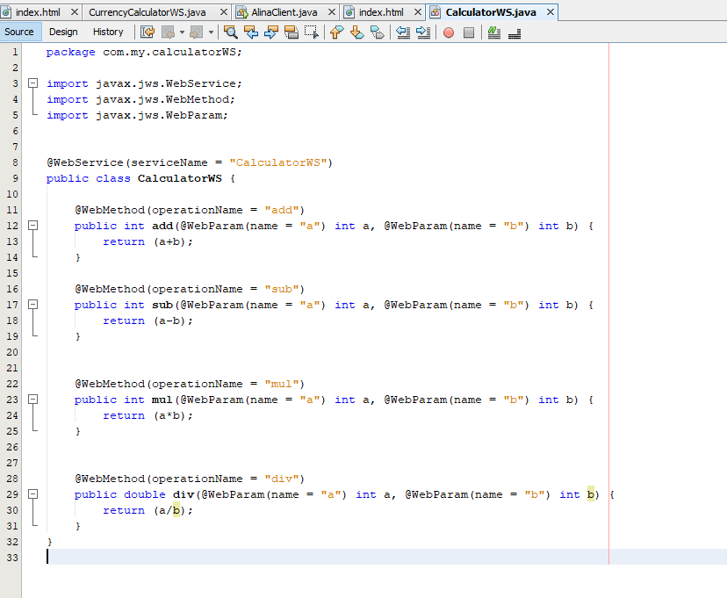

# 

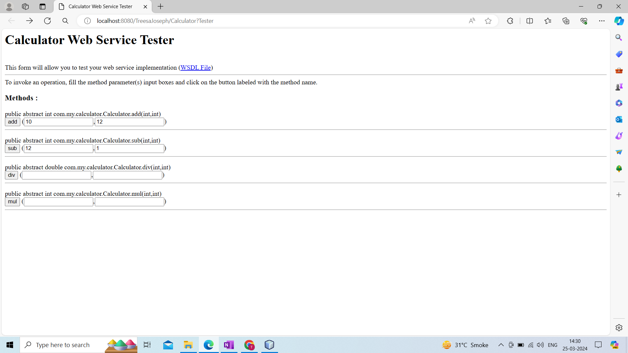

CLIENT

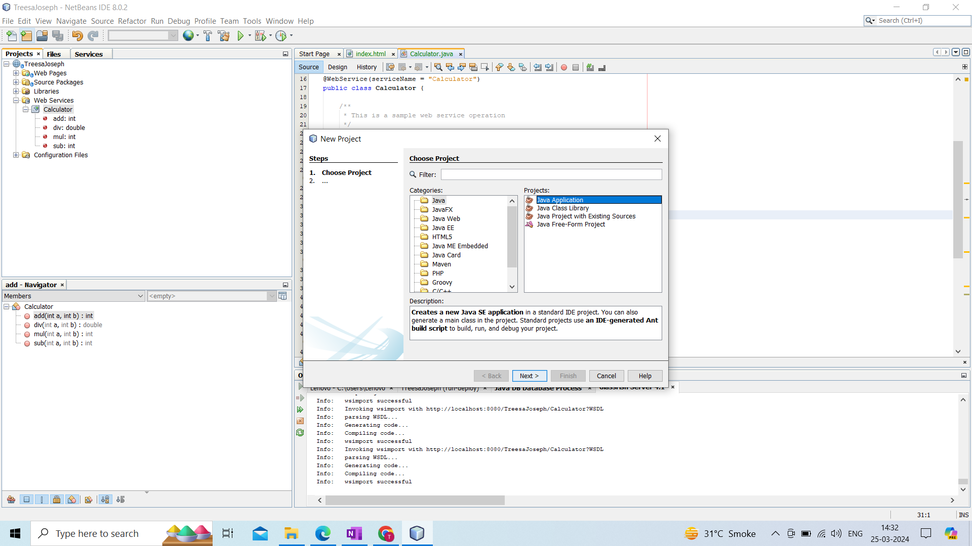

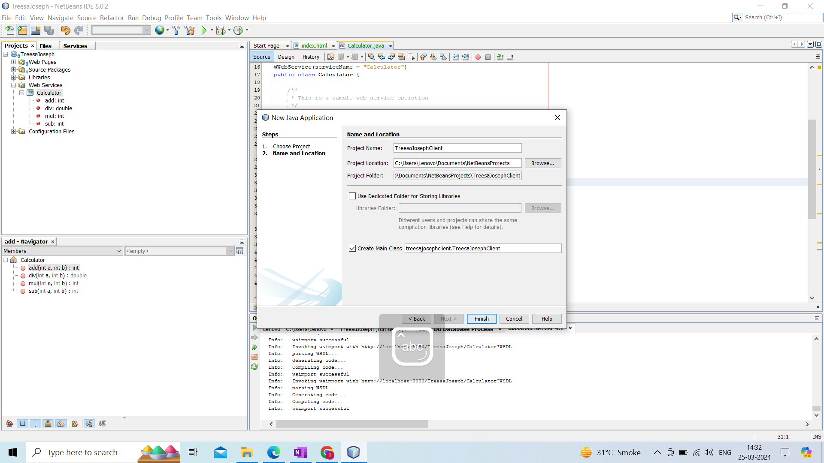

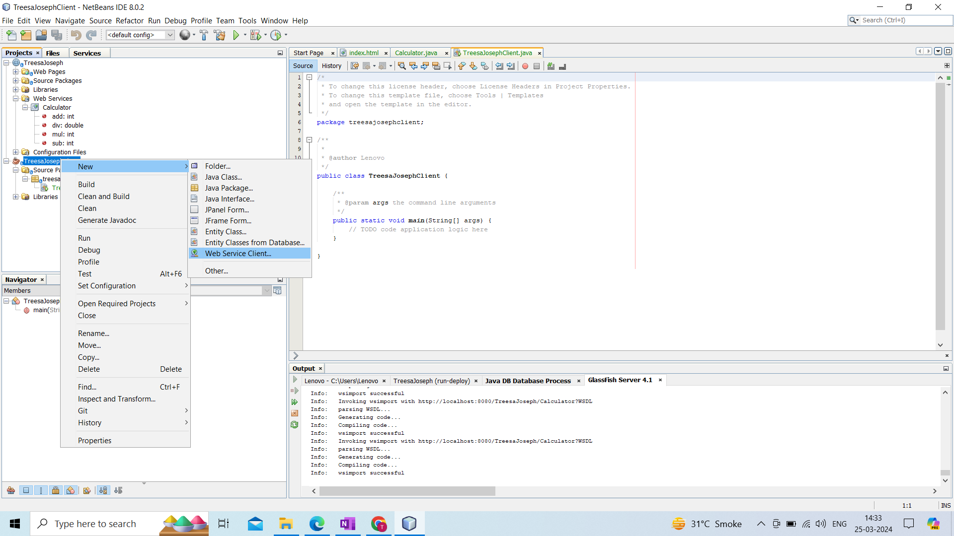

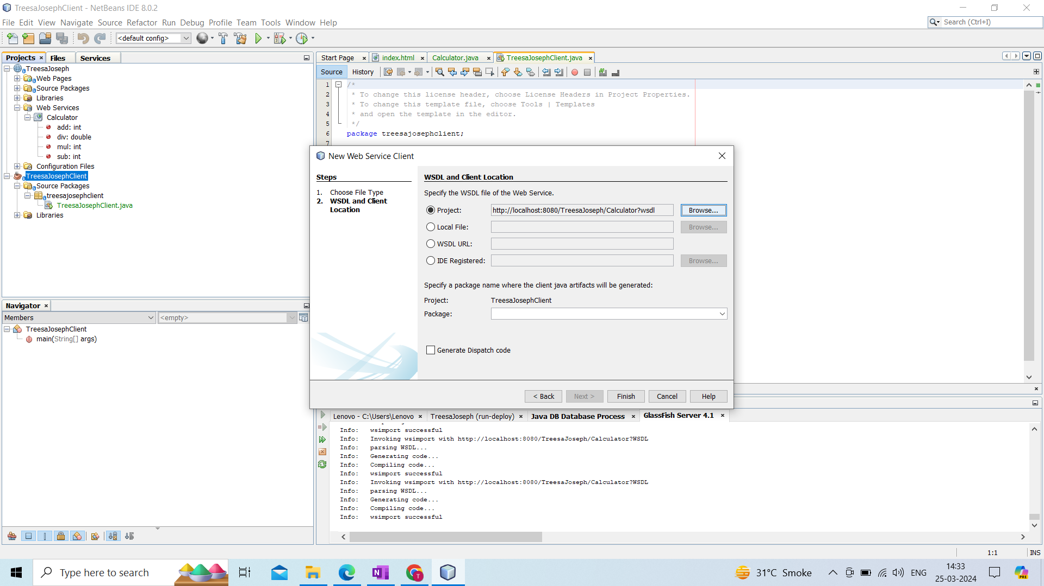

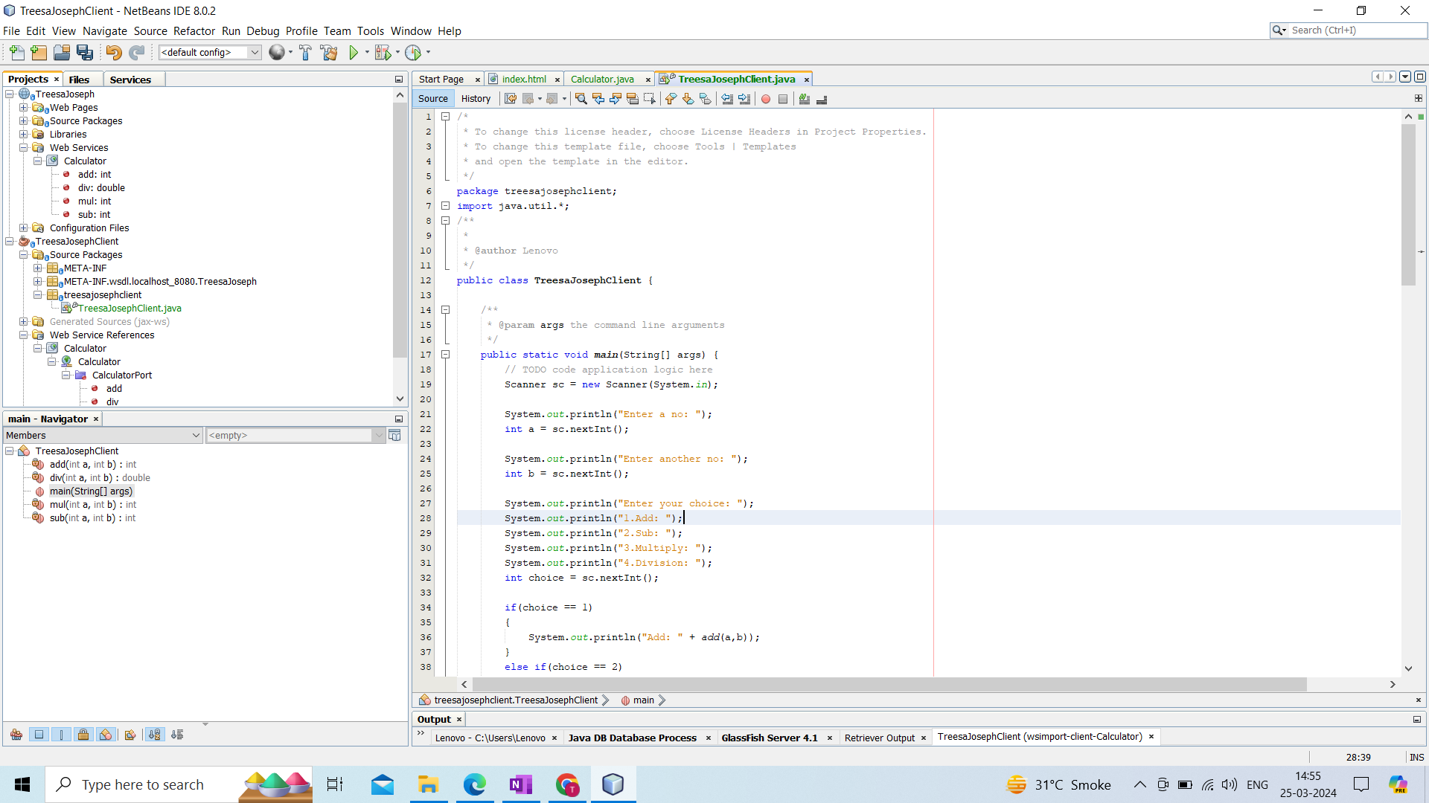

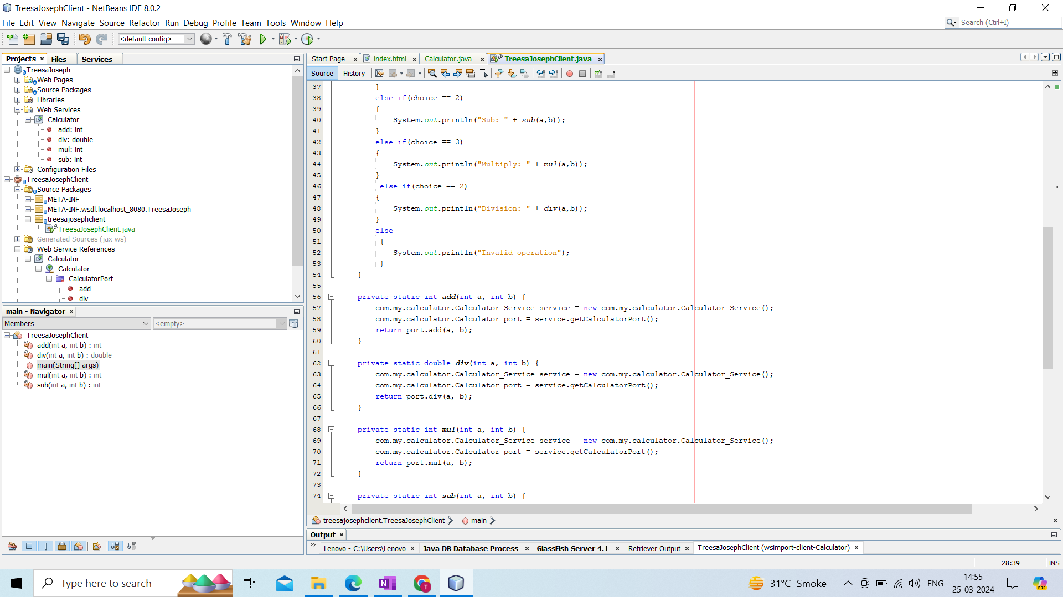

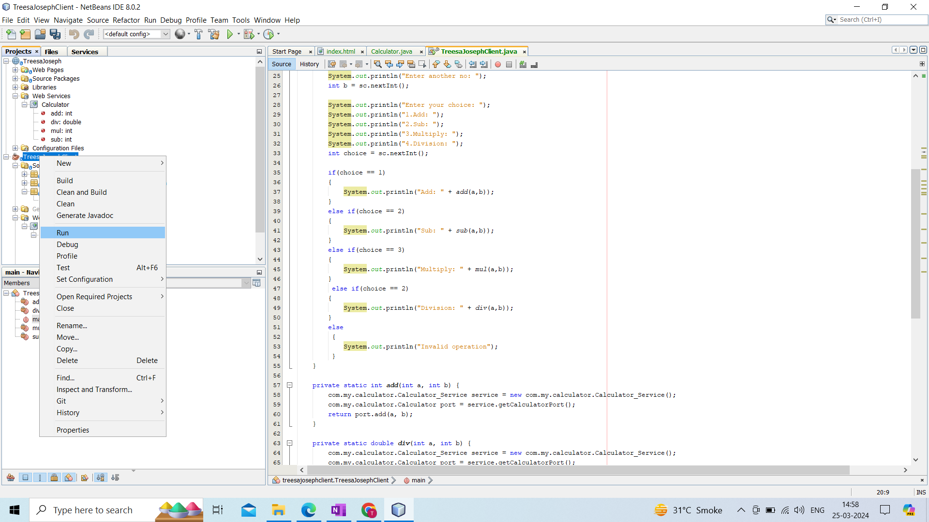

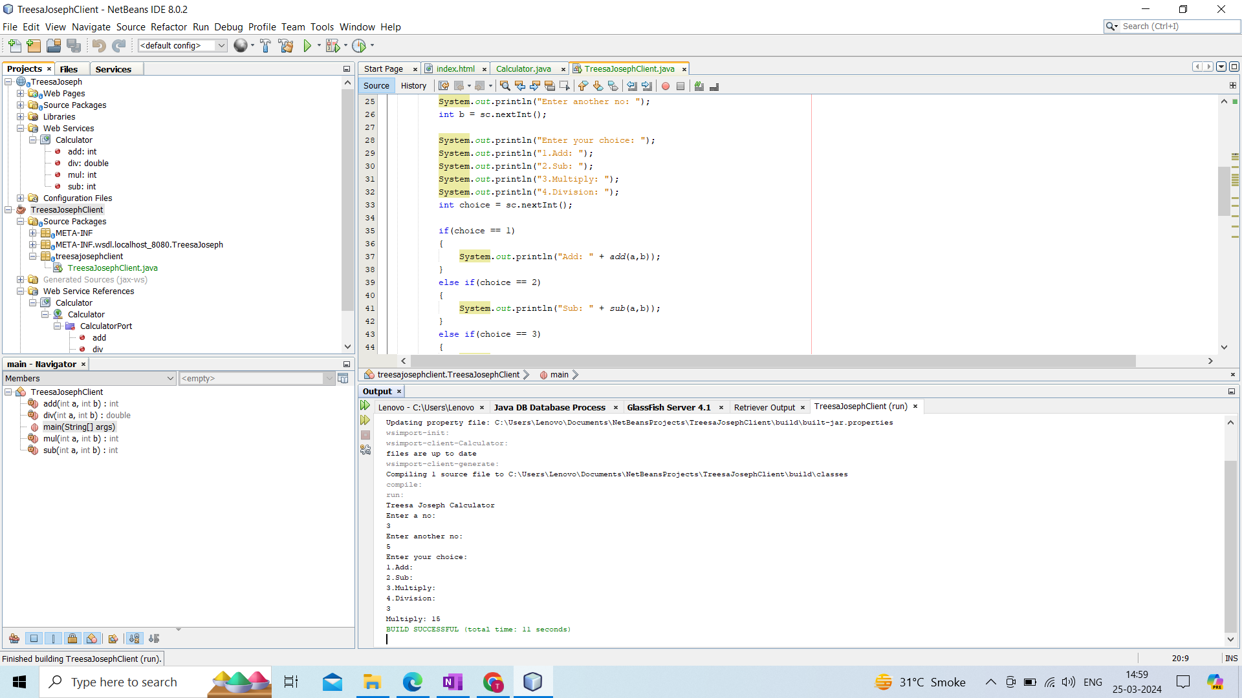

**Name : Treesa Joseph Roll No : KCTYCS(075) Date :**

# **Practical 1B : Implementation of currency convertor SOAP Web Services with. Net Technology c#**

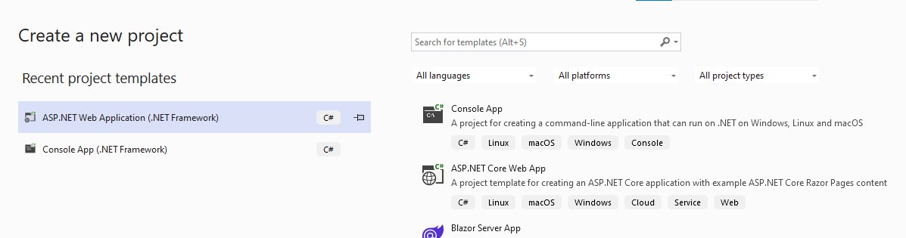

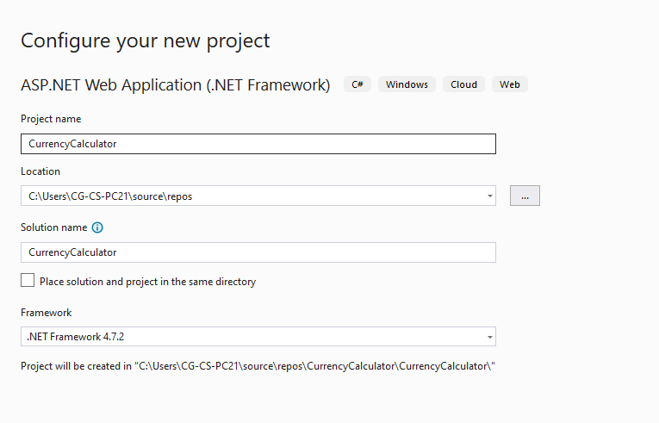

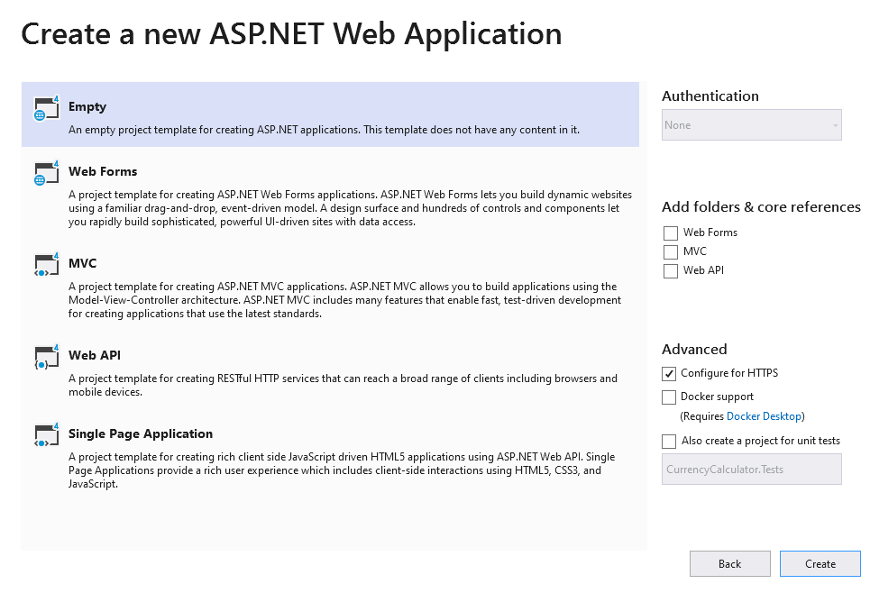

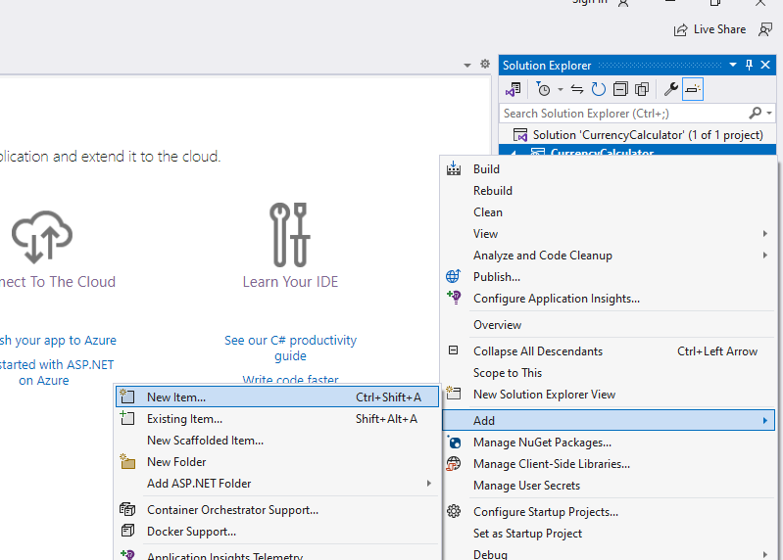

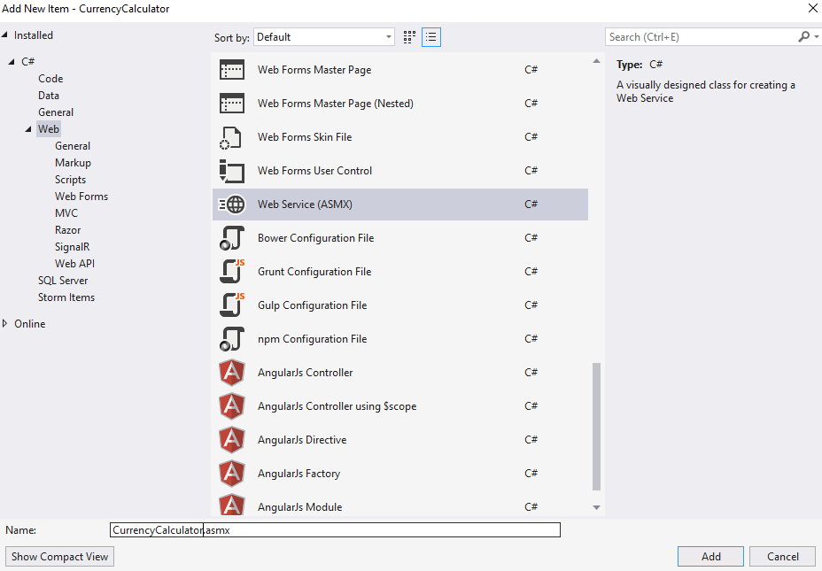

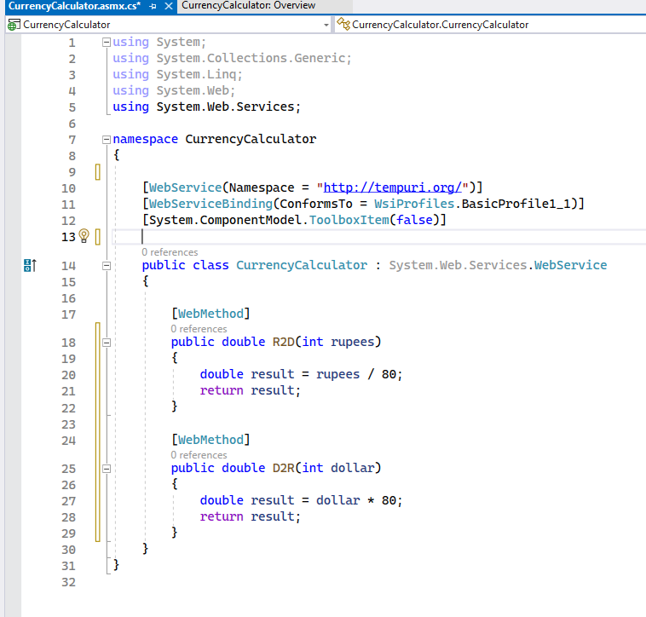

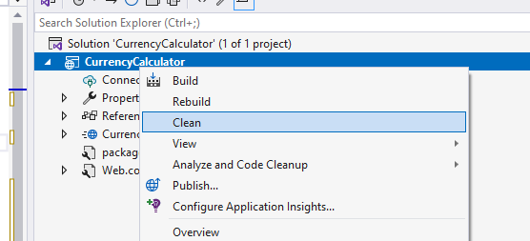

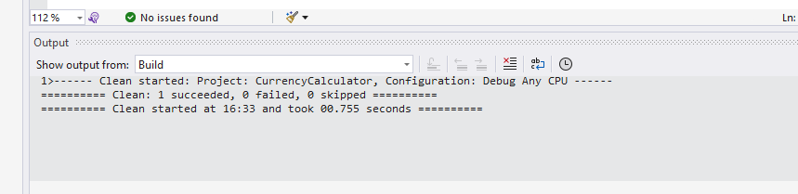

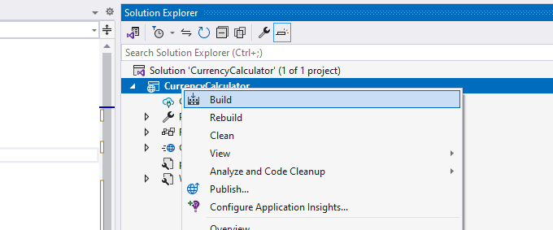

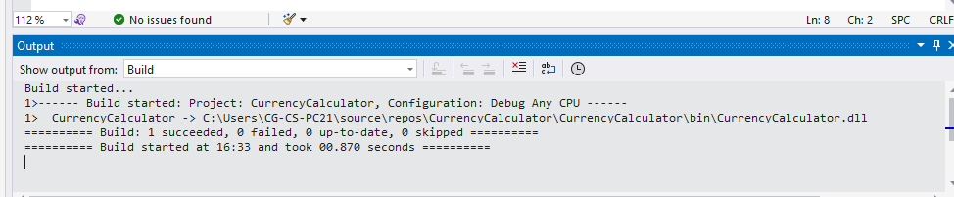

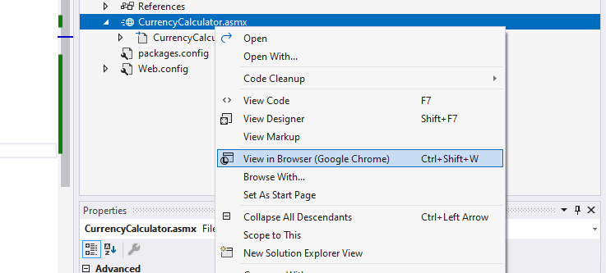

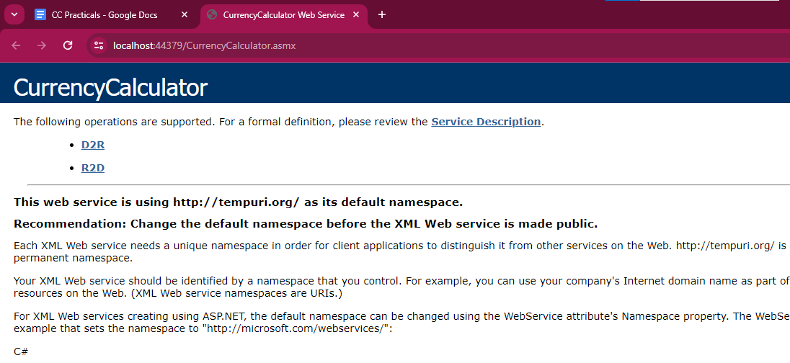

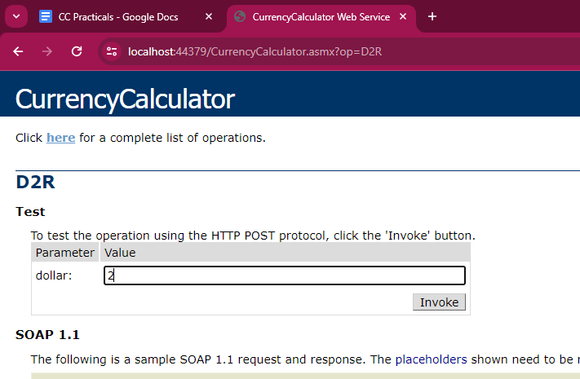

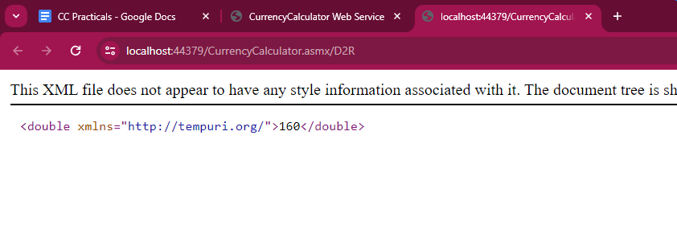

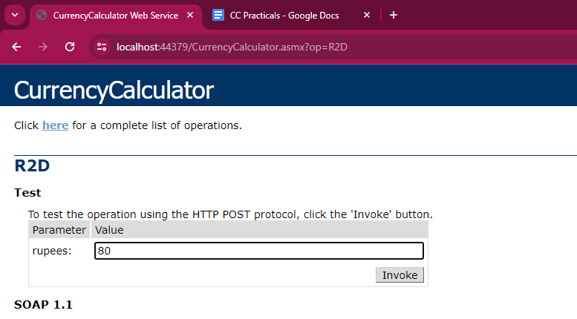

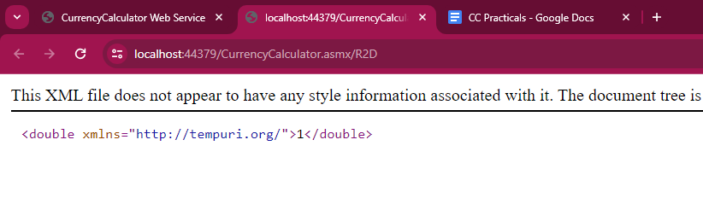

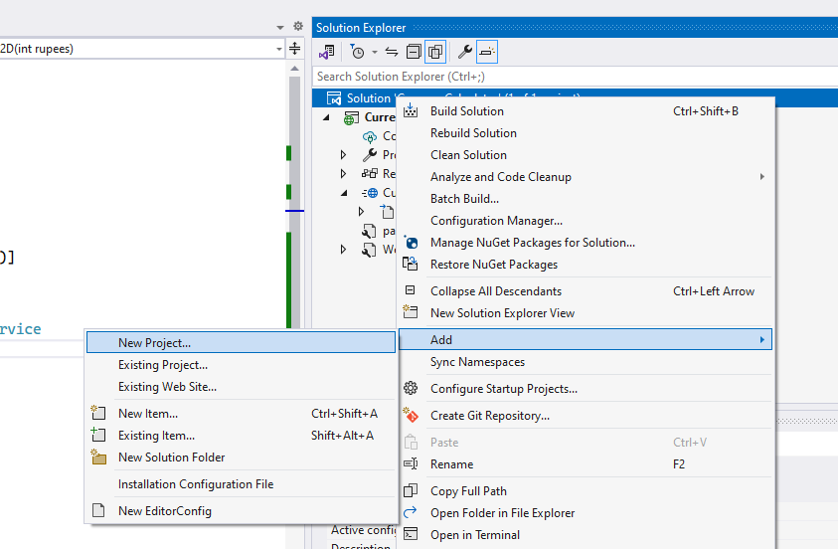

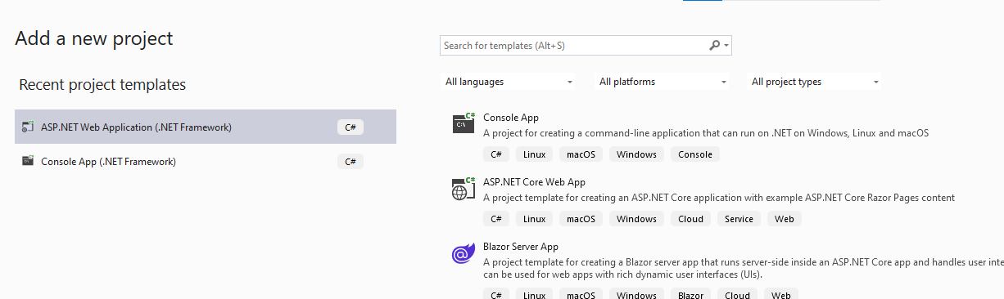

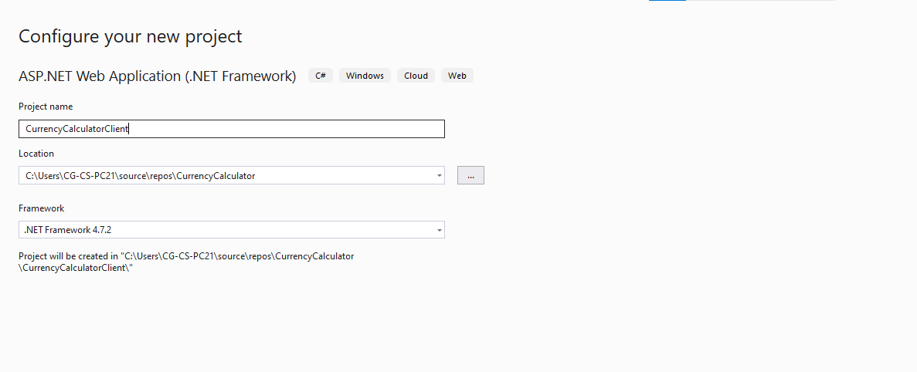

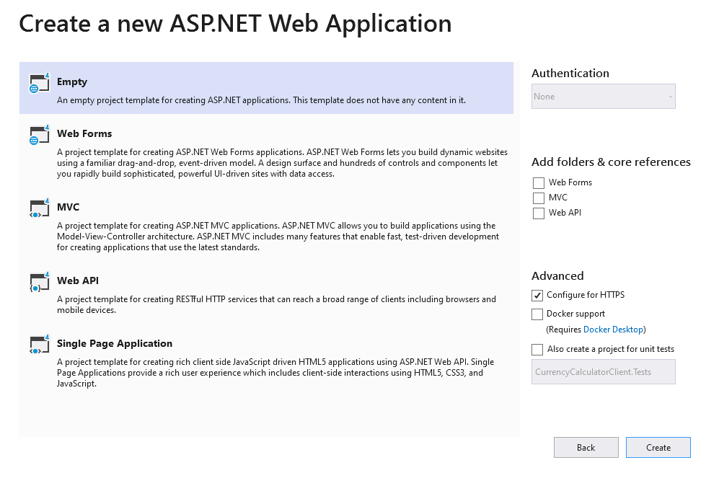

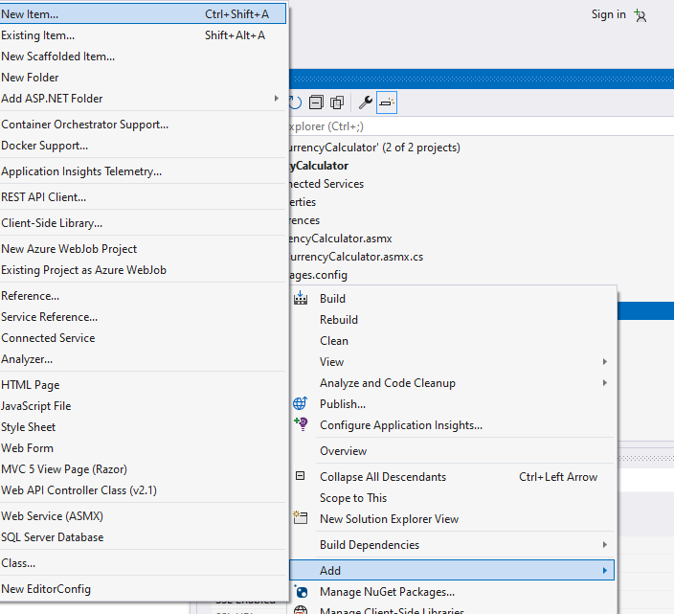

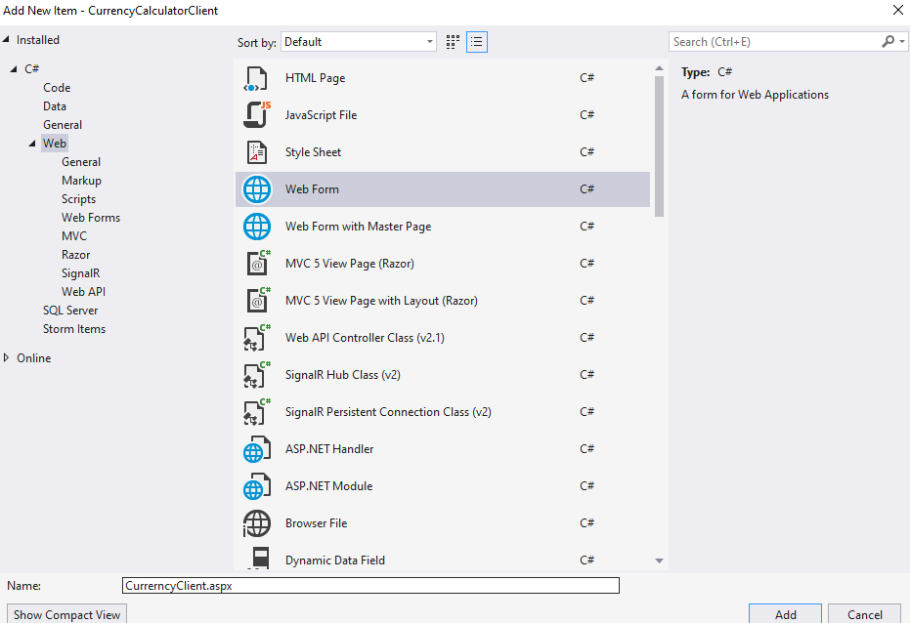

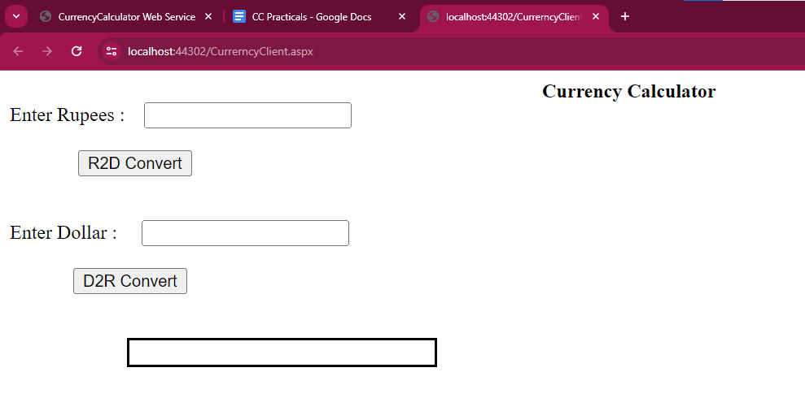

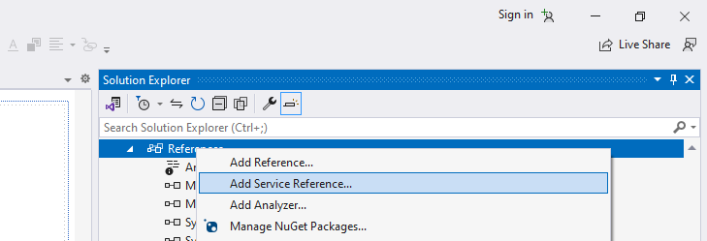

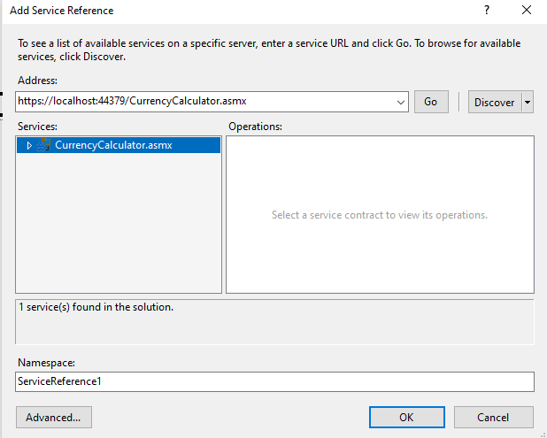

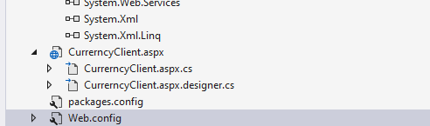

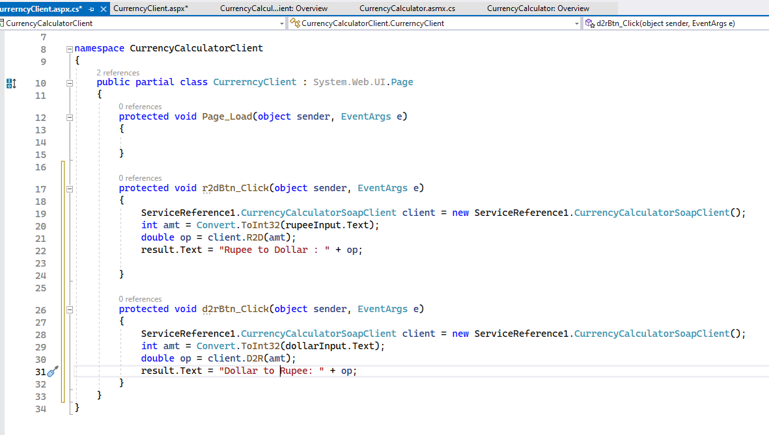

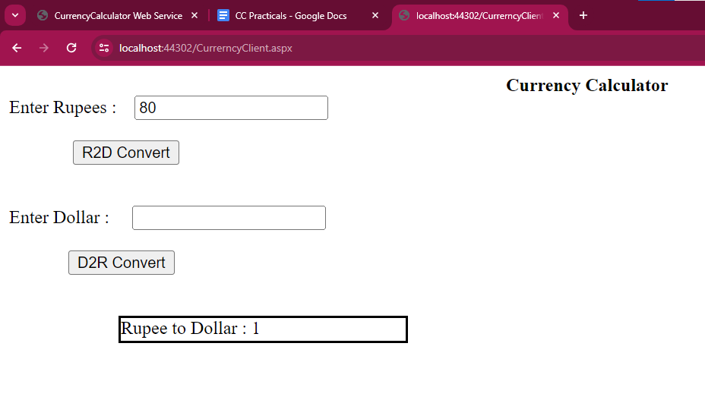

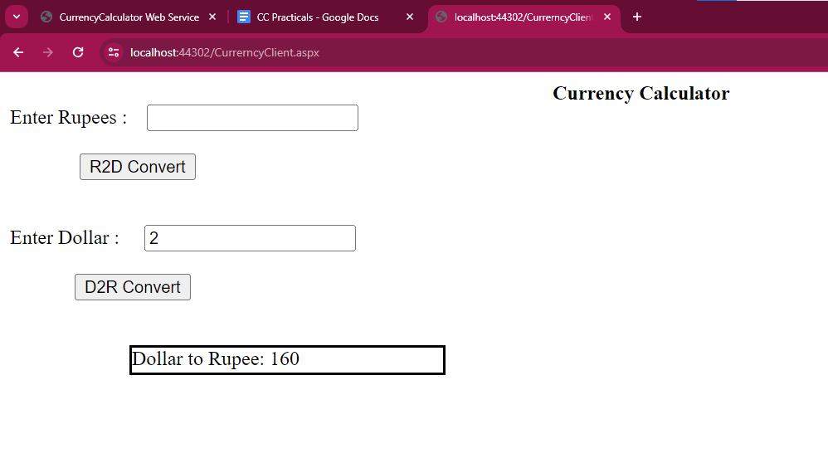

**Name : Treesa Joseph Roll No : KCTYCS(75) Date :**

# Practical 2A : Implementation of currency convertor Soap web services using java netbeans

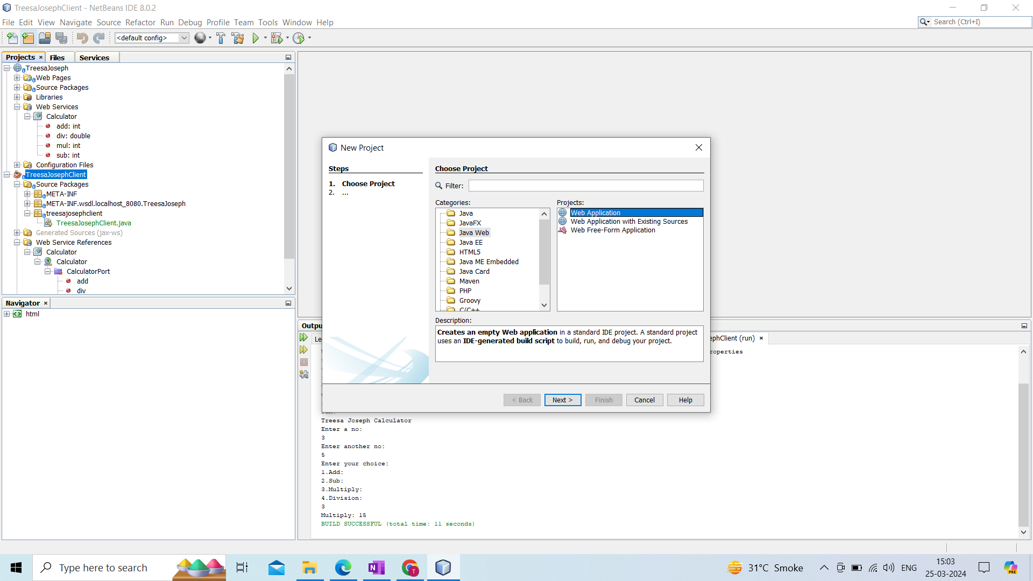

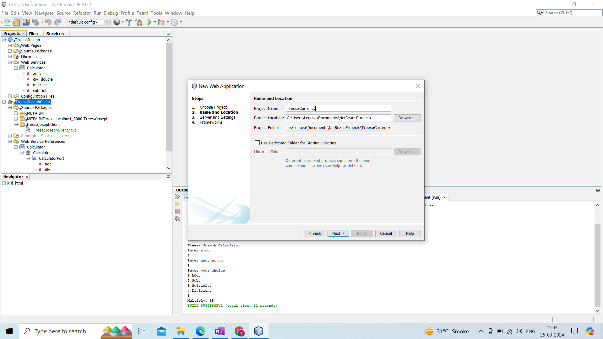

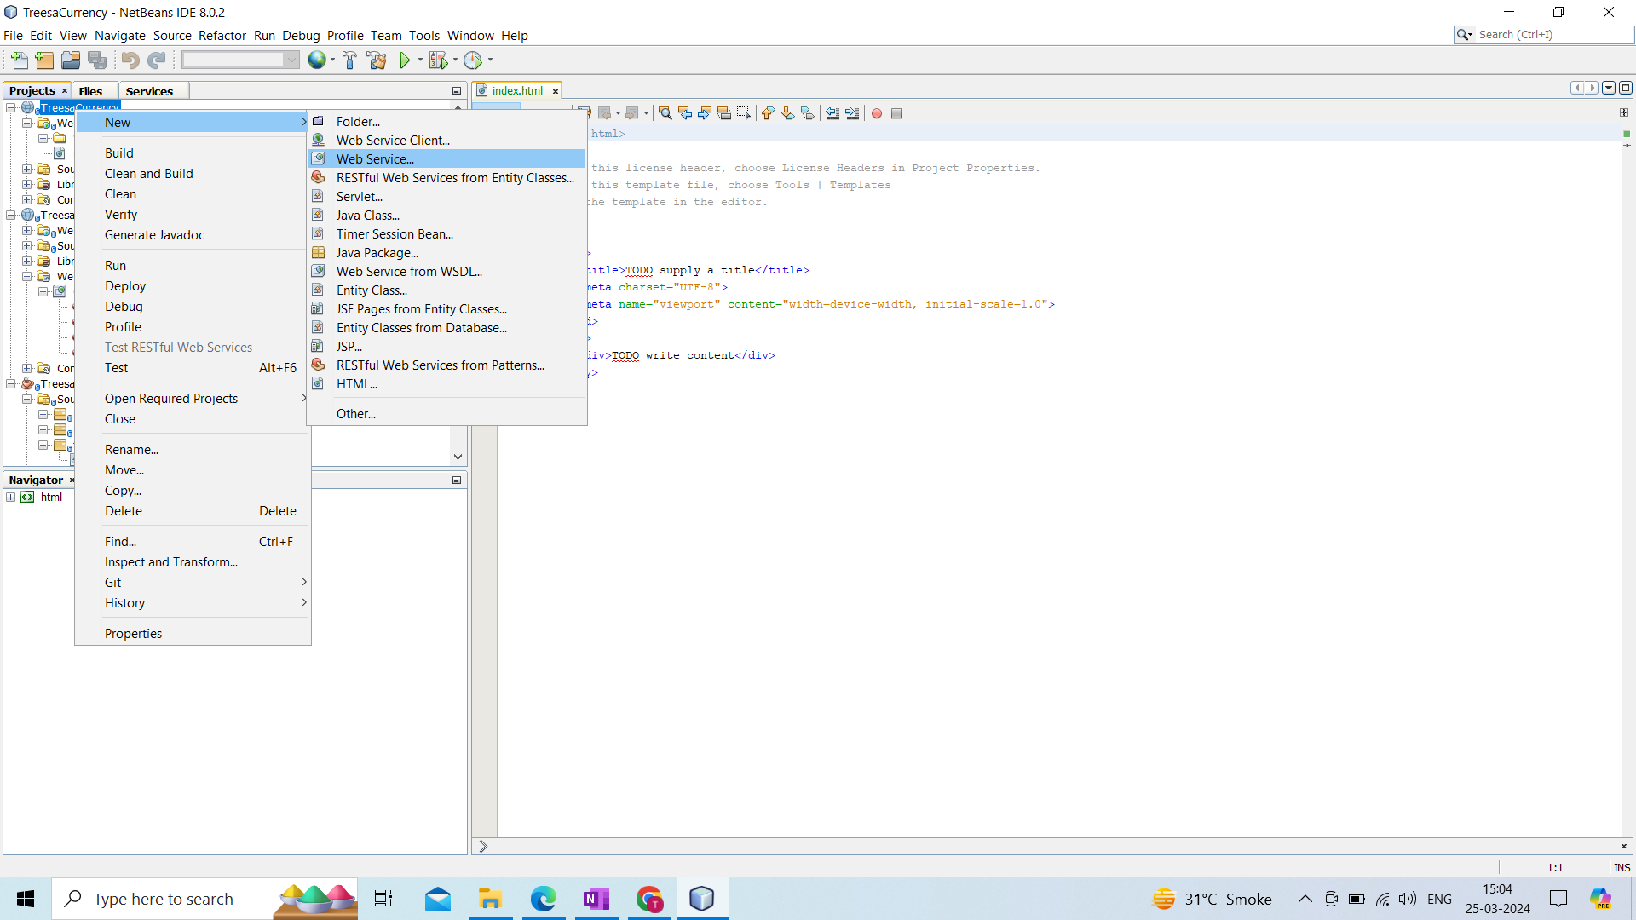

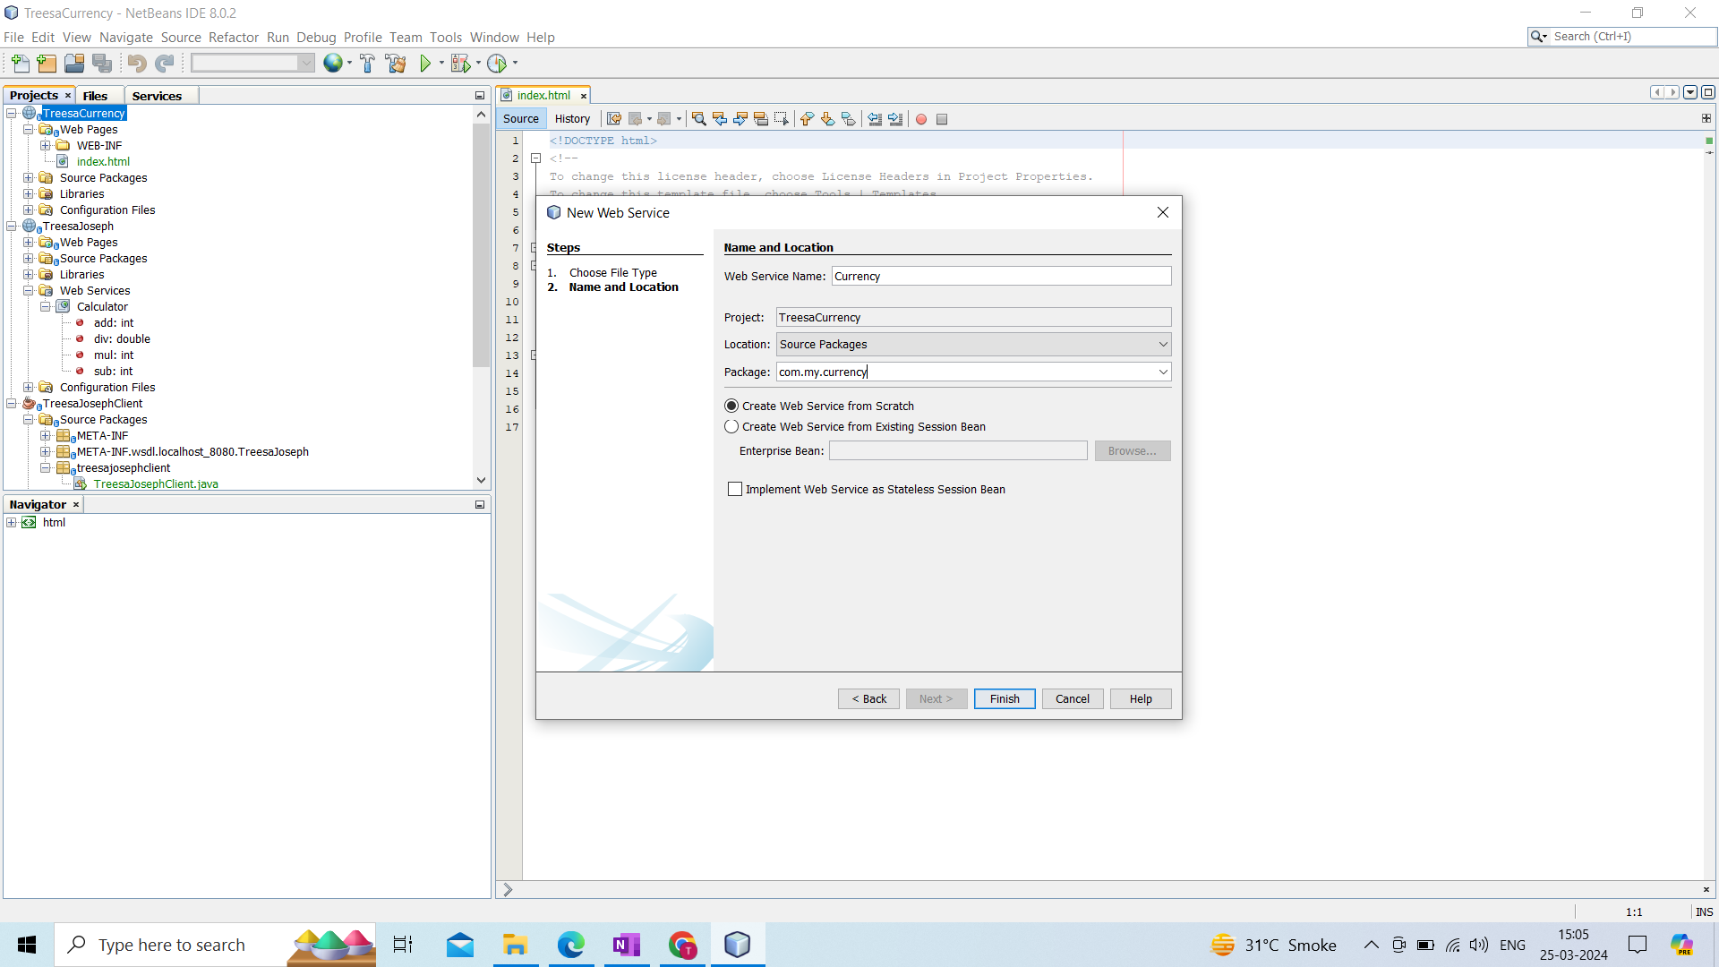

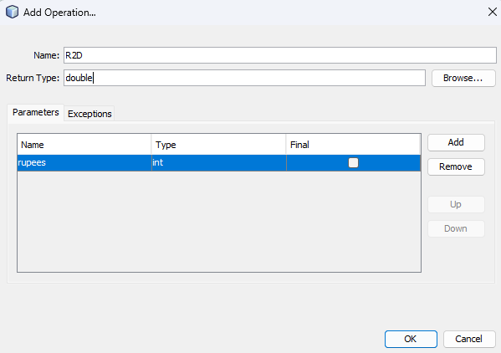

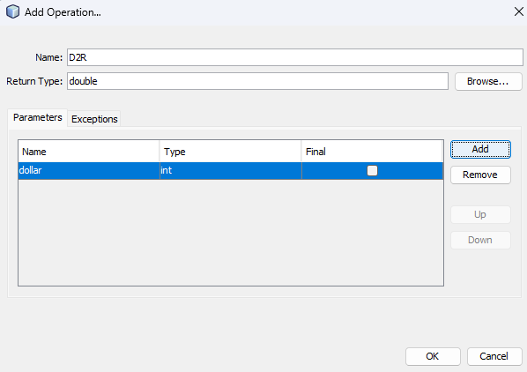

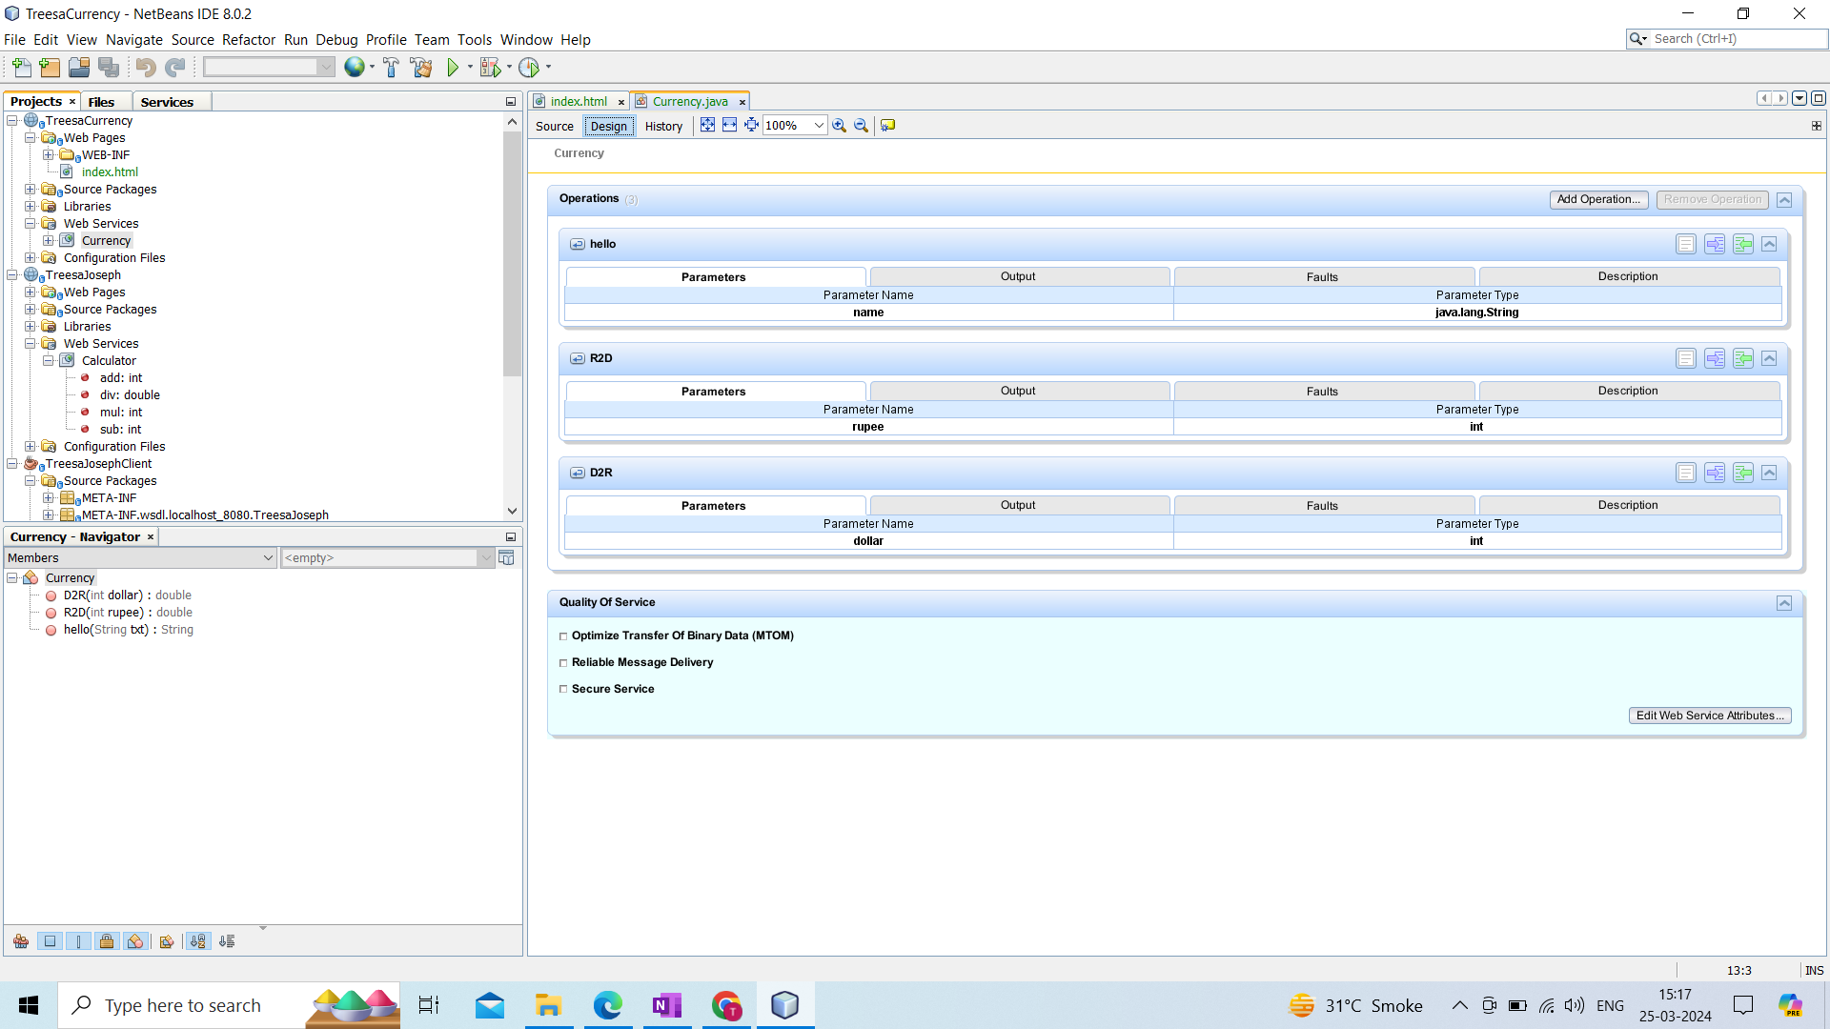

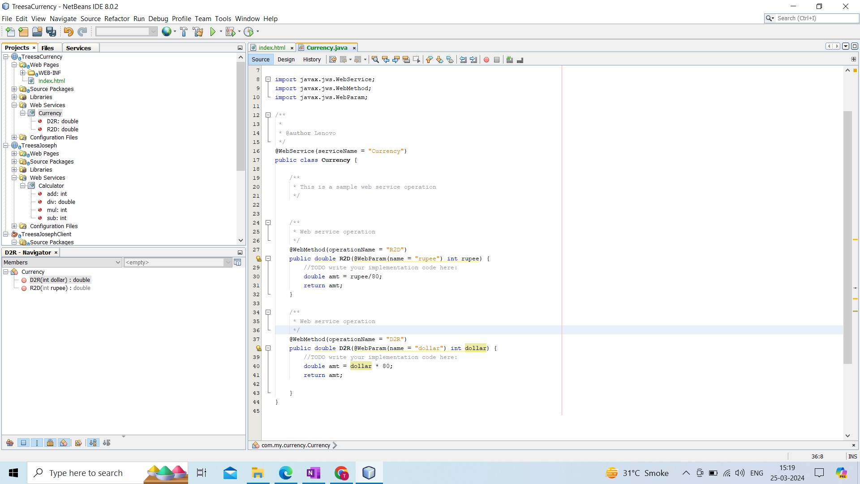

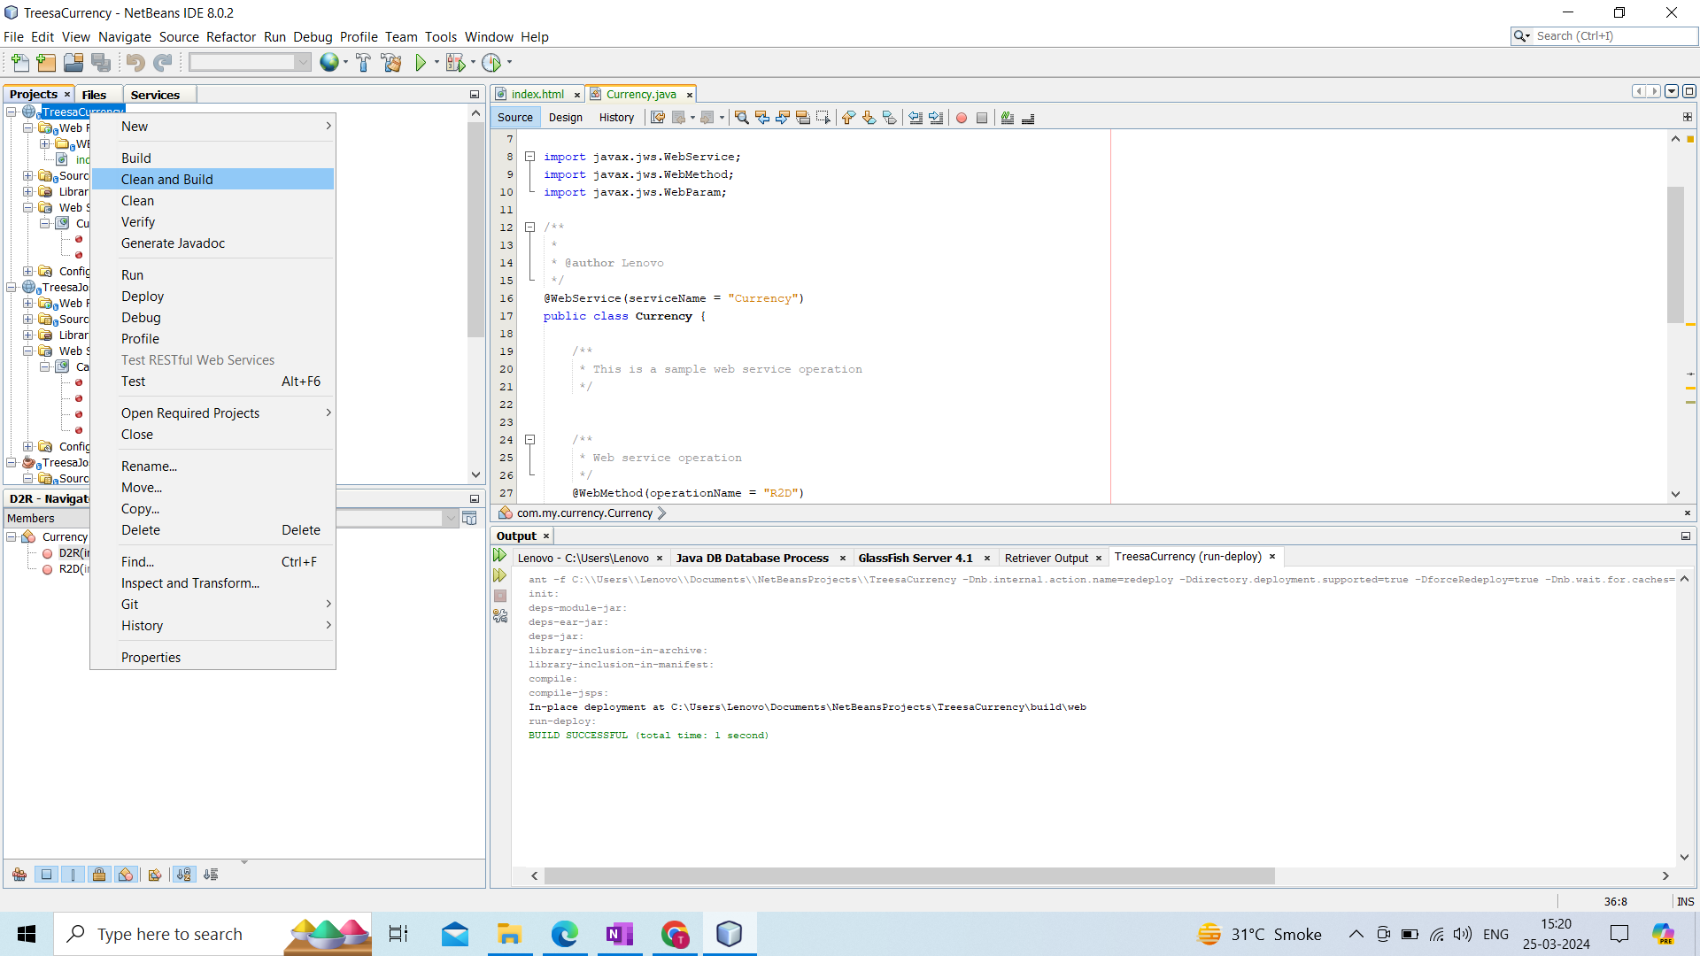

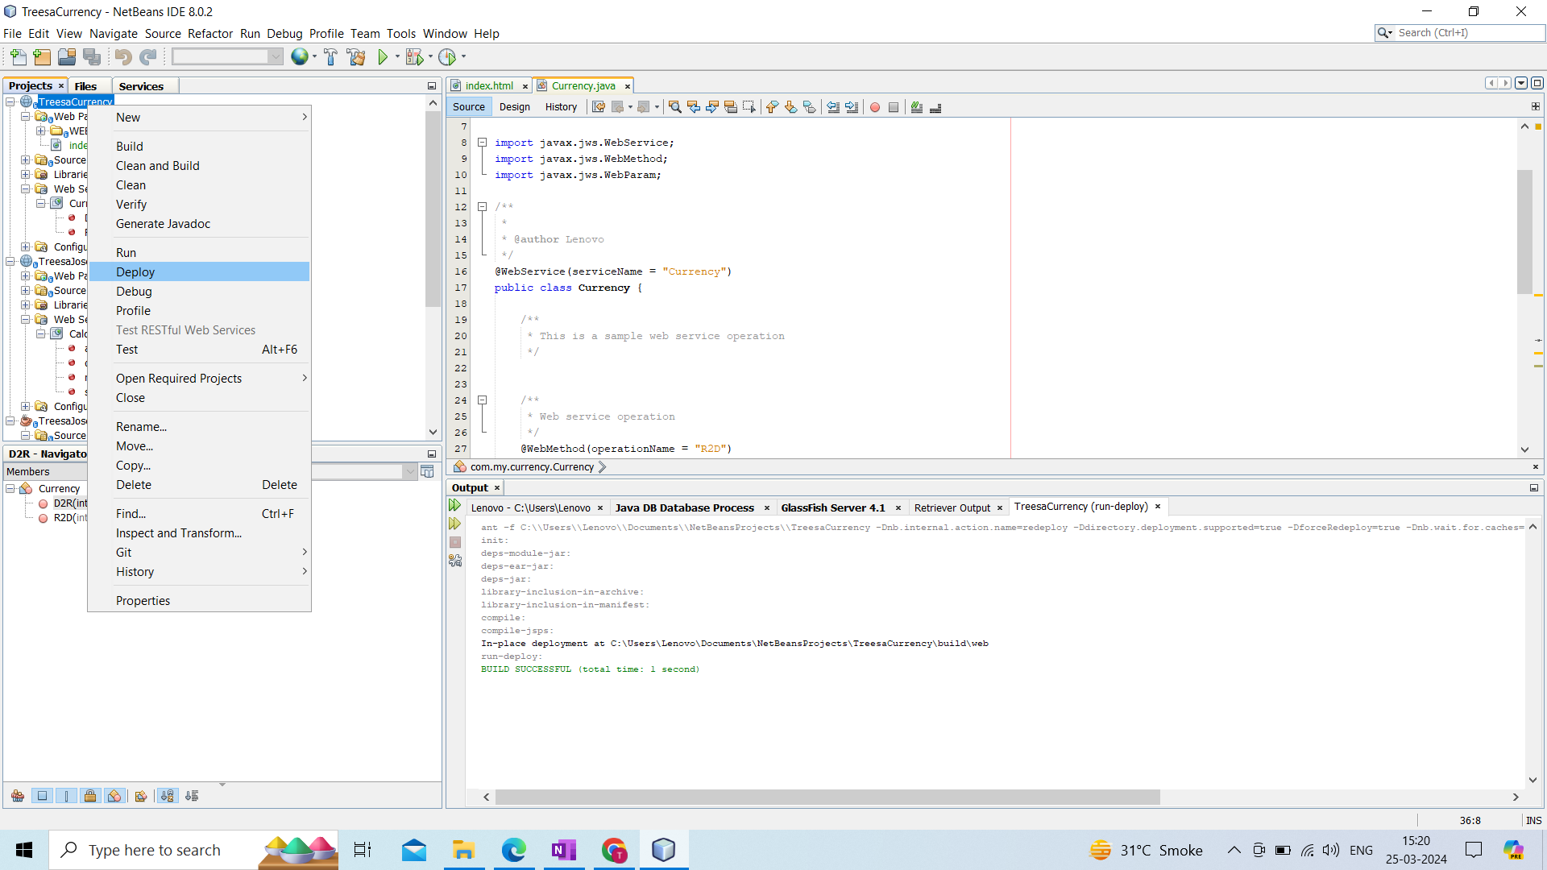

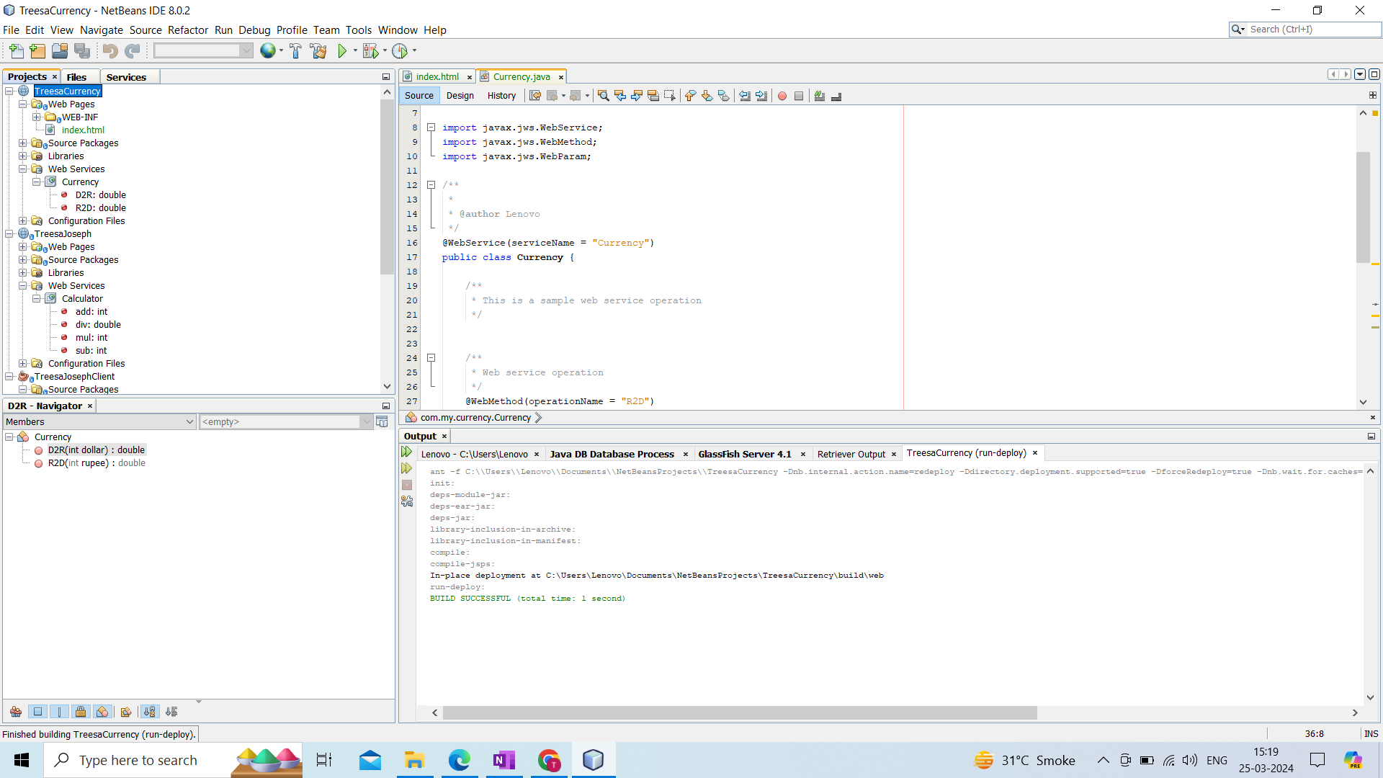

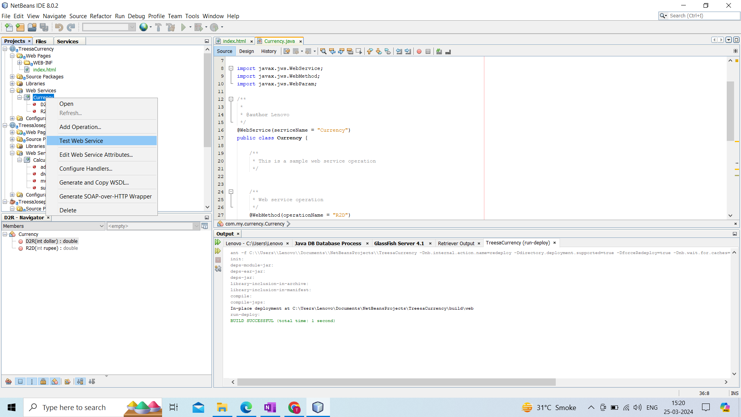

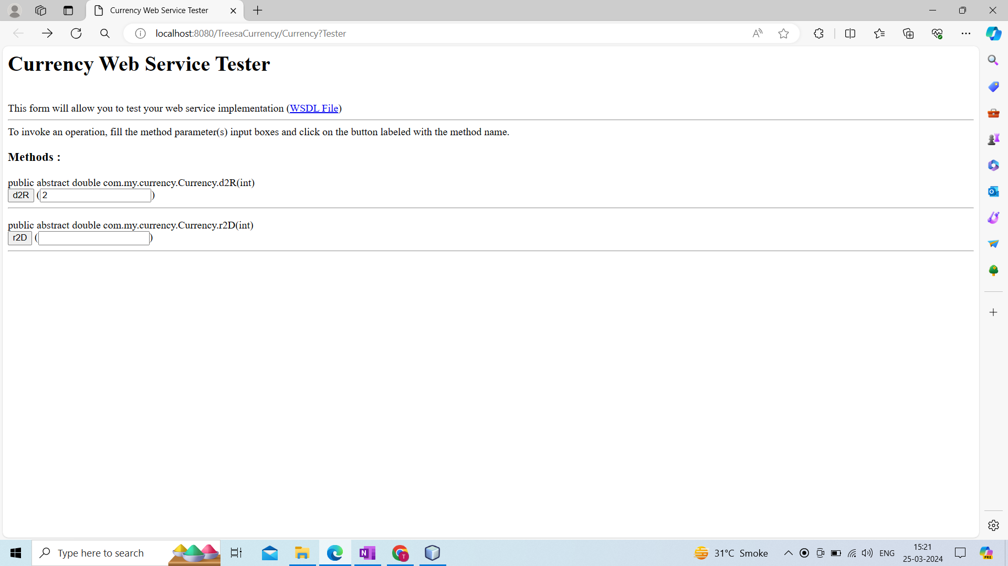

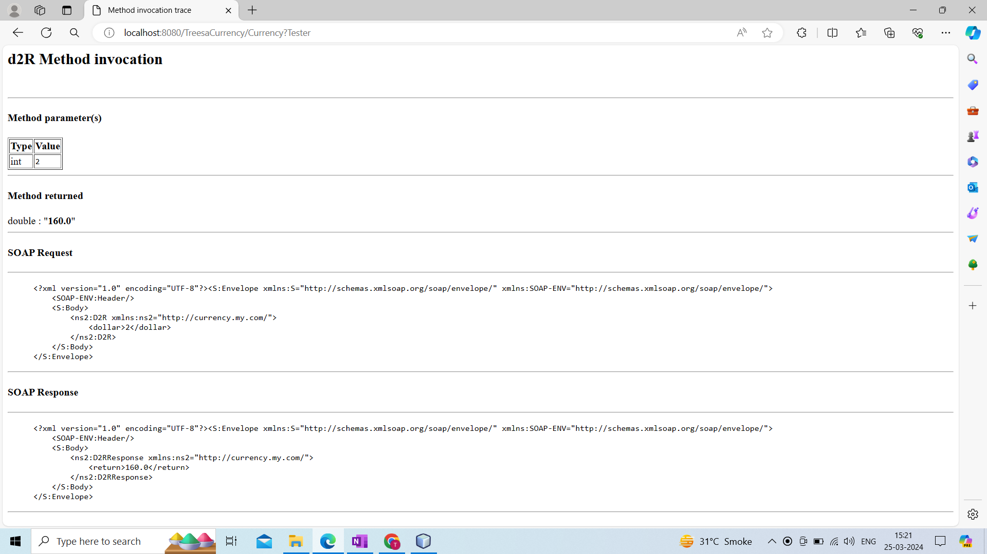

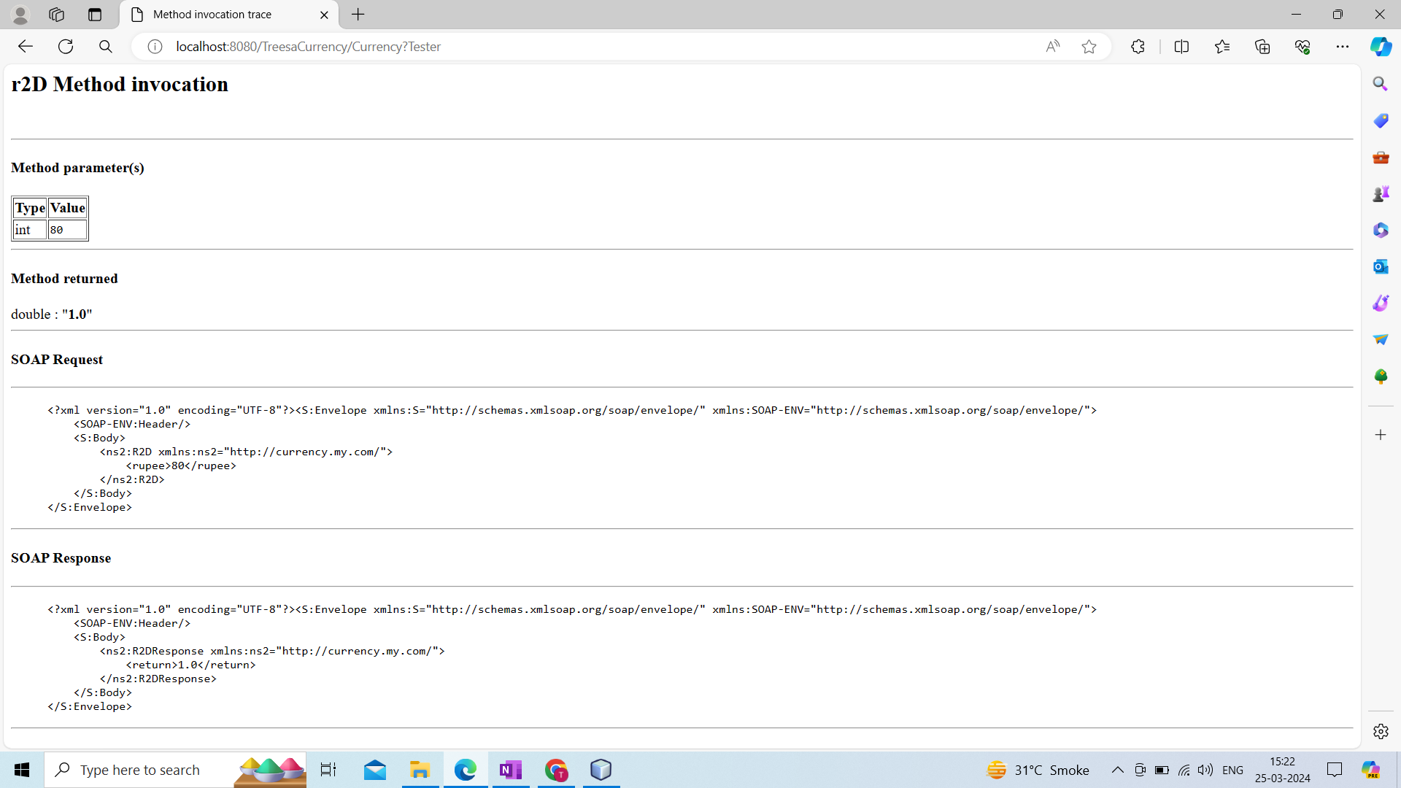

CLIENT

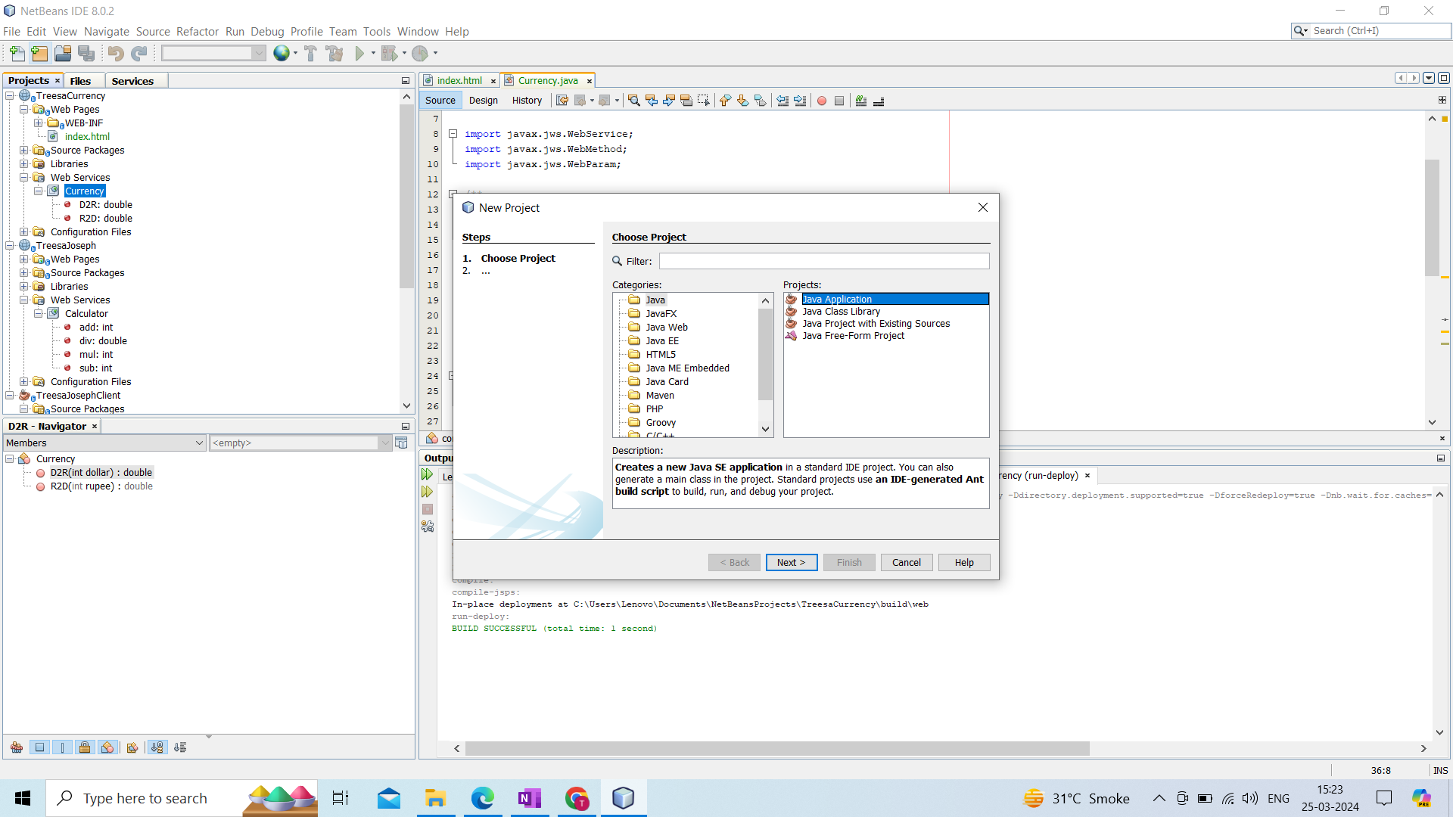

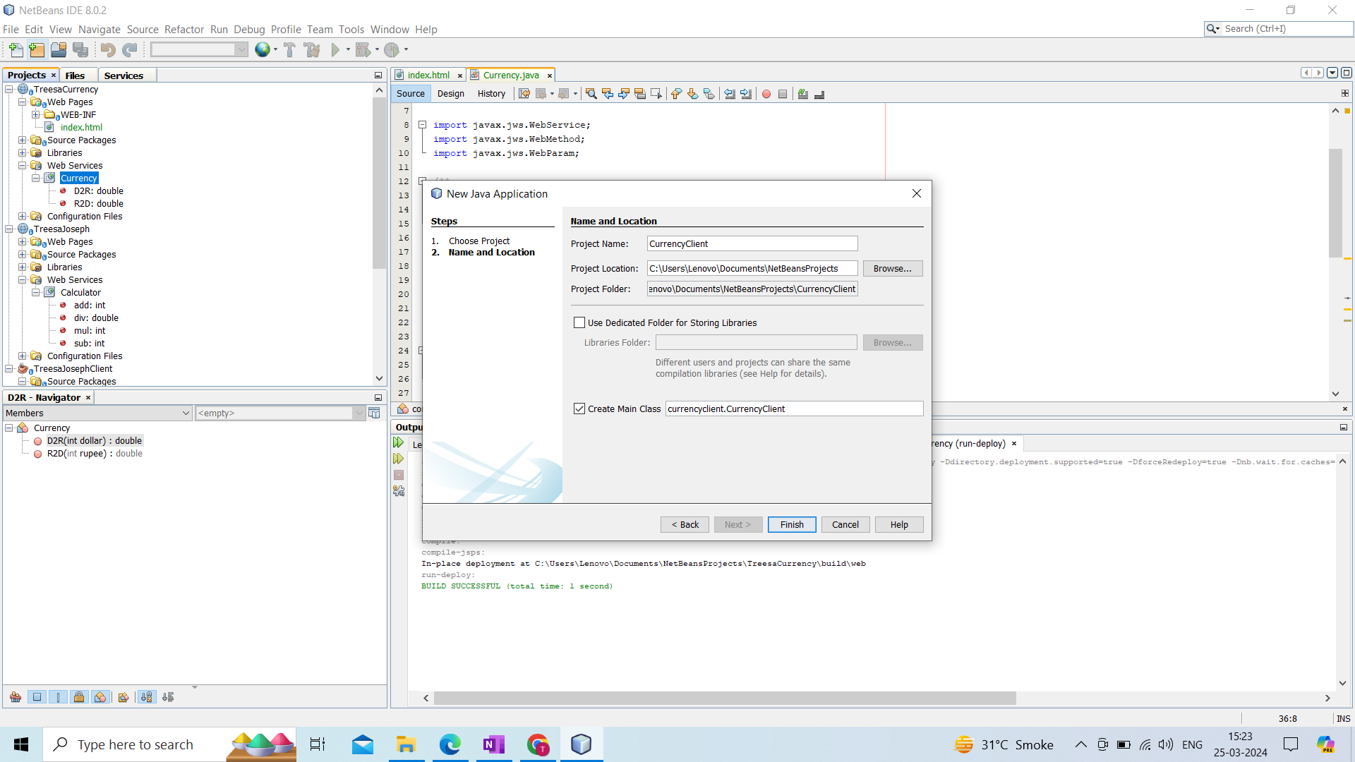

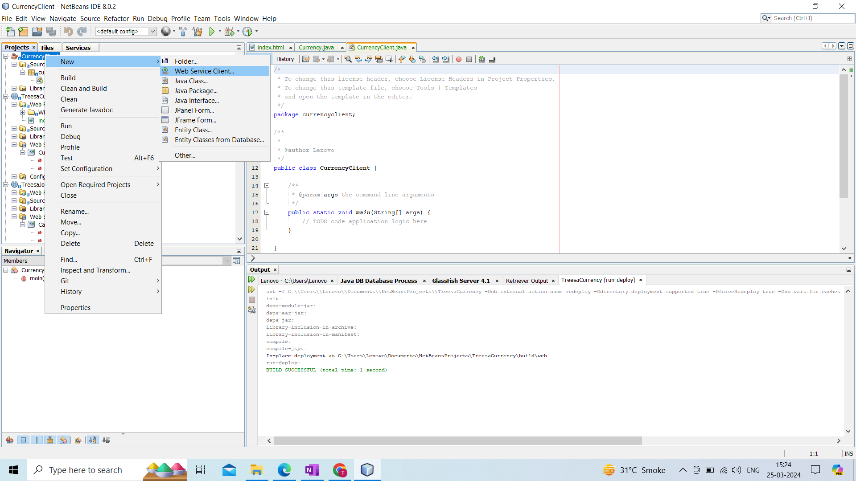

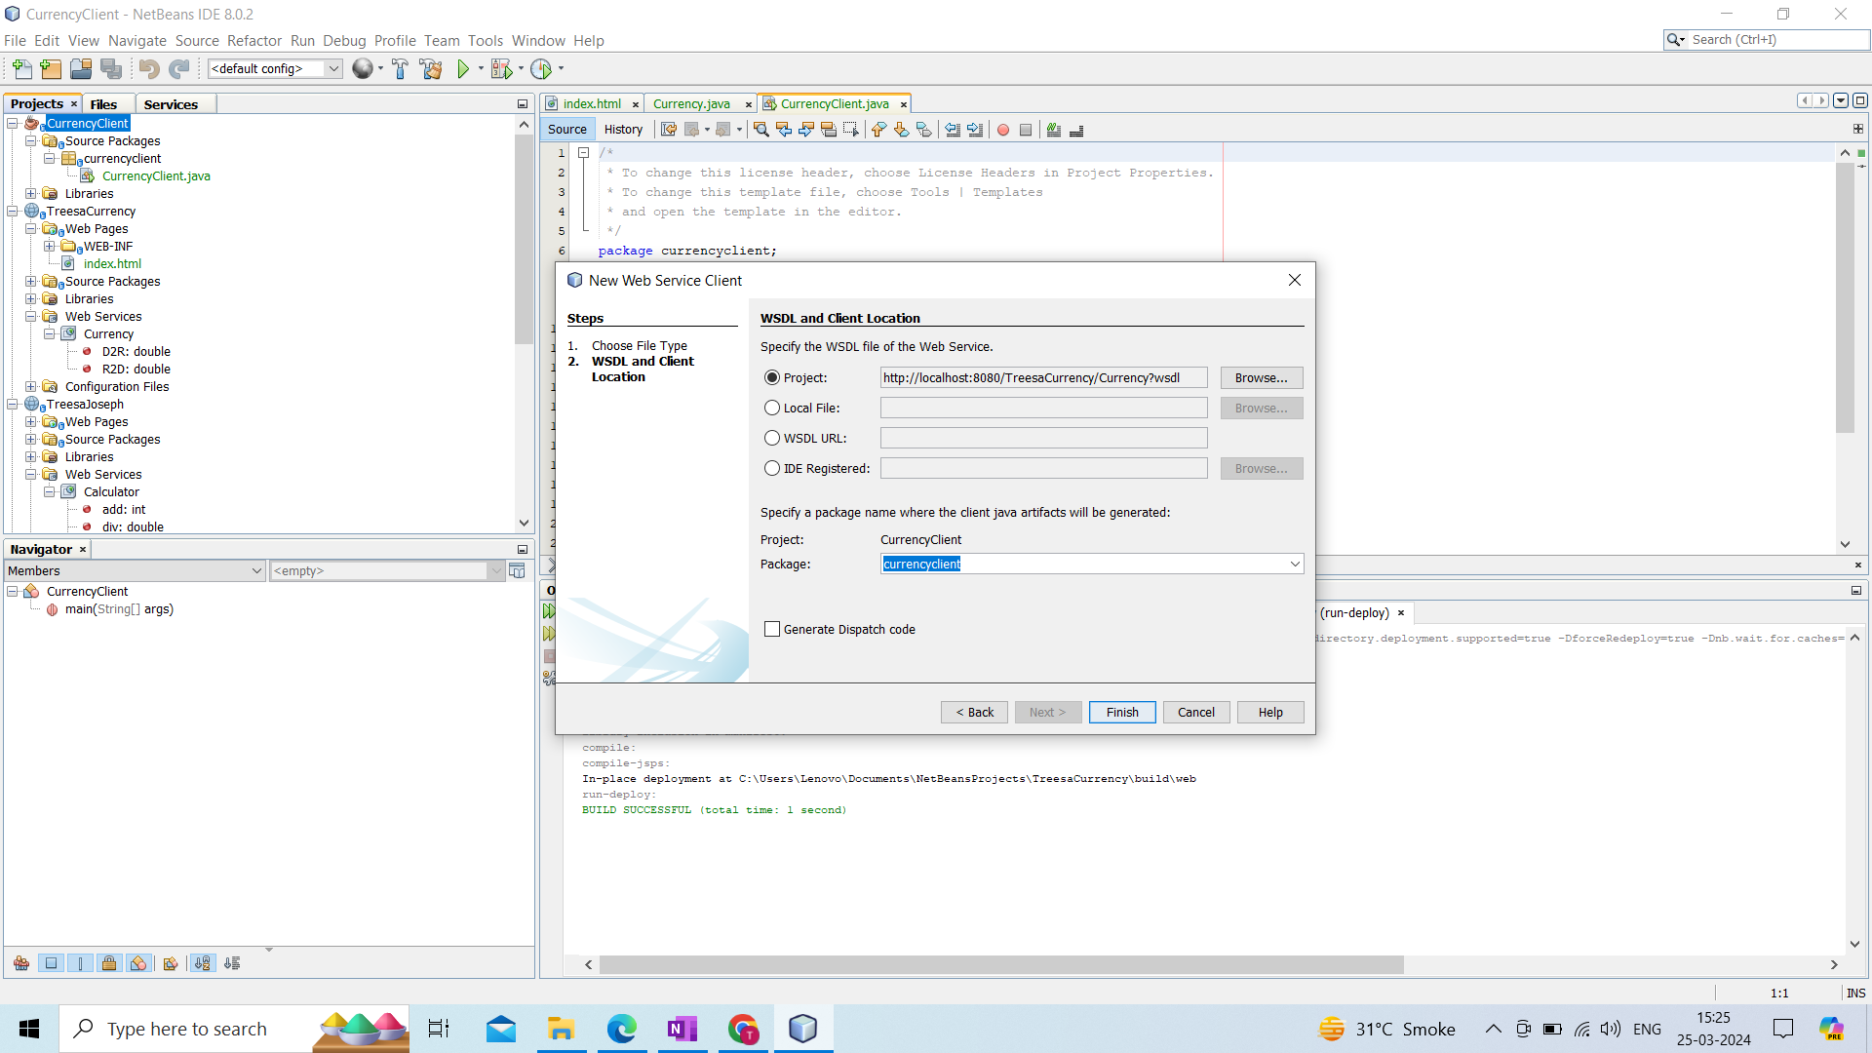

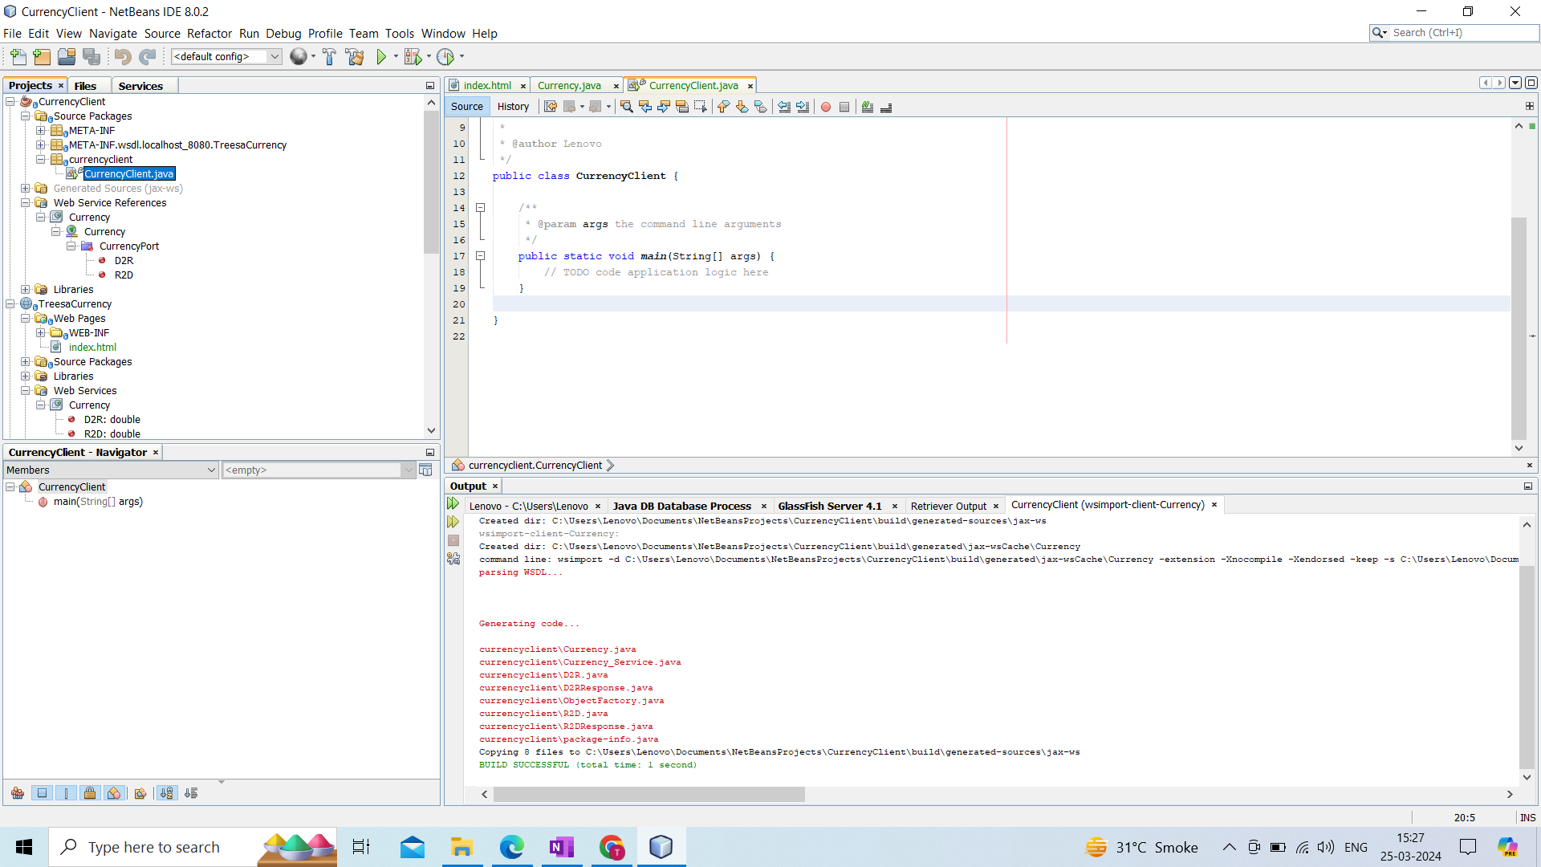

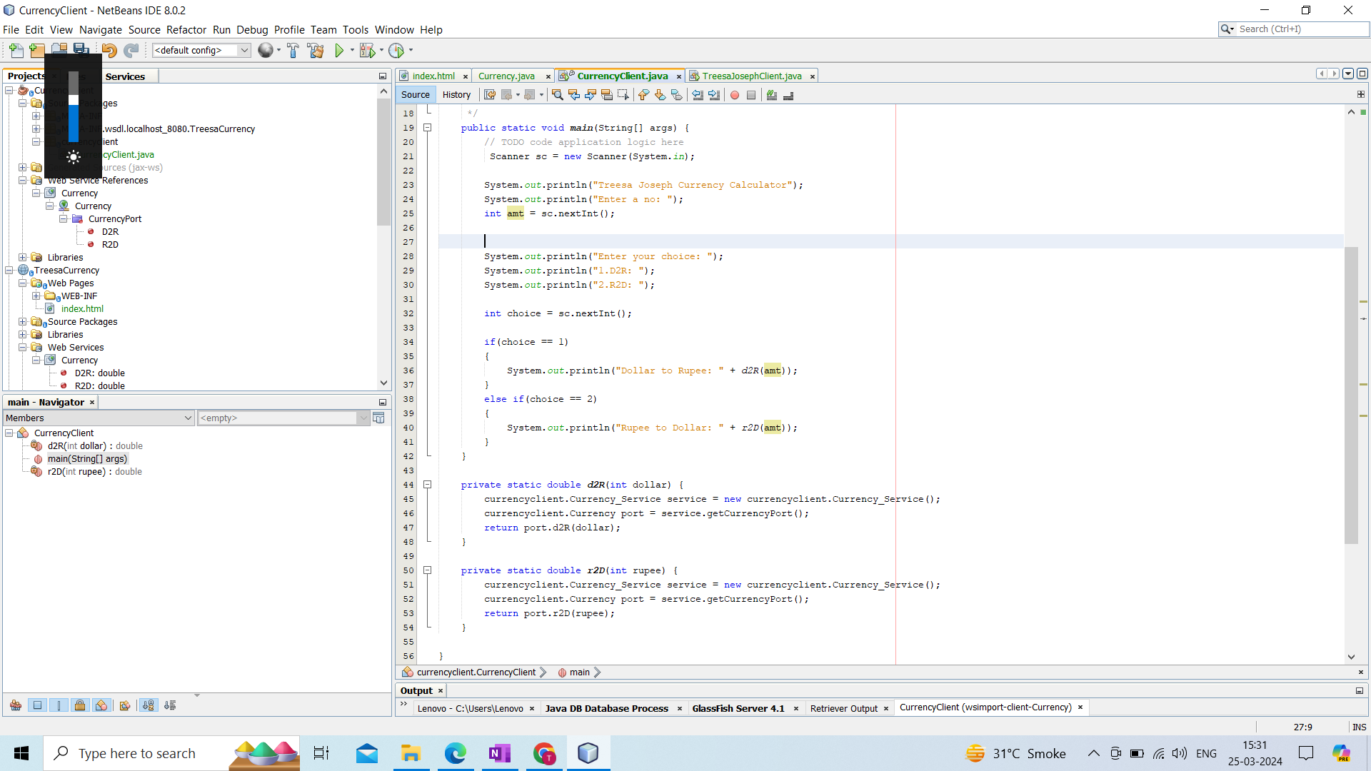

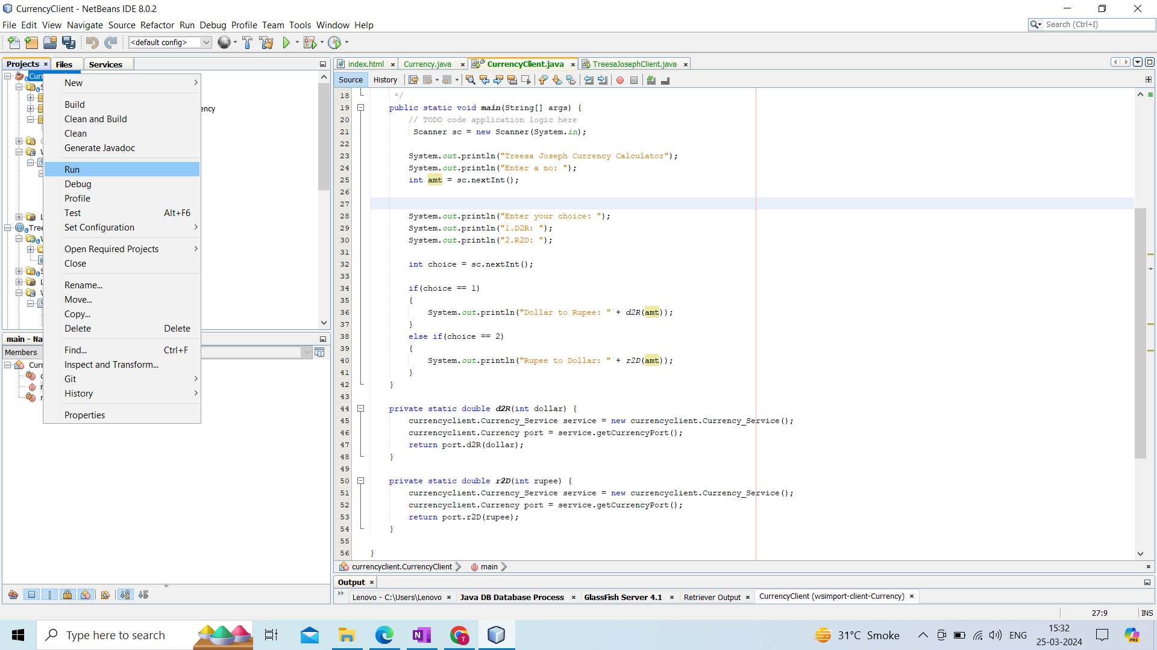

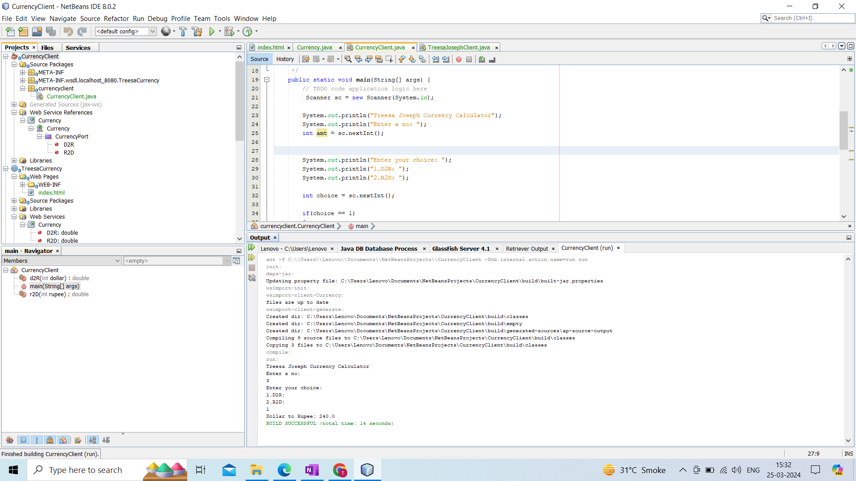

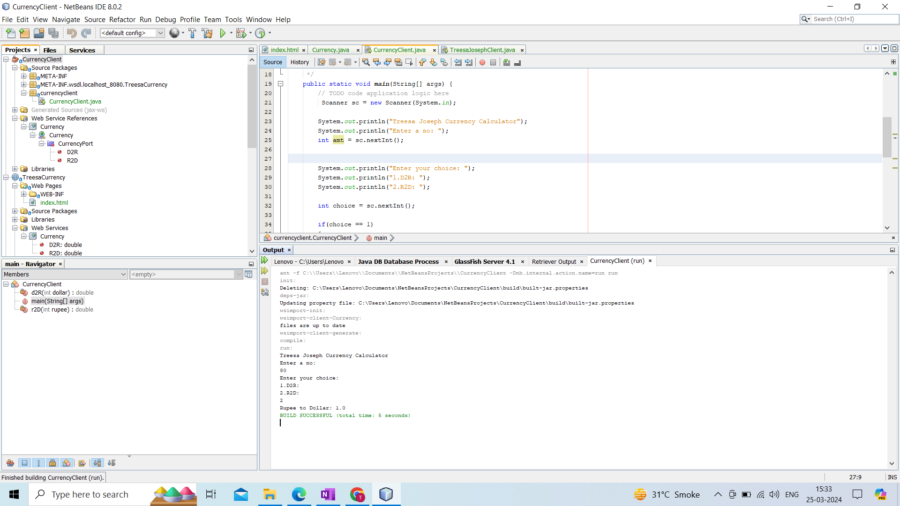

**Name : Treesa Joseph Roll No : KCTYCS(075) Date :**

# **Practical 2B : Implementation of calculator soap services using. Net c#**

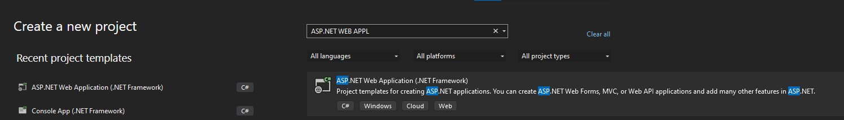

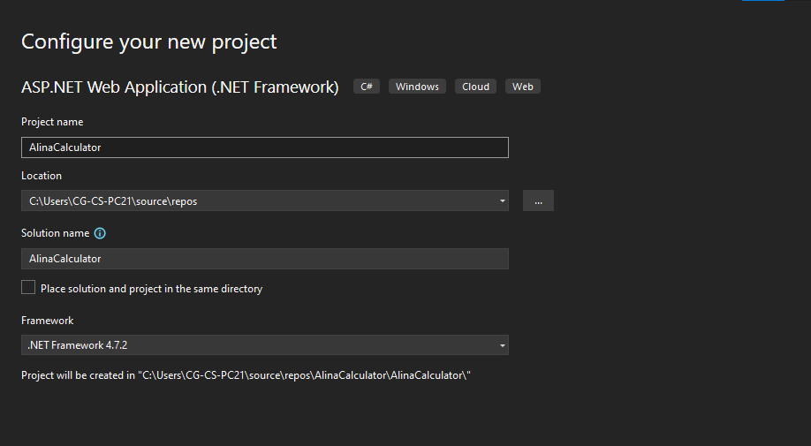

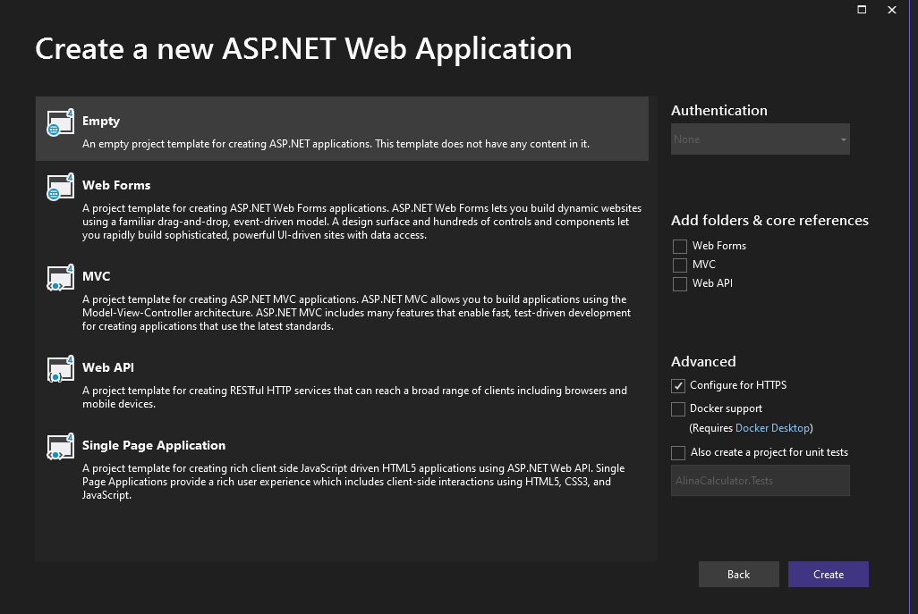

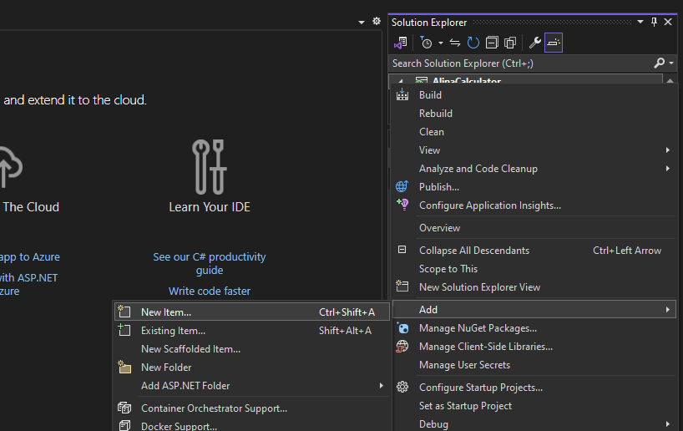

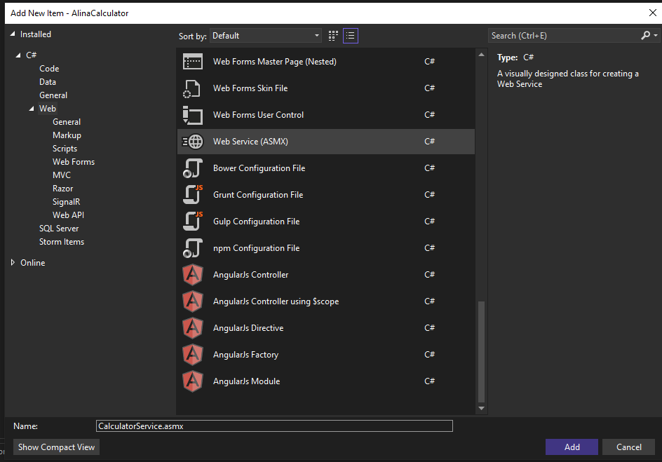

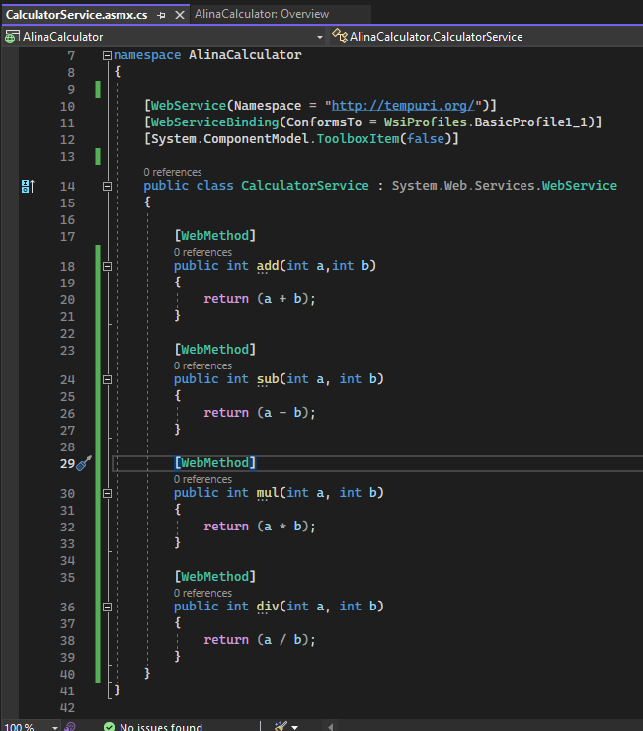

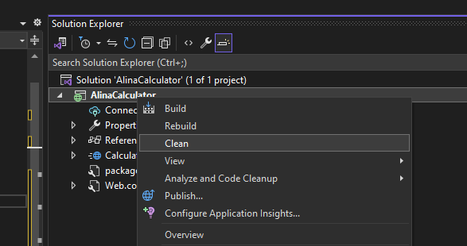

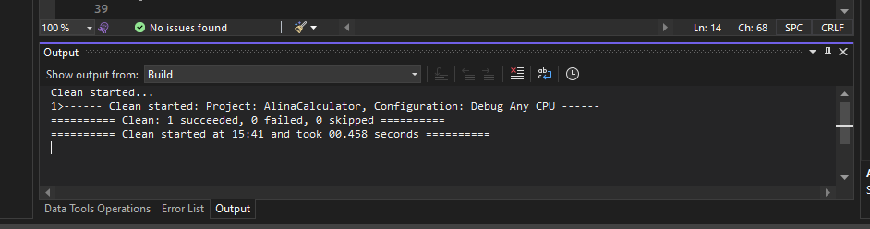

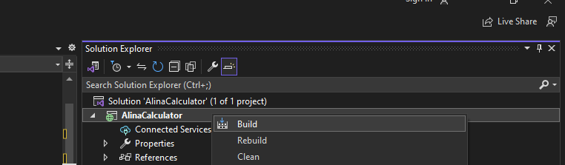

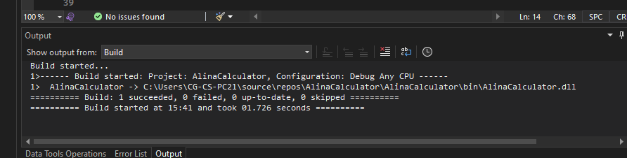

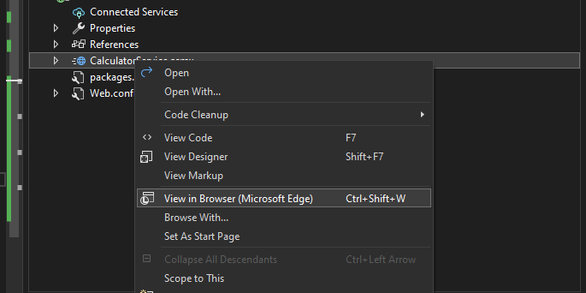

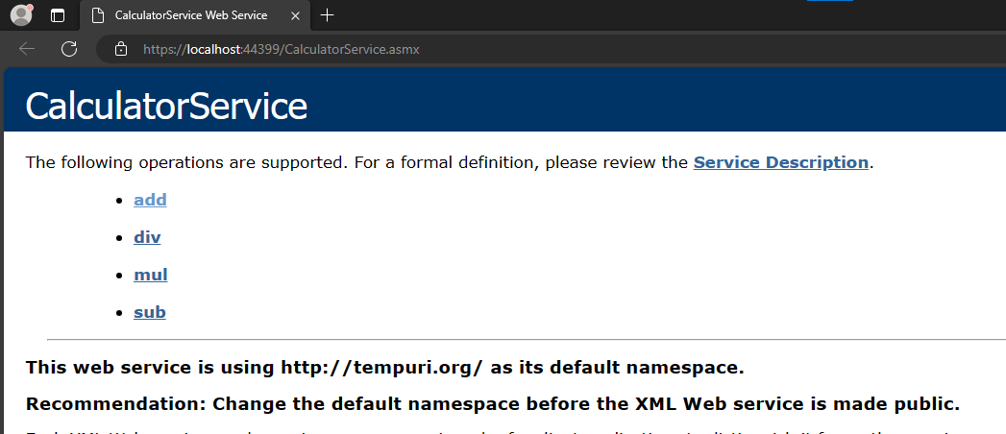

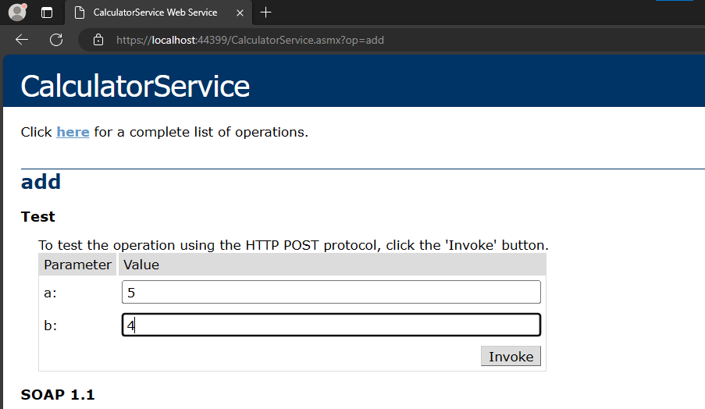

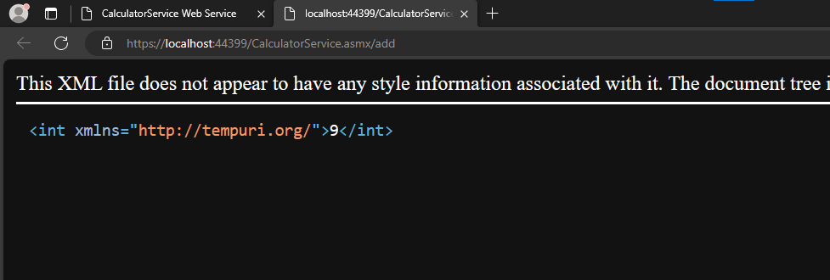

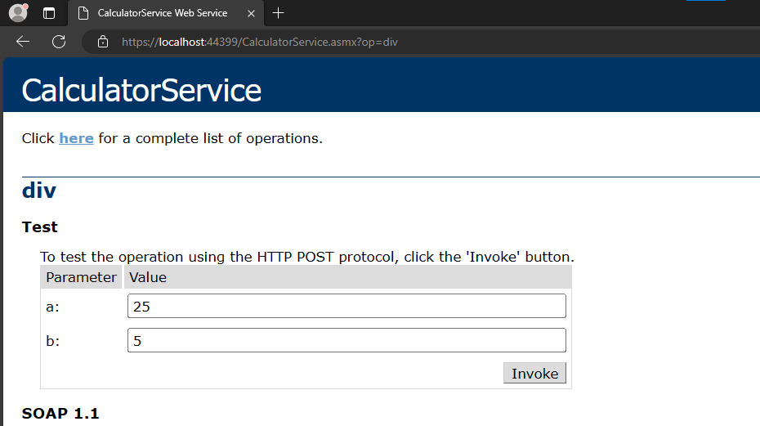

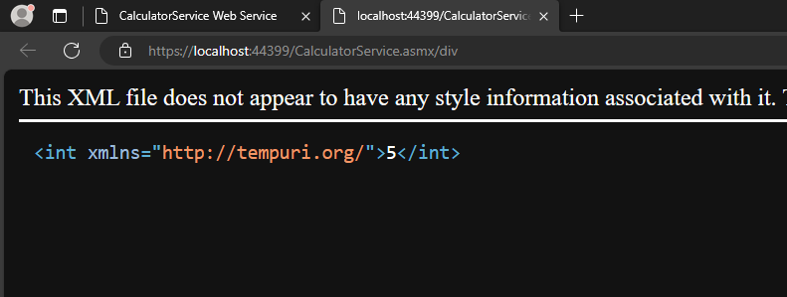

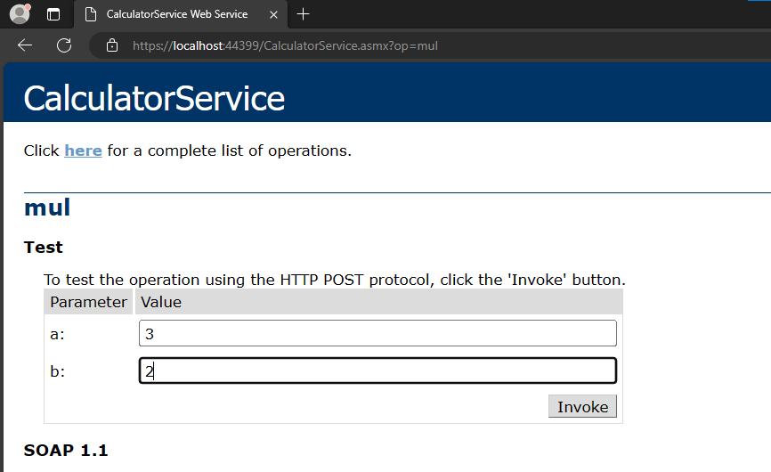

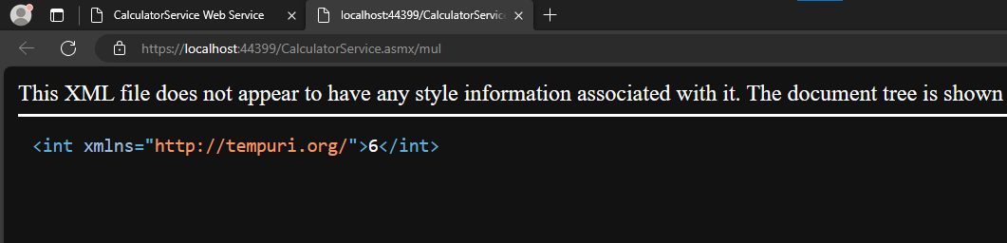

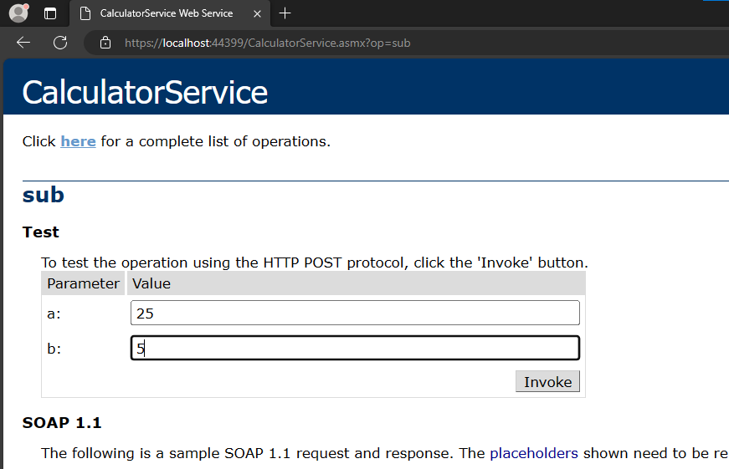

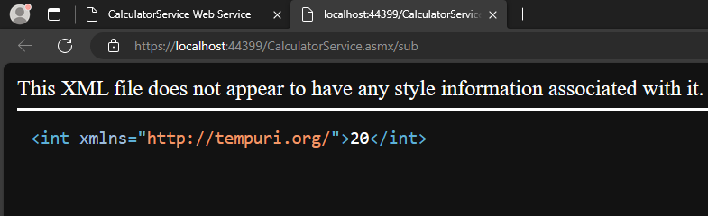

Client

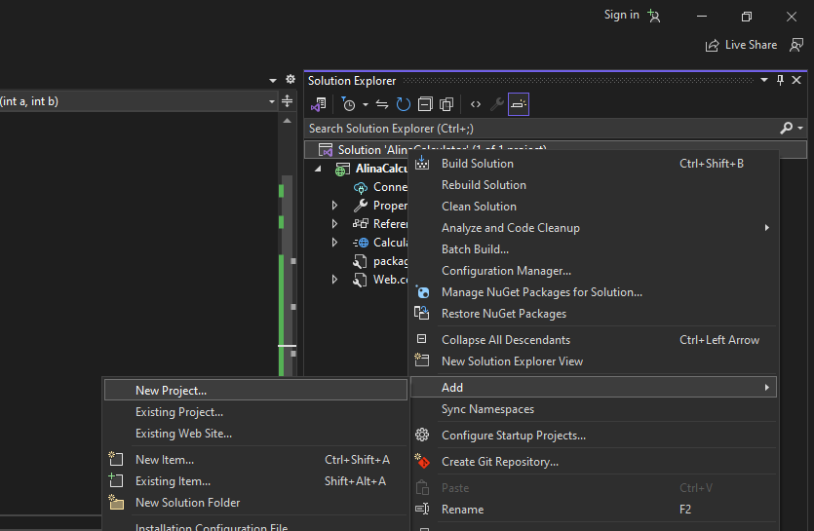

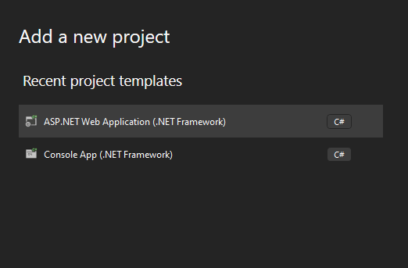

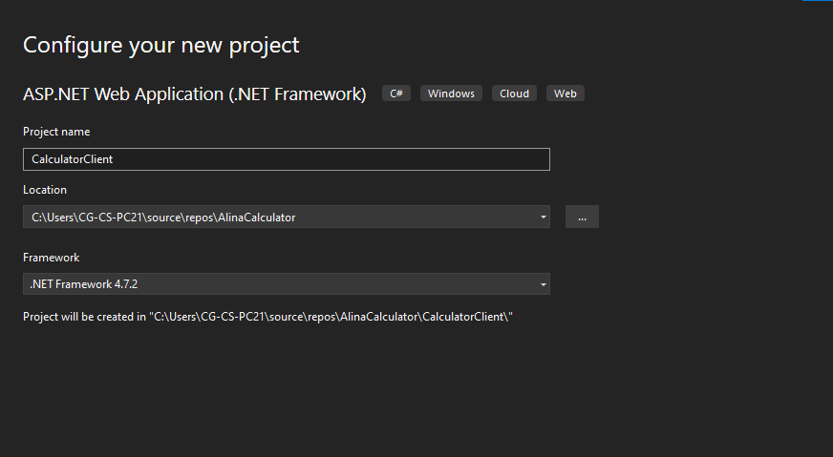

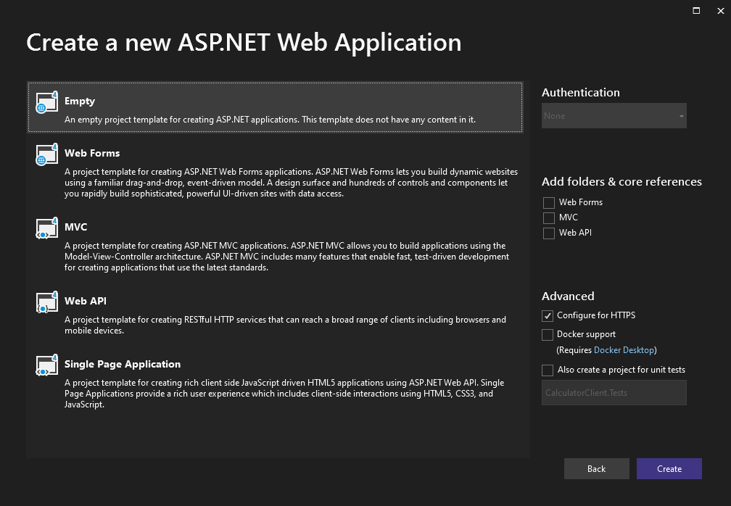

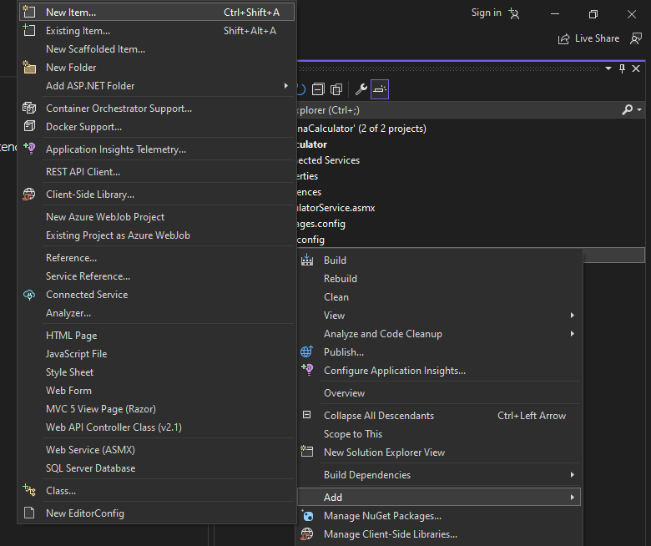

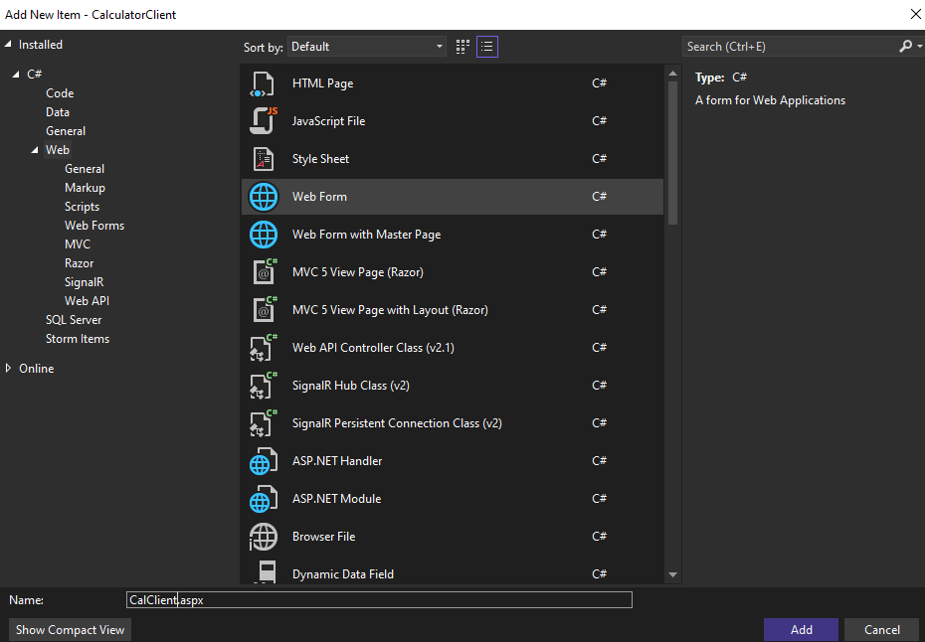

Design the page

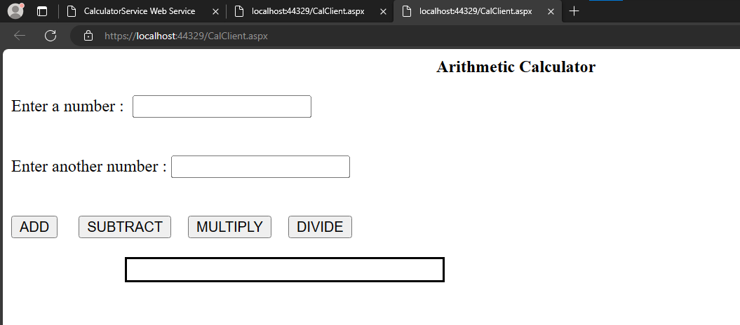

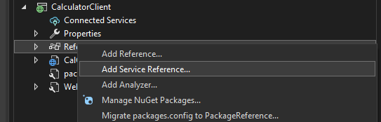

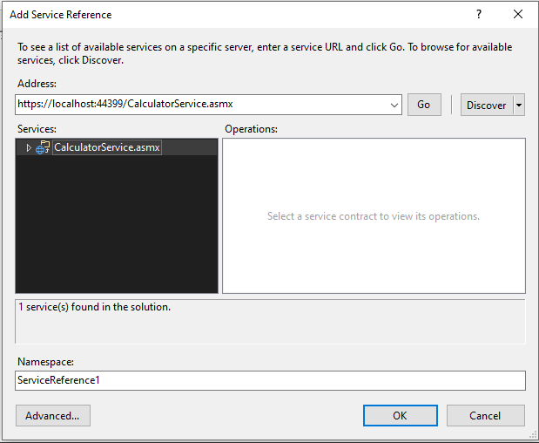

Service is available

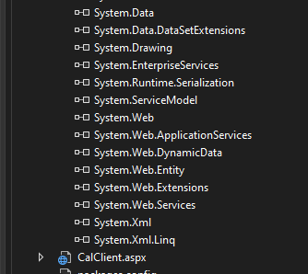

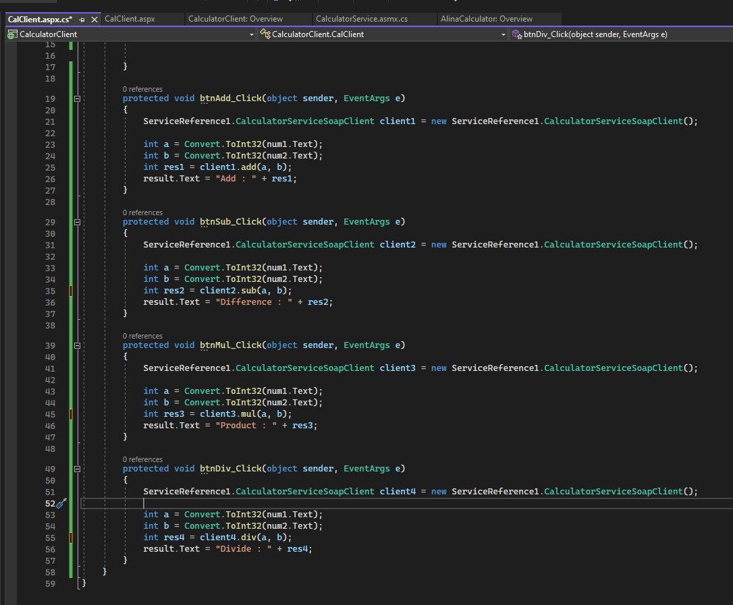

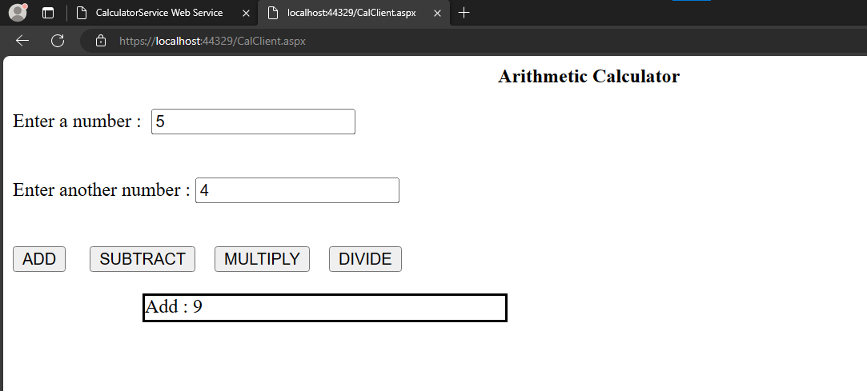

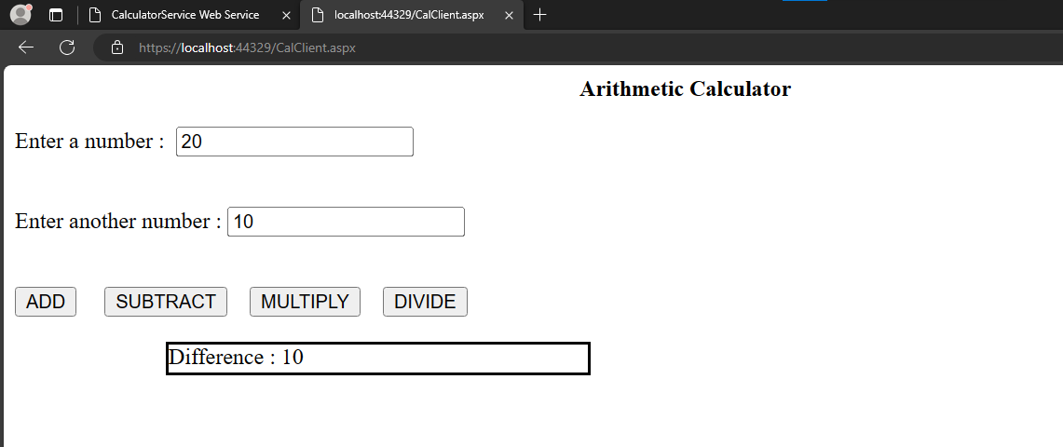

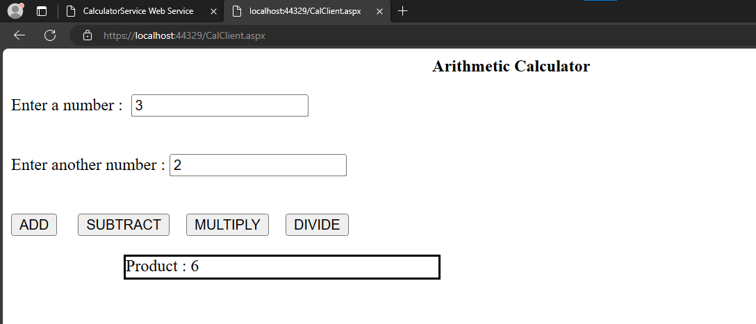

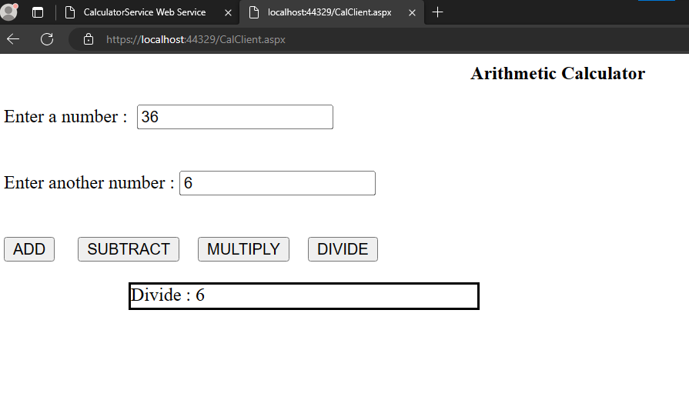

# 

# 

# 

# 

# 

# 

# 

# 

# 

# 

# 

# 

# 

# 

# 

# 

# 

# 

# 

**Name : Treesa Joseph Roll No : KCTYCS(75) Date :**

# Practical 3 : Implementation of String operations Restful Web Services using Java NetBeans

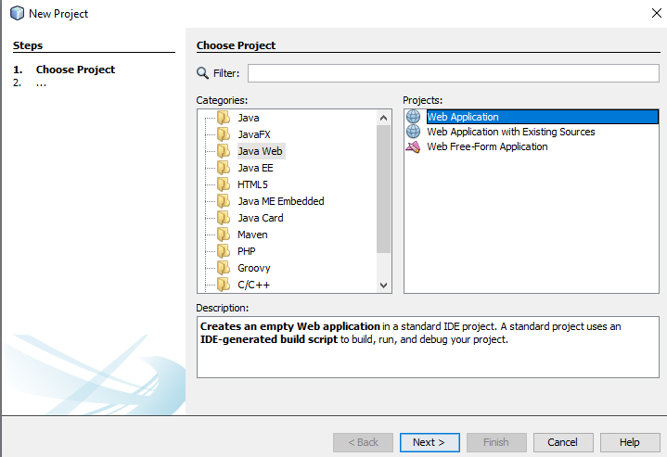

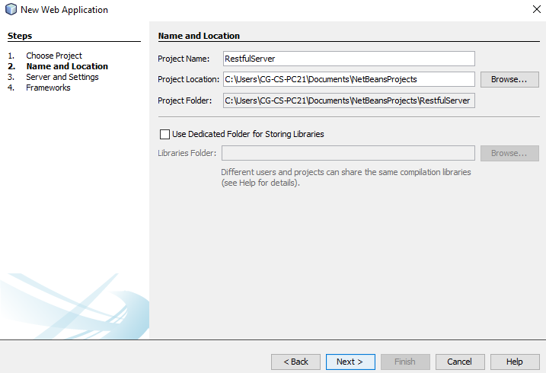

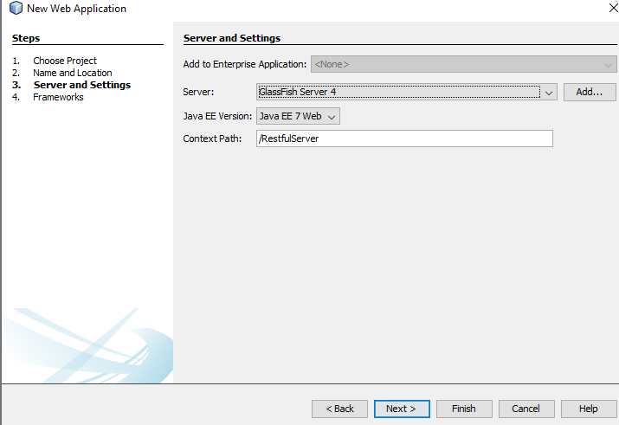

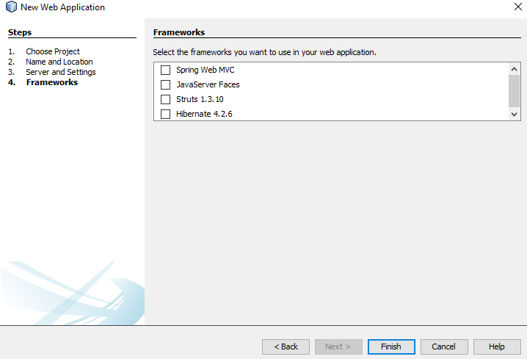

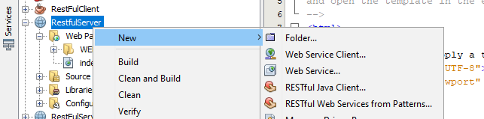

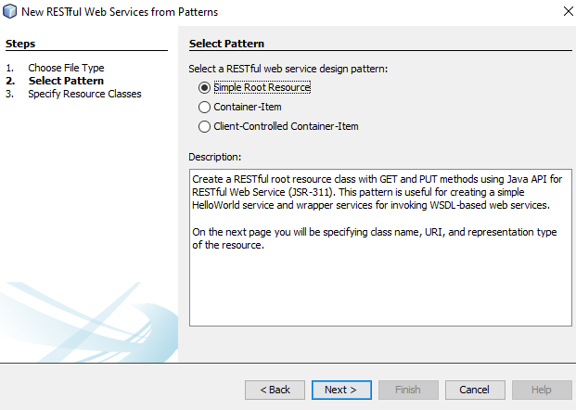

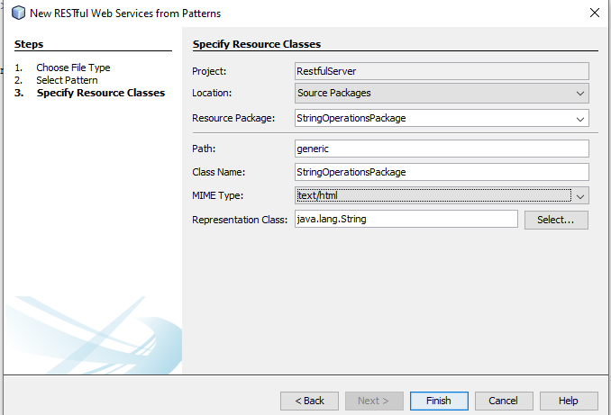

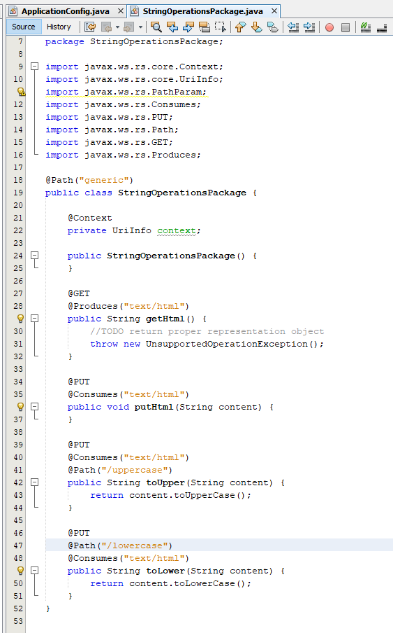

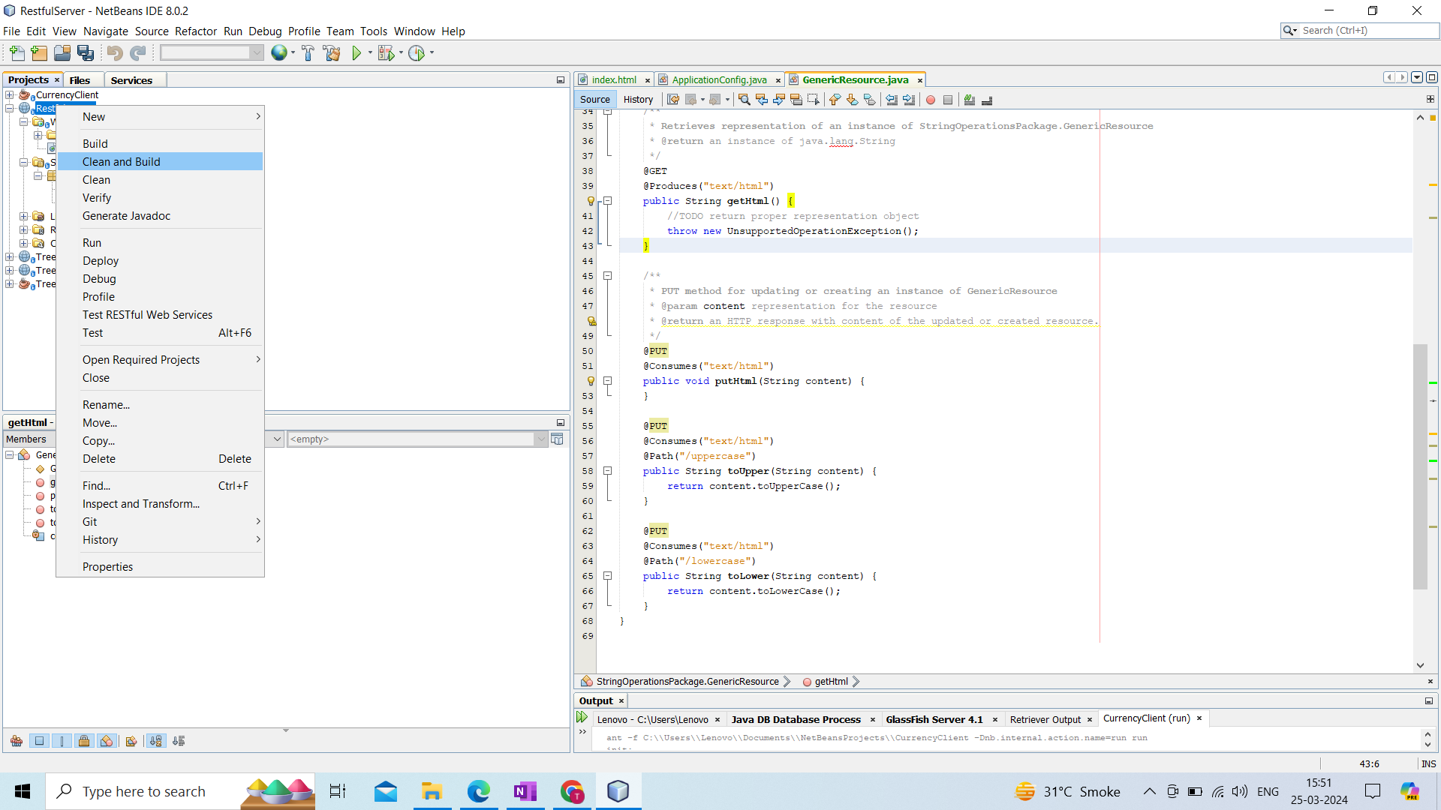

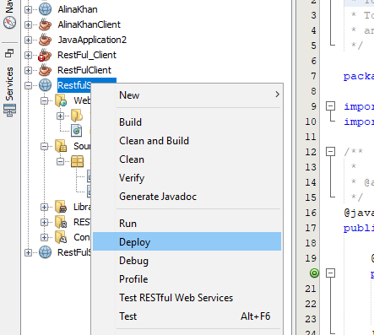

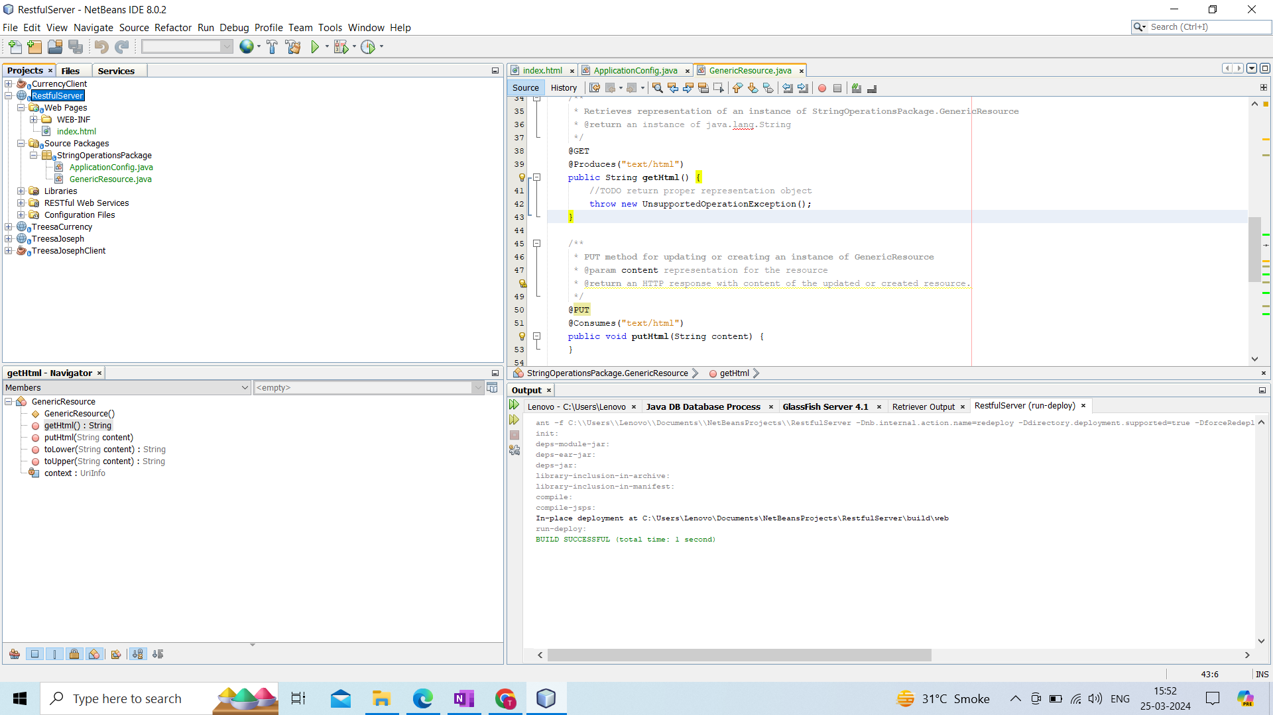

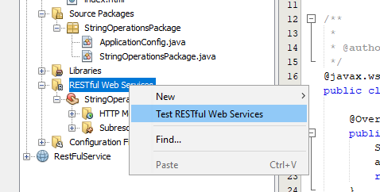

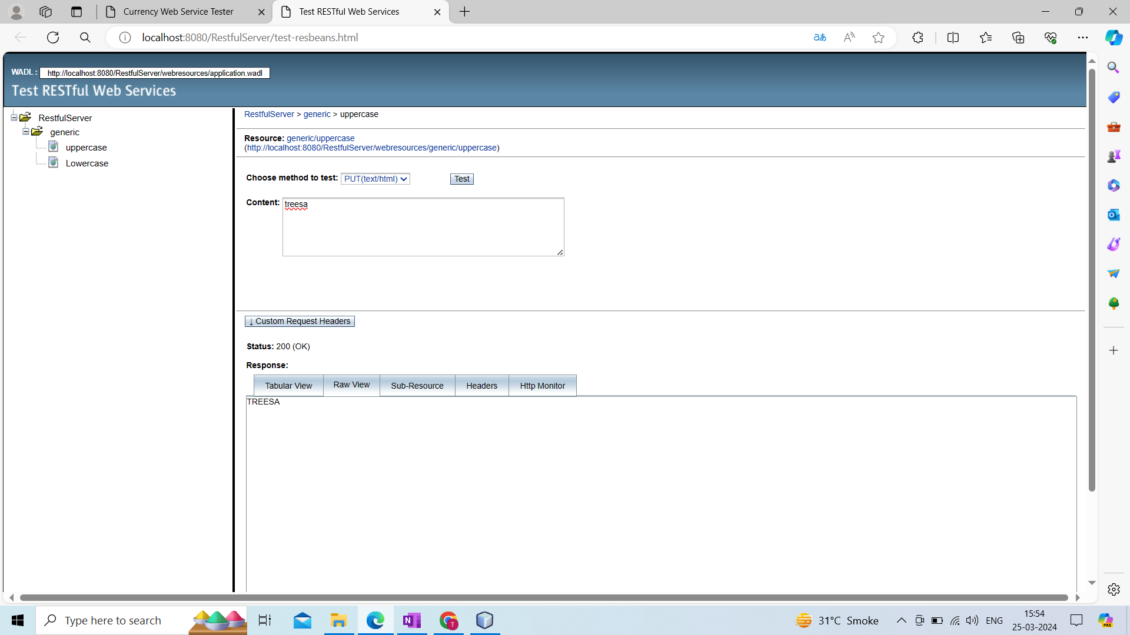

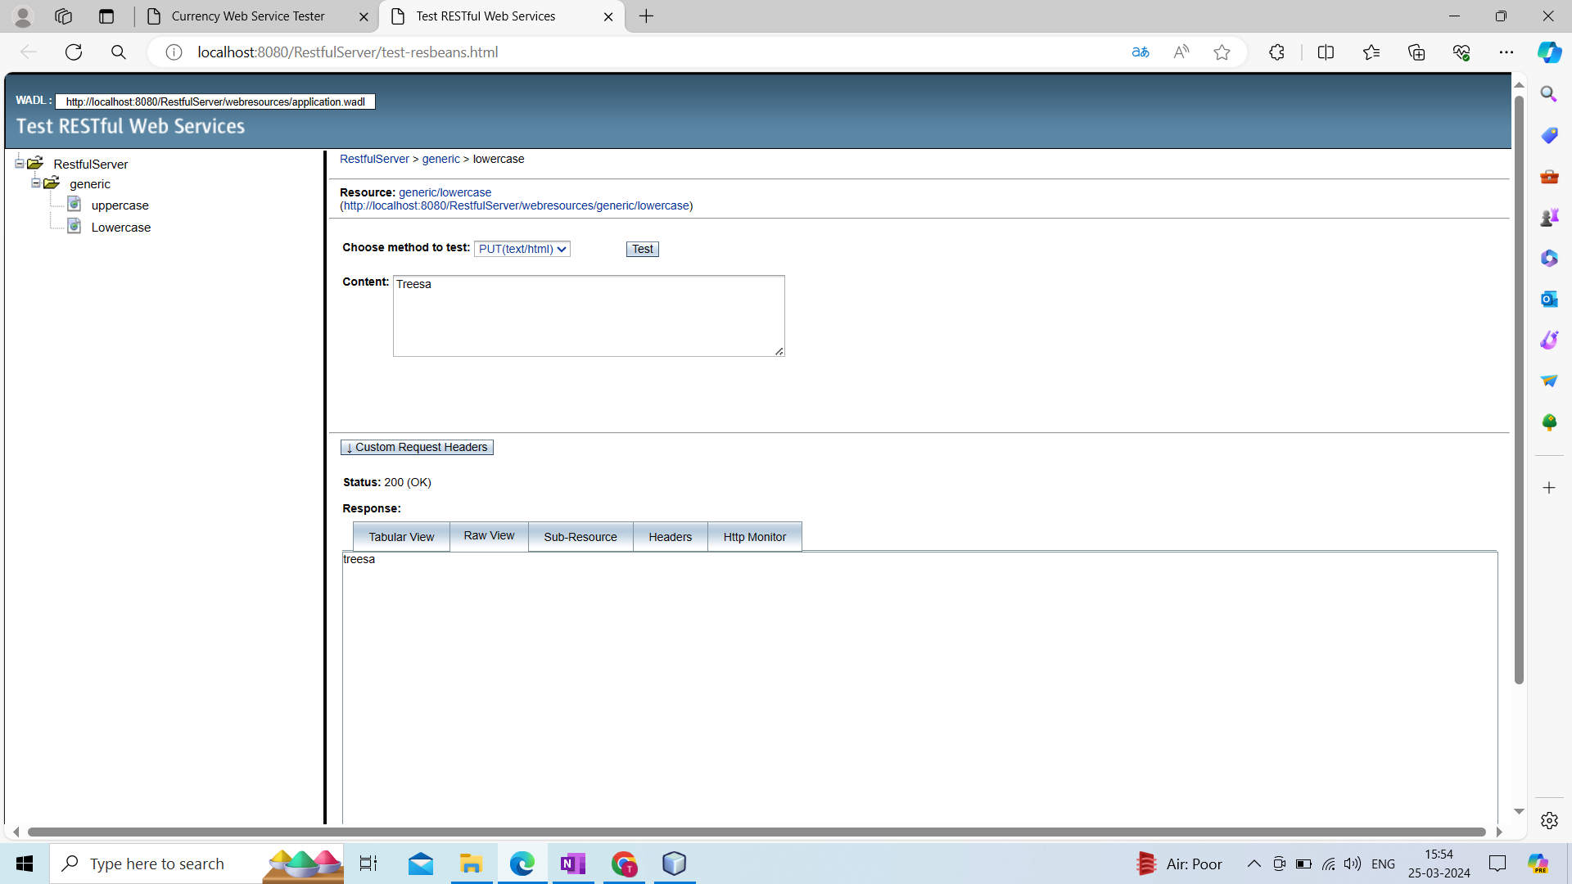

**CLIENT**

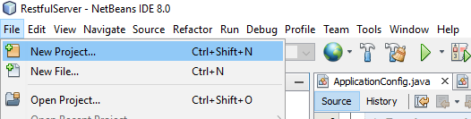

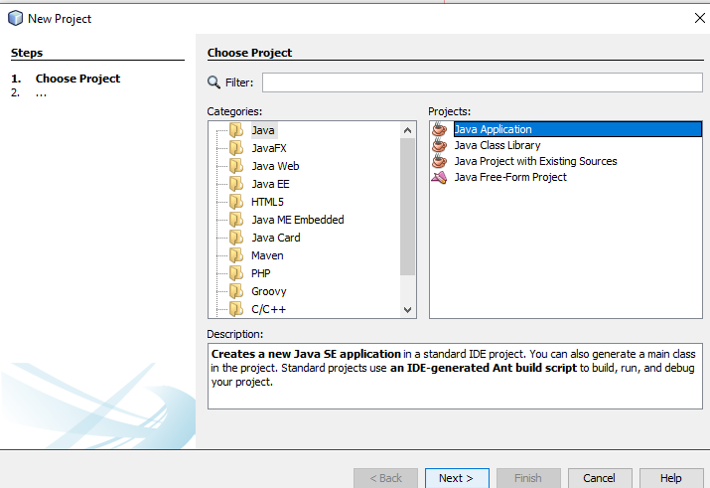

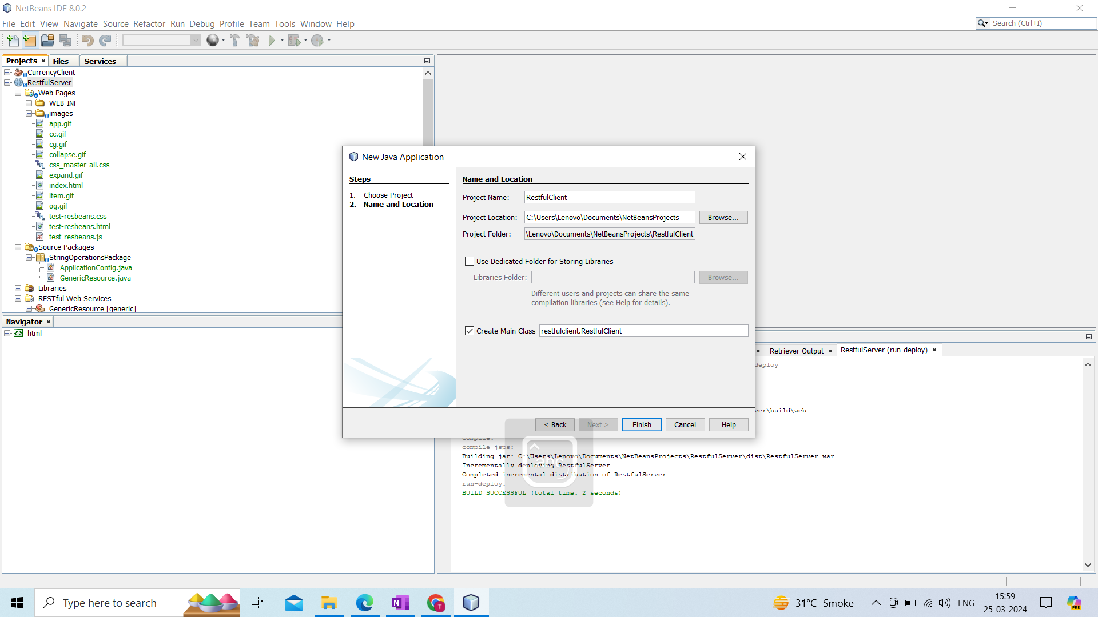

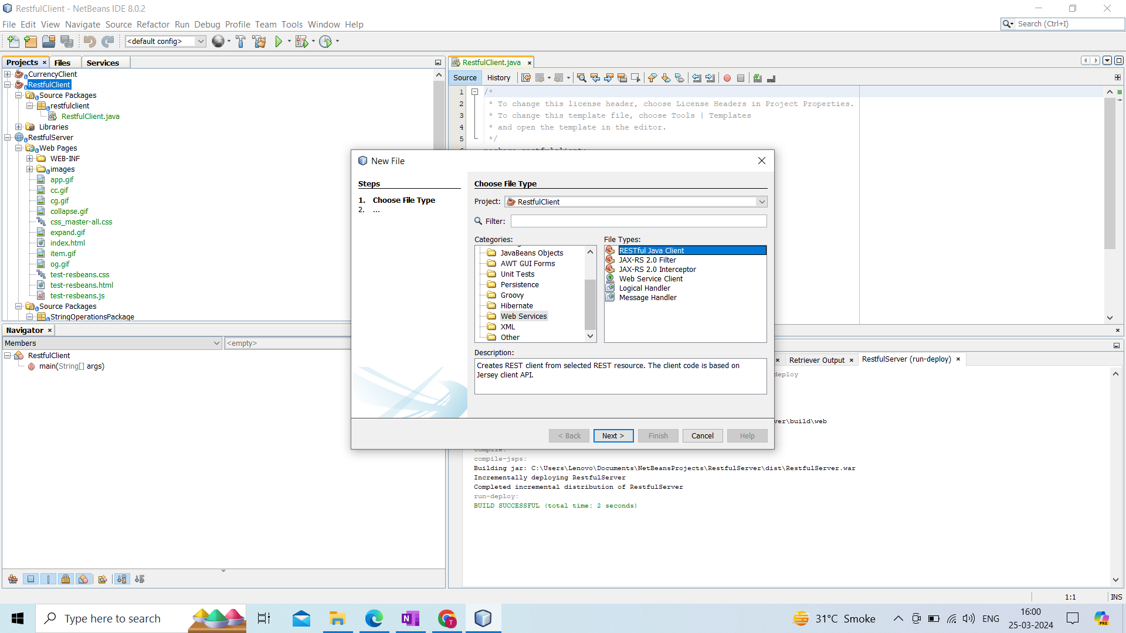

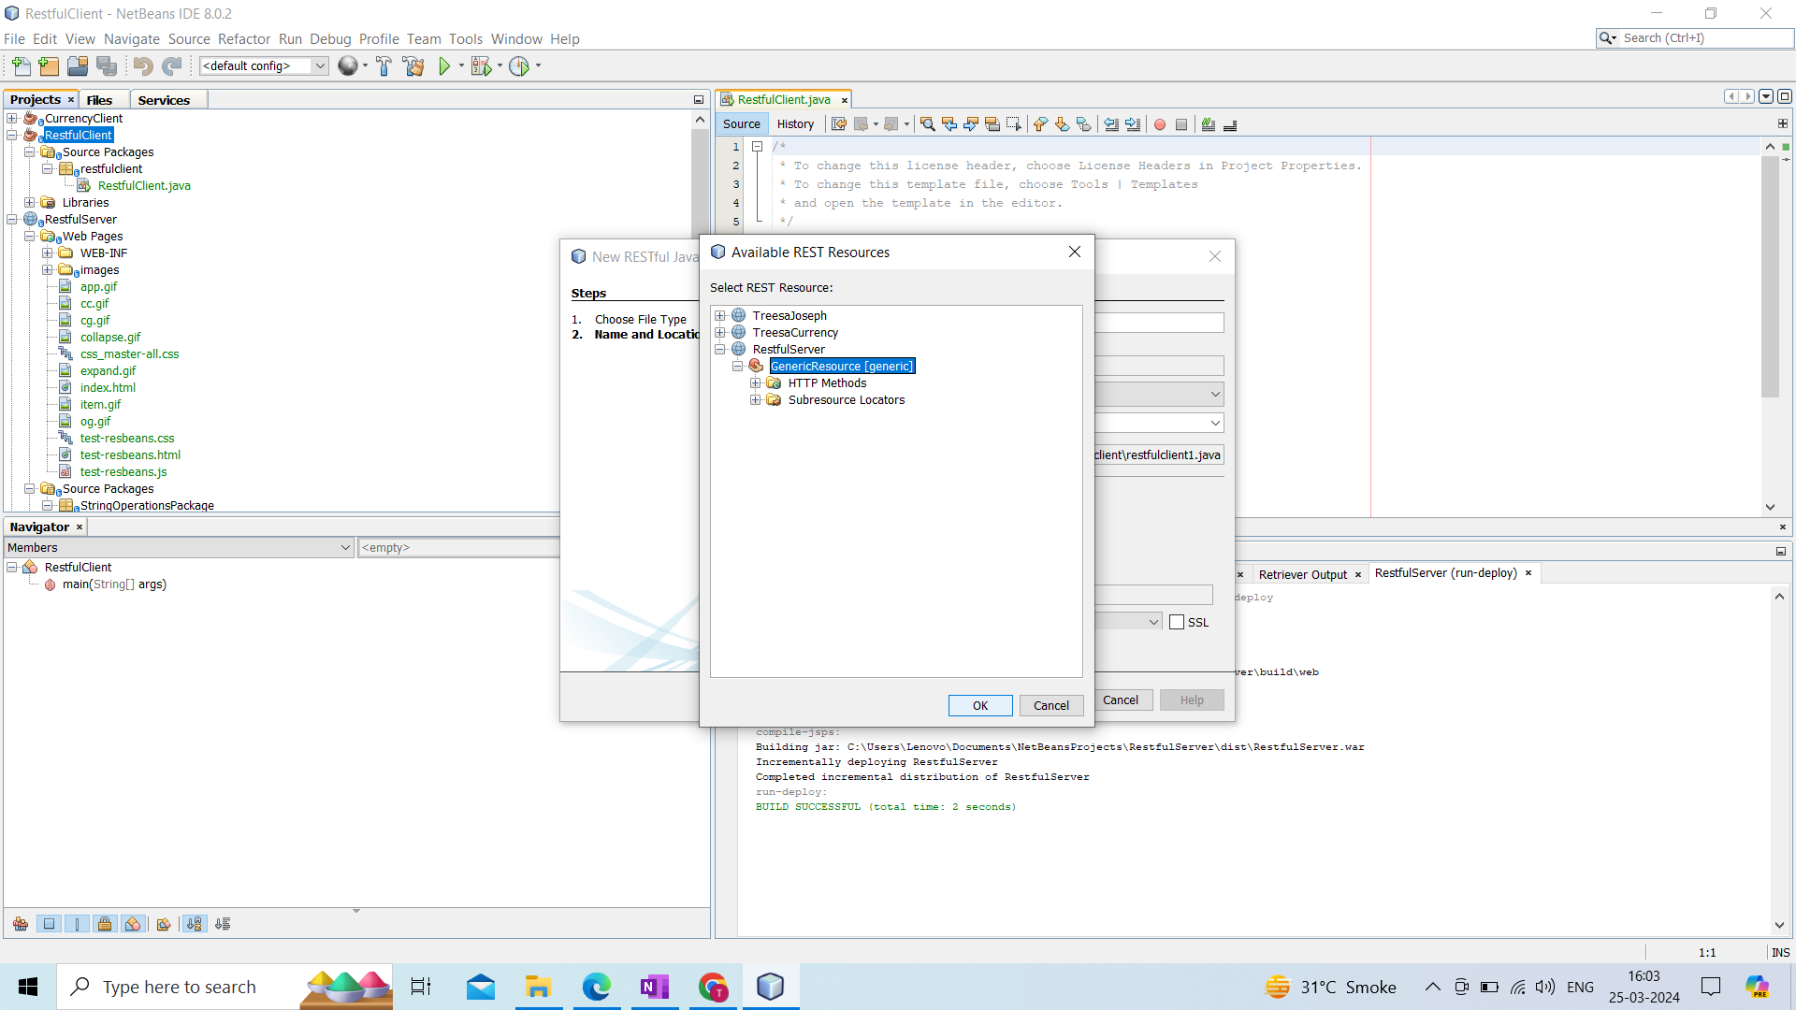

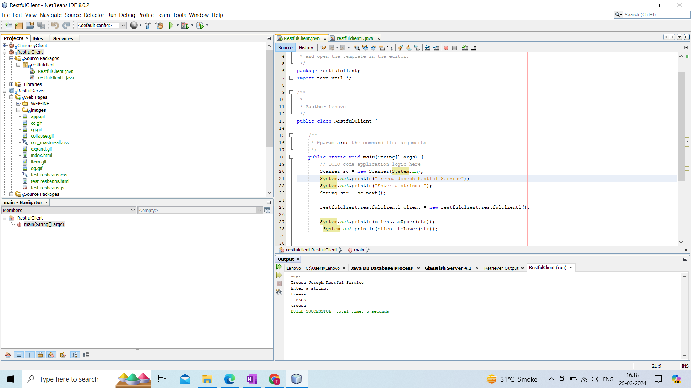

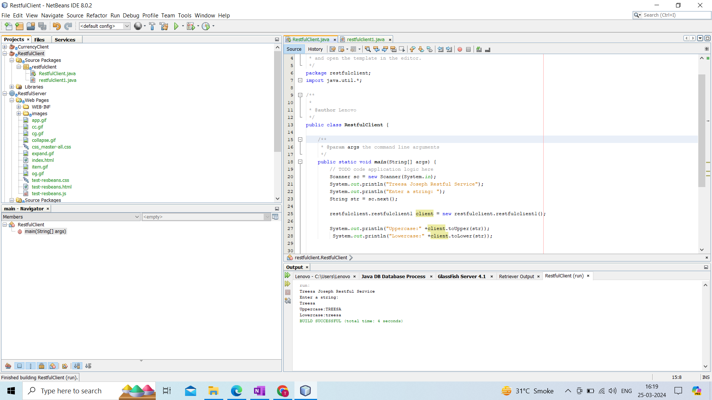

**Name : Treesa Joseph Roll No : KCTYCS(75) Date :**

# Practical 4A Aim : Implementation of RESTful Service to calculate the reverse of a number using Java NetBeans and create a client to consume the service.

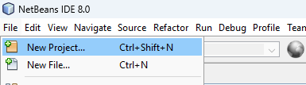

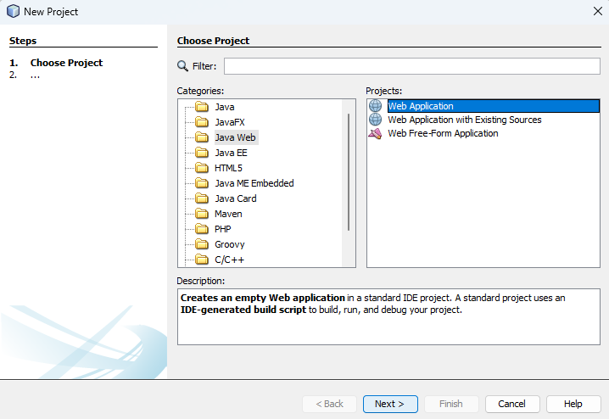

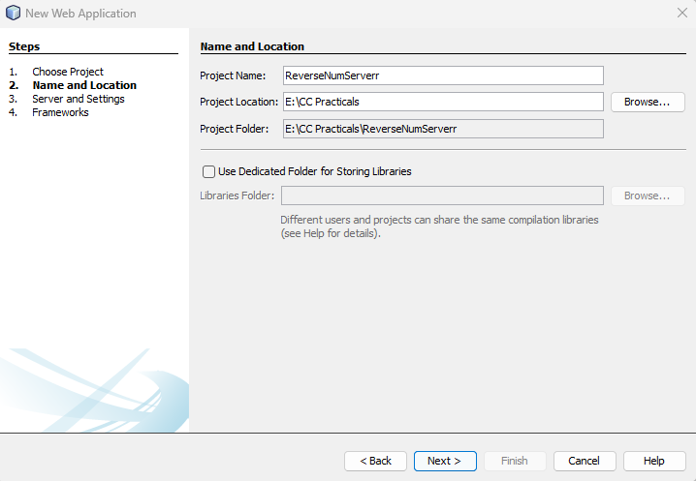

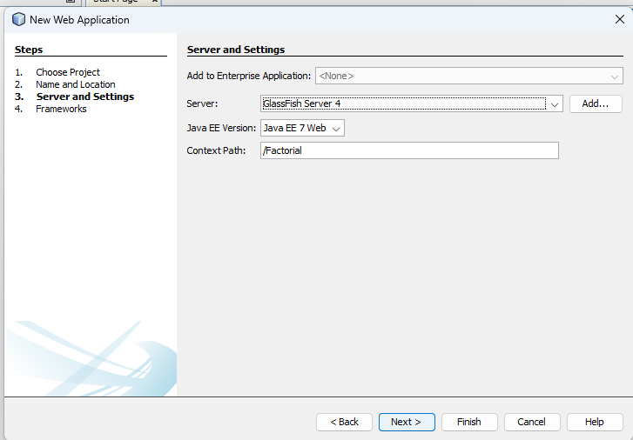

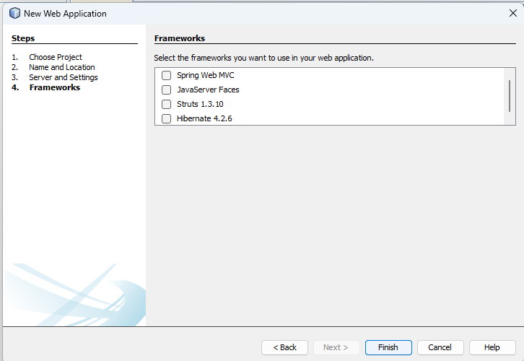

**Adding REST Service**

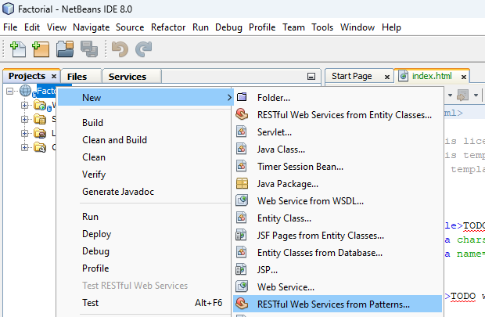

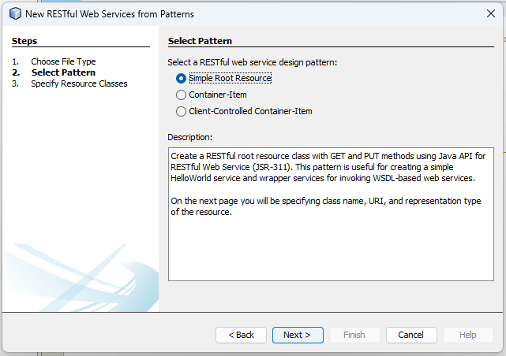

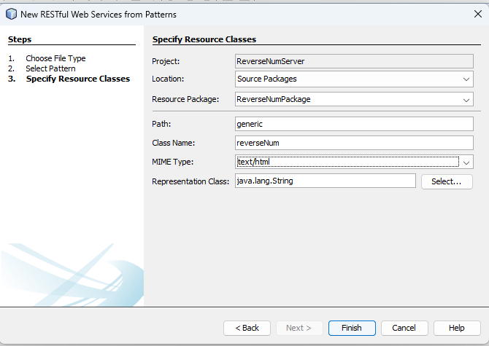

**ReverseNum.java**

@Path("/reverseNum")

@PUT

@Consumes("text/html")

public String reverseNum(String s) {

String ans = "";

StringBuilder sb = new StringBuilder(s);

for (int i = 0 ; i < sb.length()/2 ; i++) {

int front = i ;

int back = sb.length() - 1 - i;

char frontChar = sb.charAt(front);

char backChar = sb.charAt(back);

sb.setCharAt(front, backChar);

sb.setCharAt(back, frontChar);

}

ans = sb.toString();

return ans;

}

**Clean and Build**

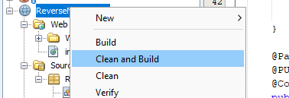

**Deploy**

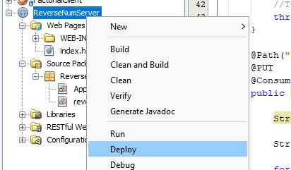

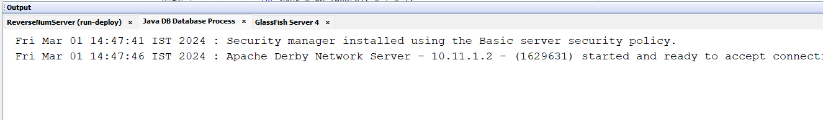

**Test the service**

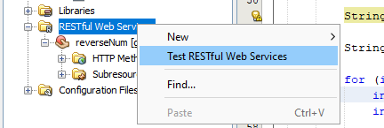

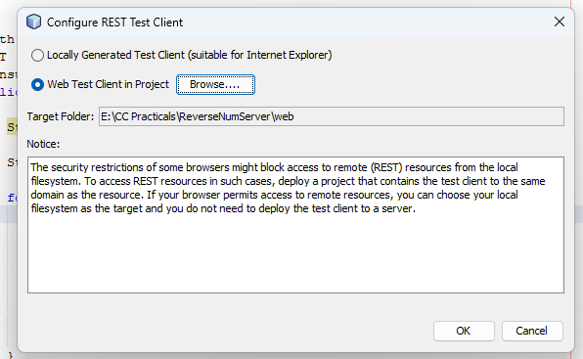

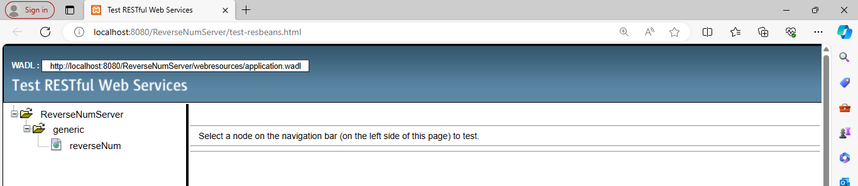

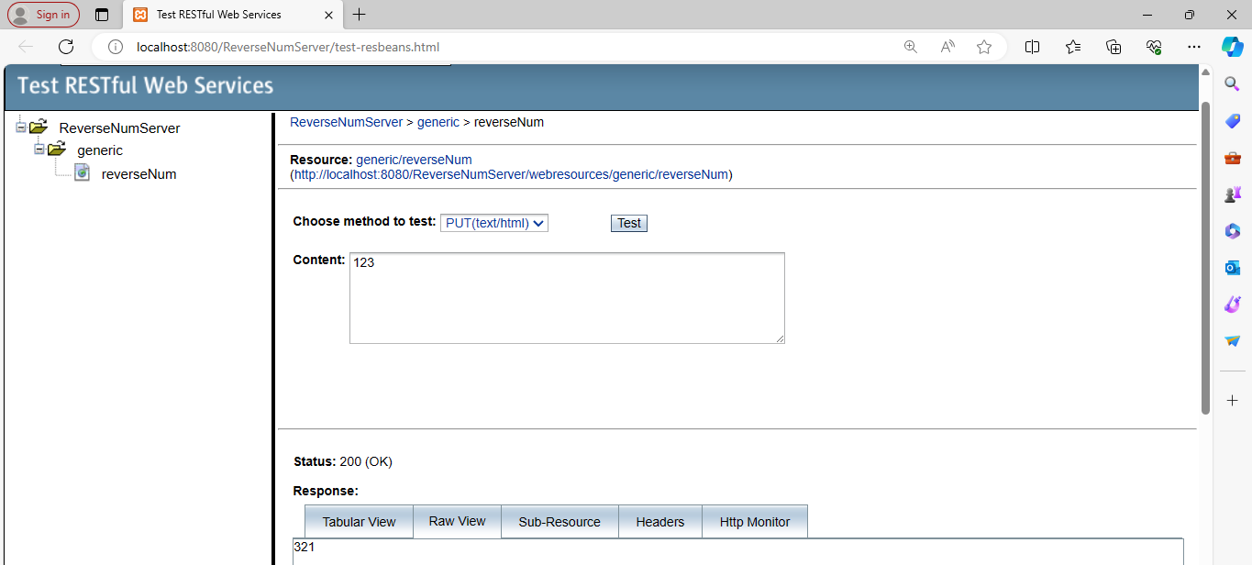

**Client Side**

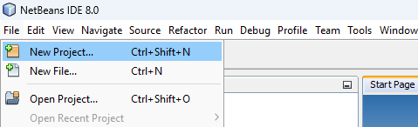

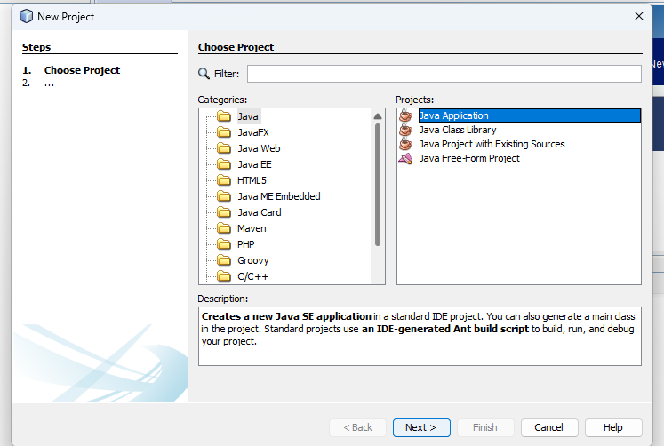

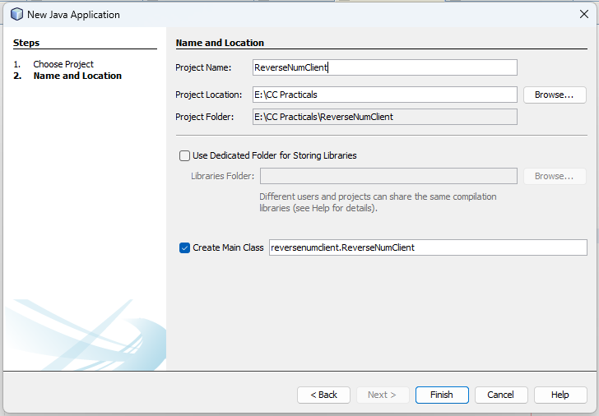

**Add RESTful Java Client**

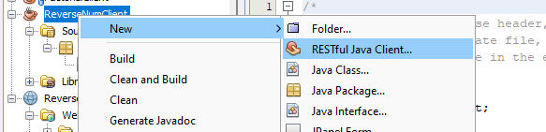

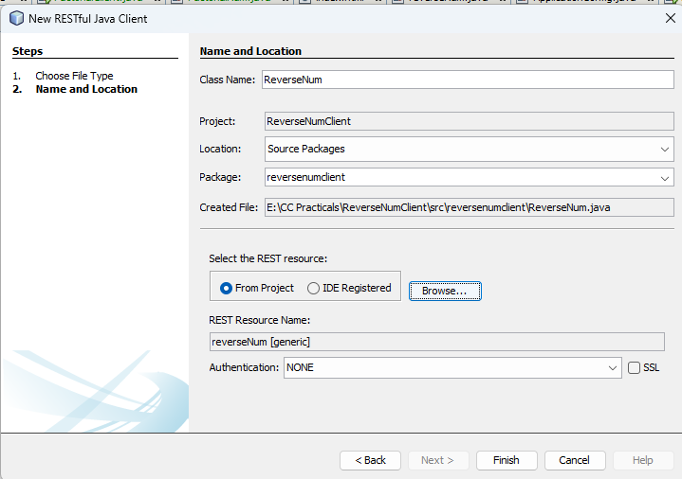

**ReverseNumClient.java**

package reversenumclient;

import java.util.*;

public class ReverseNumClient {

public static void main(String[] args) {

// TODO code application logic here

reversenumclient.ReverseNum client = new ReverseNum();

Scanner sc = new Scanner(System.in);

System.out.println("75 Treesa Joseph");

System.out.println("Enter a number : ");

String num = sc.next();

System.out.println("Reverse = " + client.reverseNum(num));

}

}

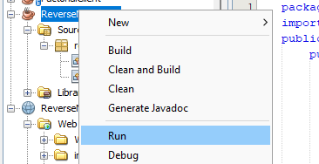

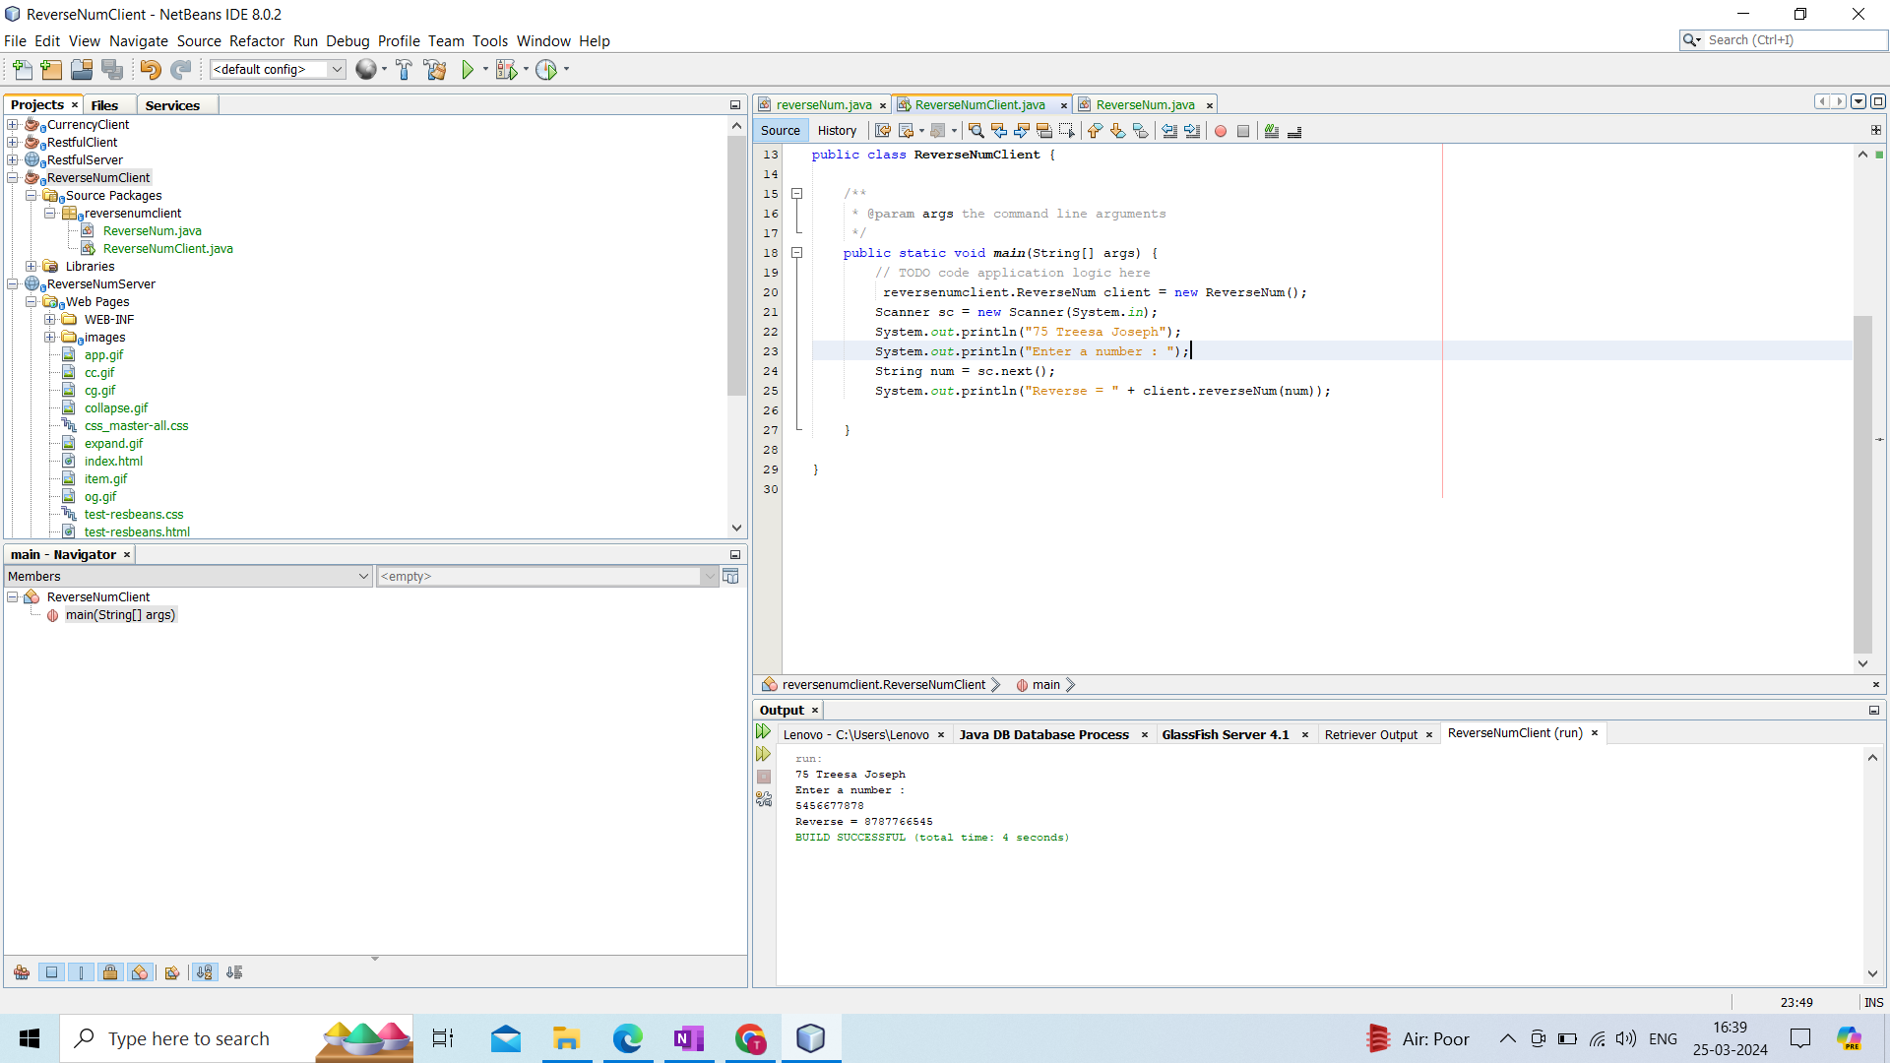

**Name : Treesa Joseph Roll No : KCTYCS(75) Date :**

# Practical 4B Aim : Implementation of RESTful Service to check if a number is even or odd using Java NetBeans and create a client to consume the service.

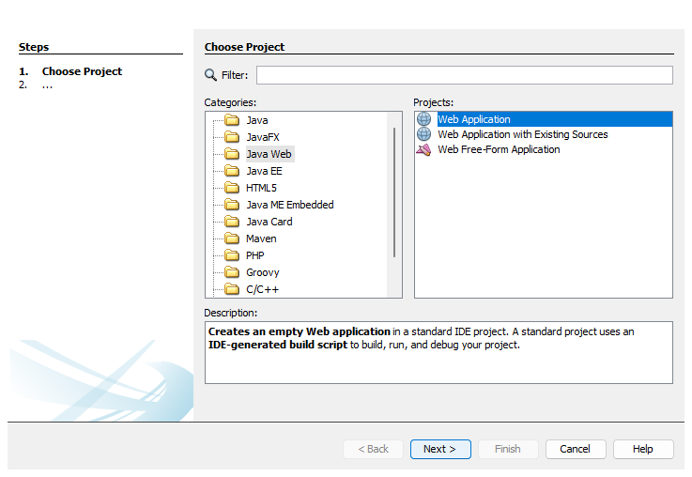

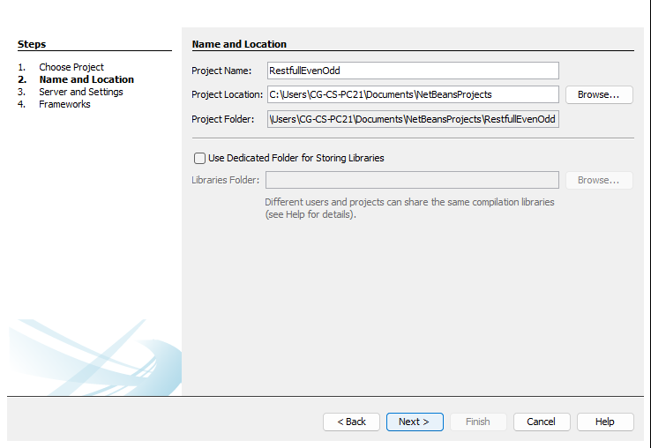

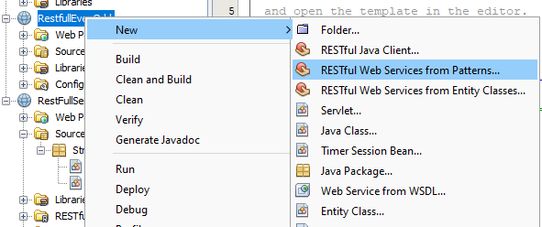

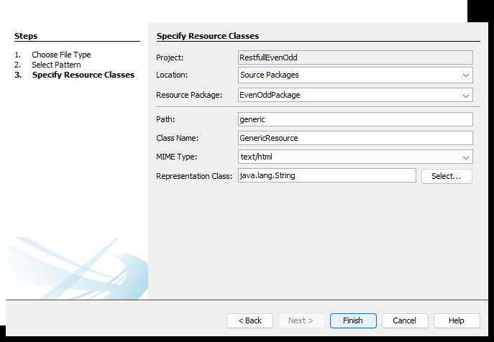

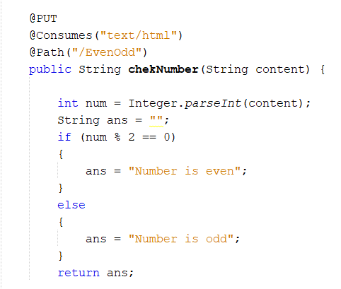

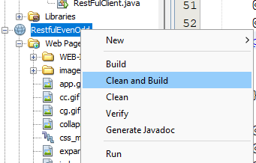

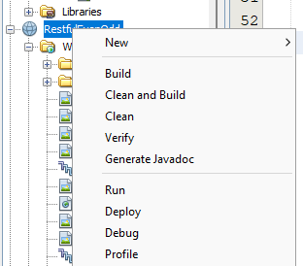

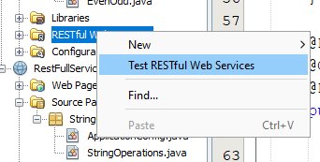

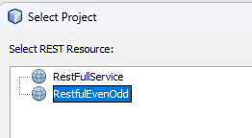

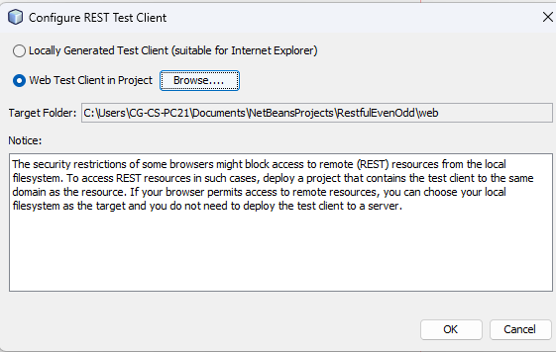

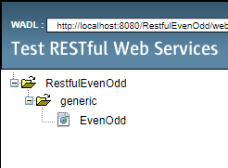

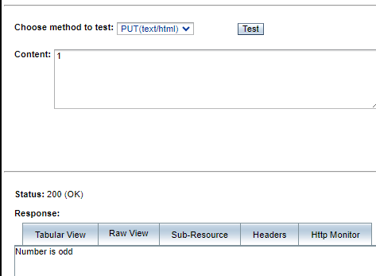

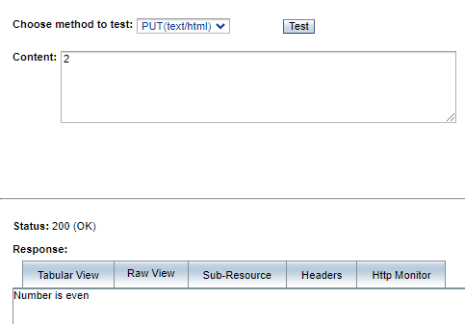

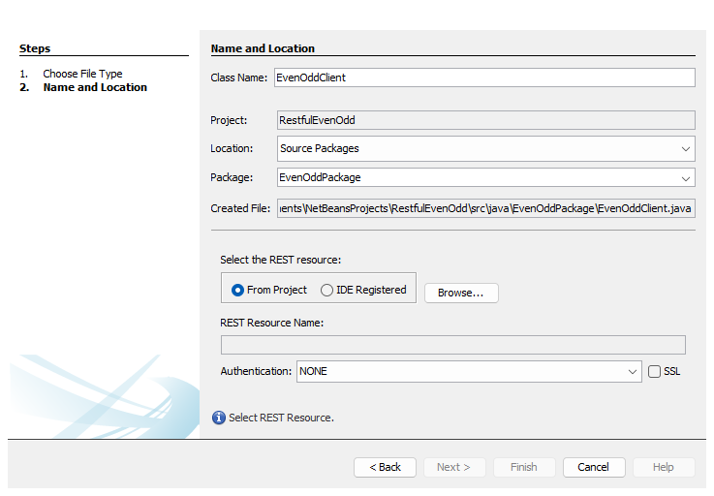

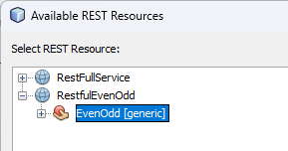

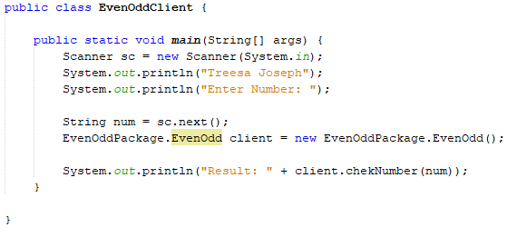

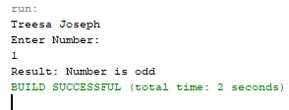

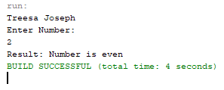

**Name : Treesa Joseph Roll No : KCTYCS(75) Date :**

# Practical 4C Aim : Implementation of RESTful Service to calculate the factorial of a number using Java NetBeans and create a client to consume the service





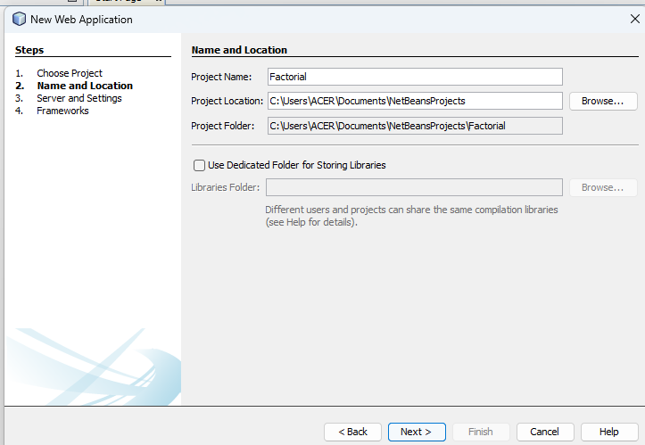





**Adding REST Service**





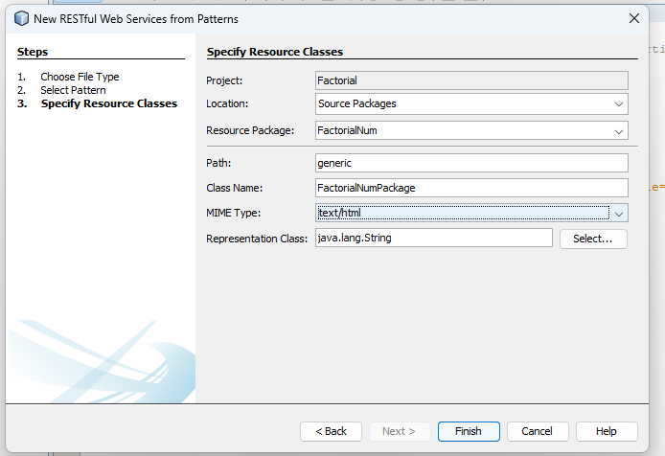

**FactorialNumPackage.java**

@Path("/factorial")

@PUT

@Consumes("text/html")

public String factorialNum(String content) {

int num = Integer.parseInt(content);

String ans = "";

int fact = 1;

for (int i = 1 ; i <= num ; i++) {

fact *= i;

}

ans = Integer.toString(fact);

return ans;

}

**Clean and Build**

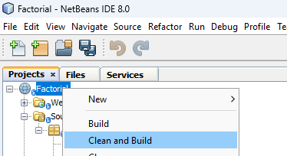

**Now, Deploy**

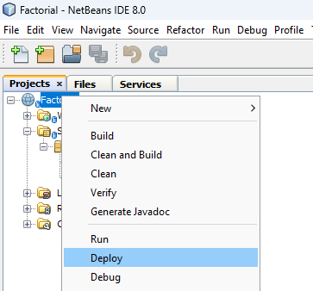

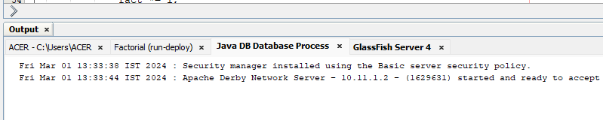

**Test the web service**

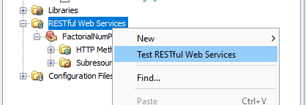

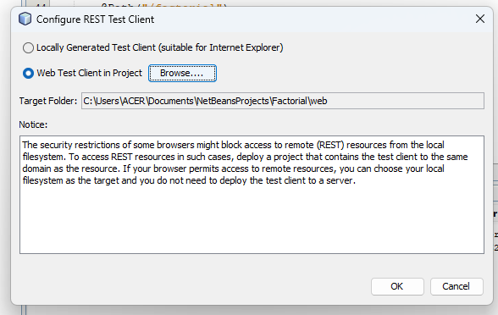

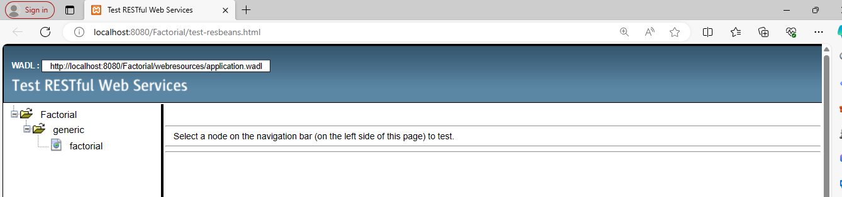

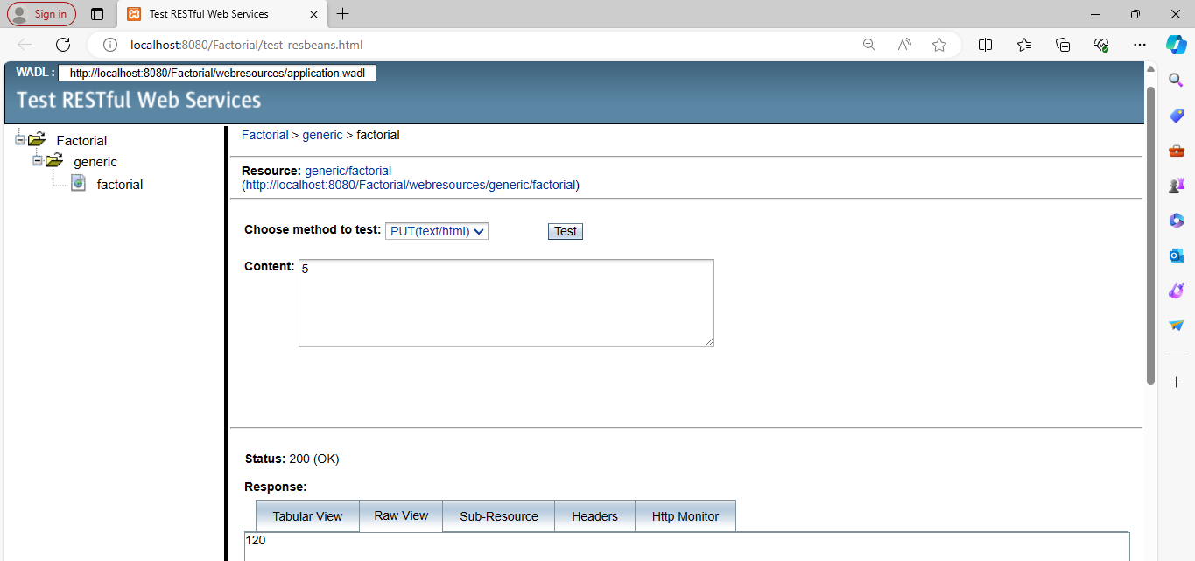

**Client Side**





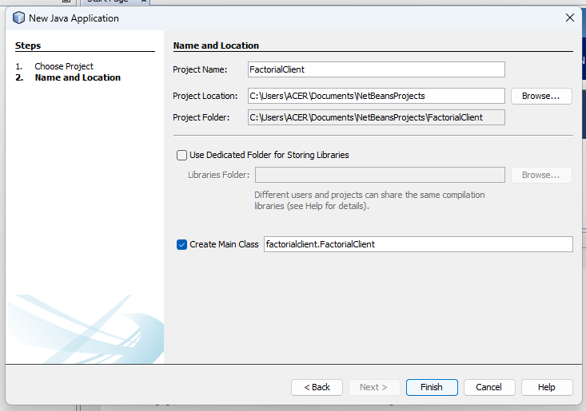

**Add RESTful Java Client**

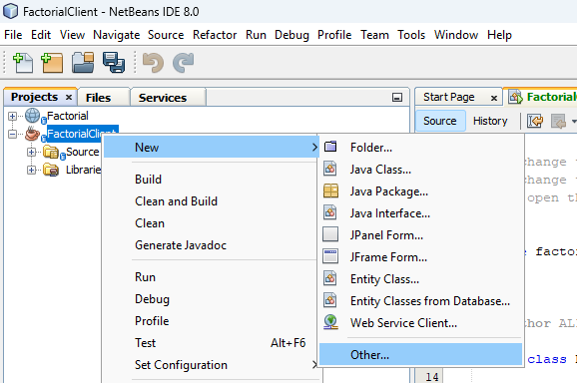

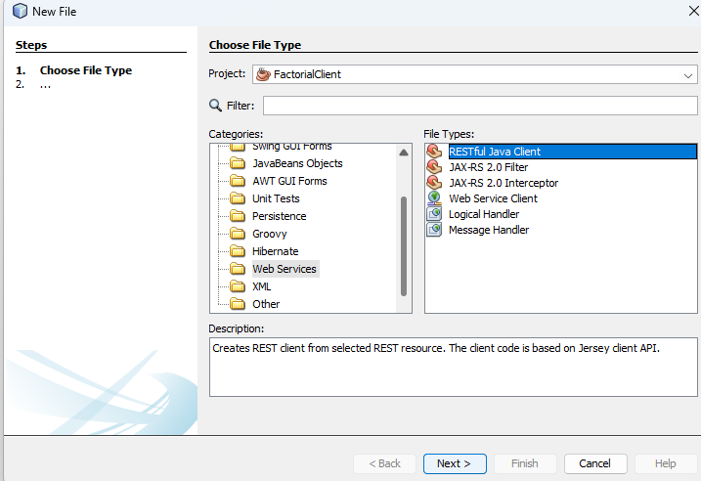

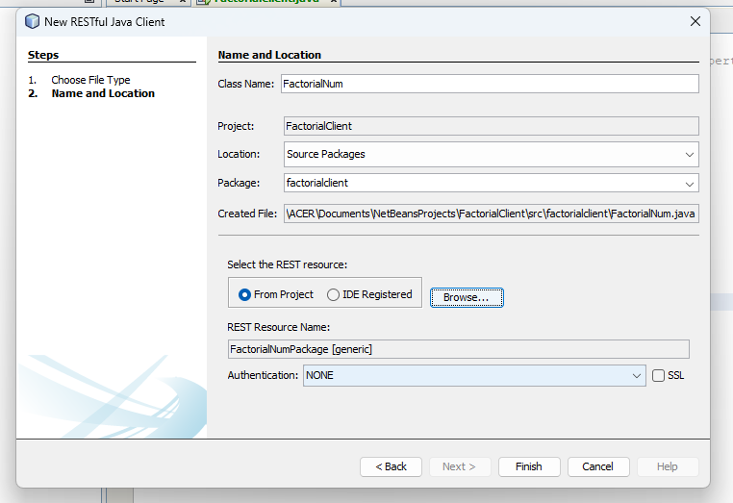

**FactorialClient.java**

package factorialclient;

import java.util.*;

public class FactorialClient {

public static void main(String[] args) {

// TODO code application logic here

factorialclient.FactorialNum client = new FactorialNum();

Scanner sc = new Scanner(System.in);

System.out.println("75 Treesa Joseph");

System.out.println("Enter a number : ");

String num = sc.next();

System.out.println("Factorial = " + client.factorialNum(num));

}

}

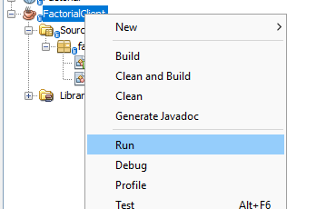

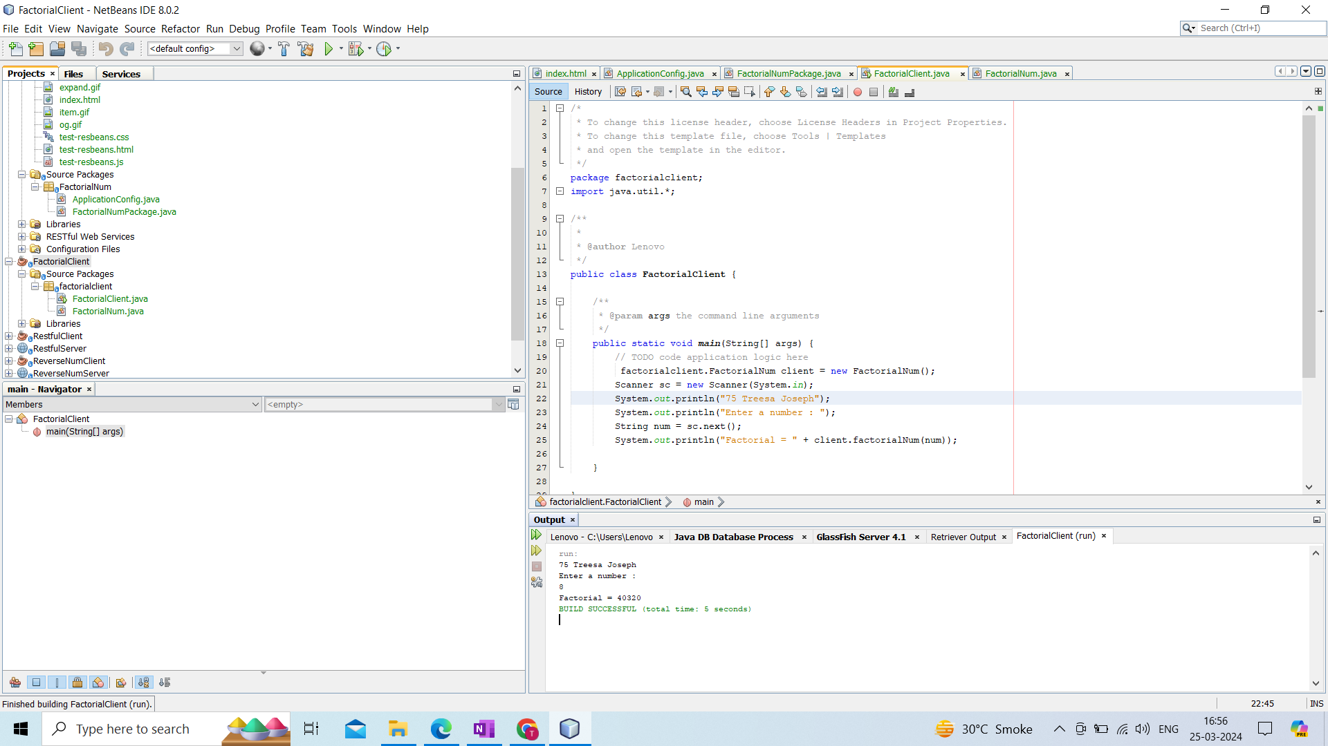

**Name : Treesa Joseph Roll No : KCTYCS(75) Date :**

# Practical 5 : Study and Implementation of Infrastructure as a Service

**Steps to create an EC2 instance are as follows:**

1. Sign in into your AWS account as Root or an IAM user

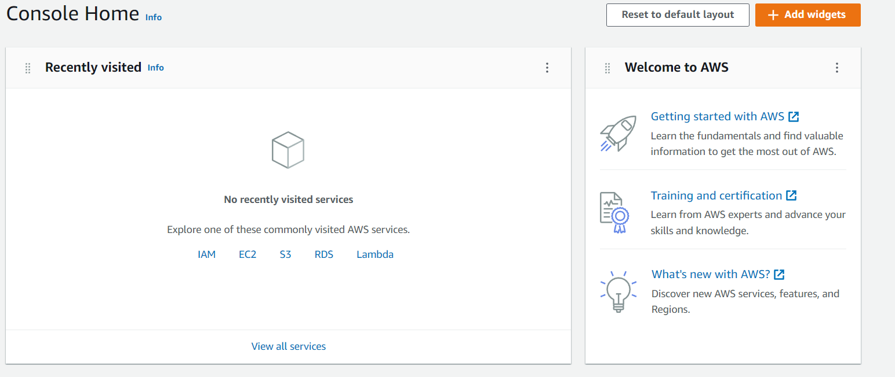

1. Select Services -> compute -> EC2

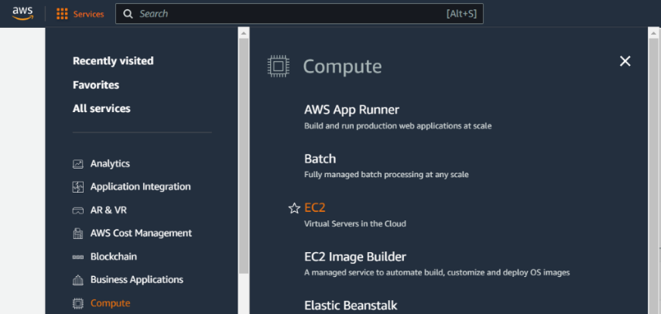

1. After you go to EC2 dashboard, select launch instance

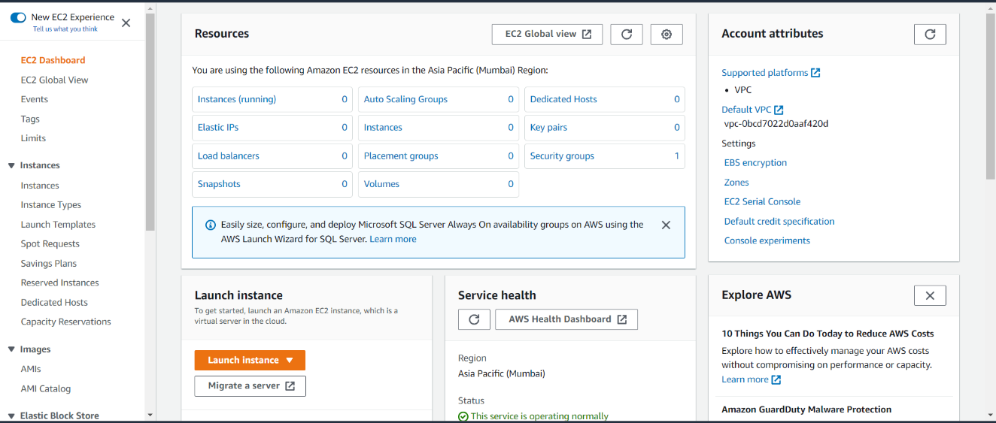

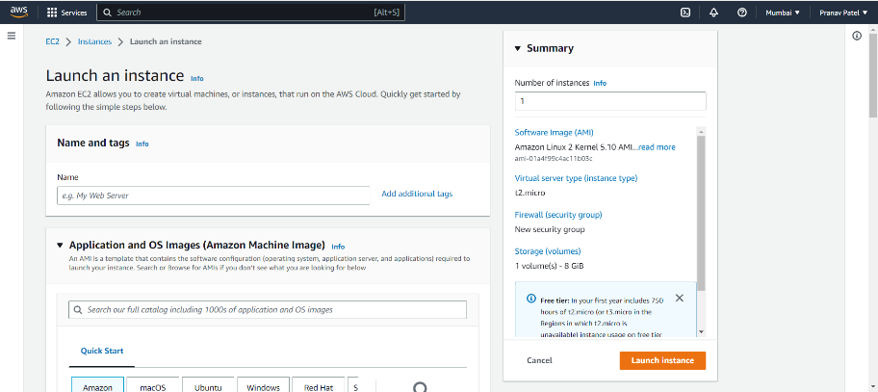

1. Add details to the instance such as name and tag

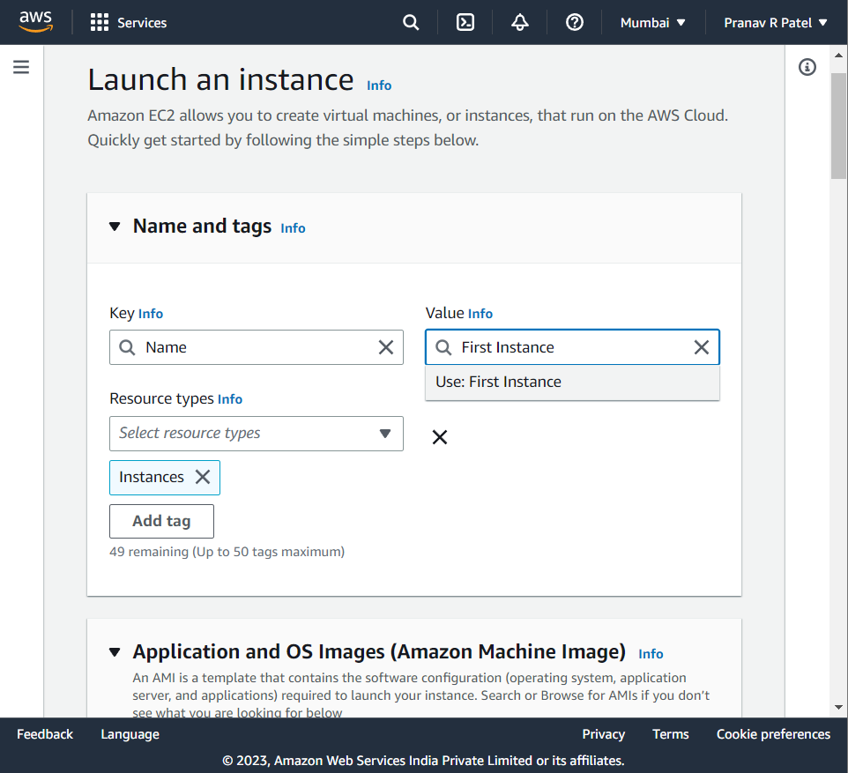

1. Add the OS for the instance and select the instance type

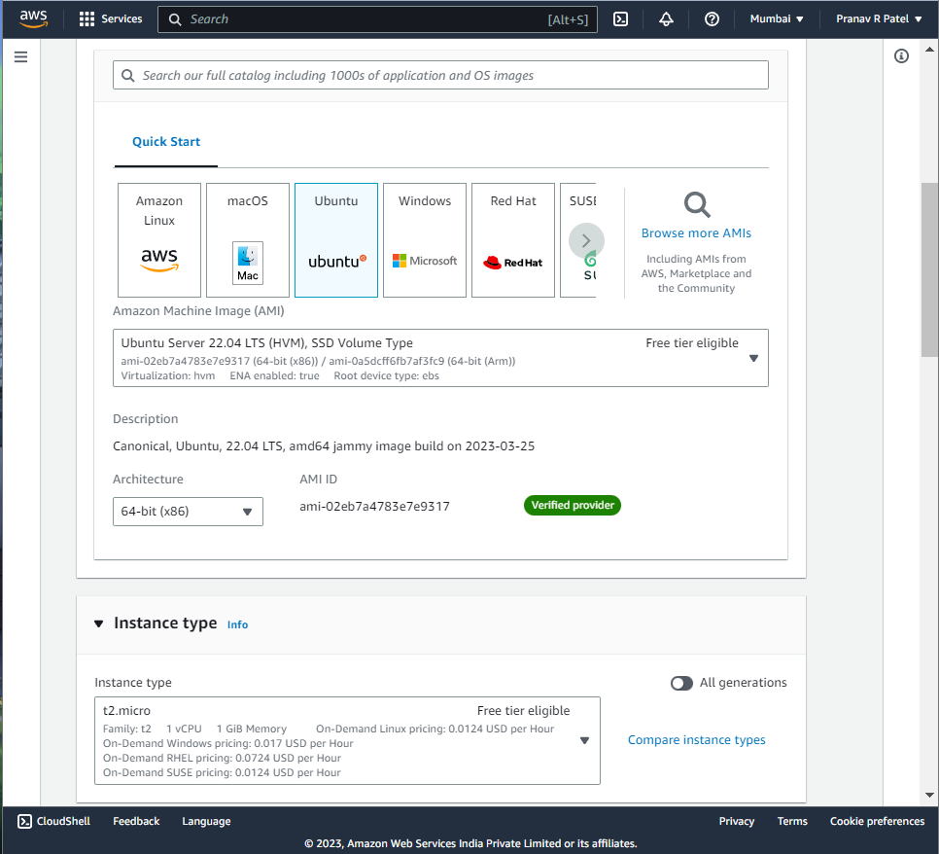

1. Select a key pair, or create a new key pair by selecting the type and the file format for the same

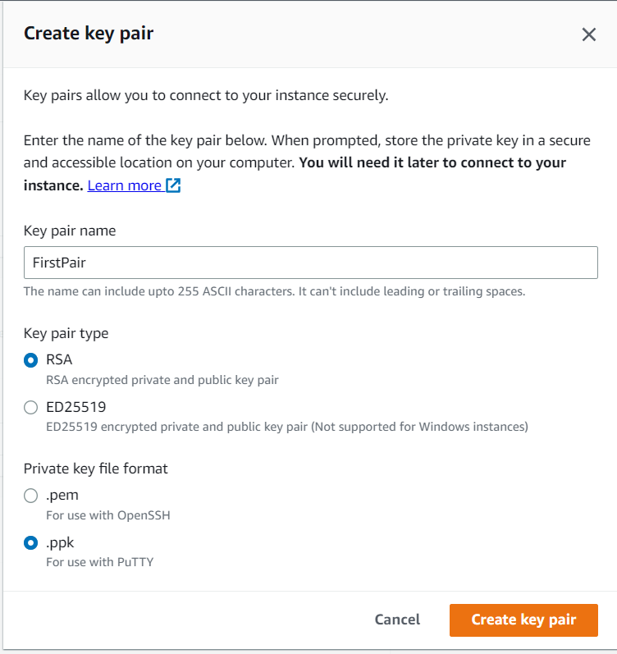

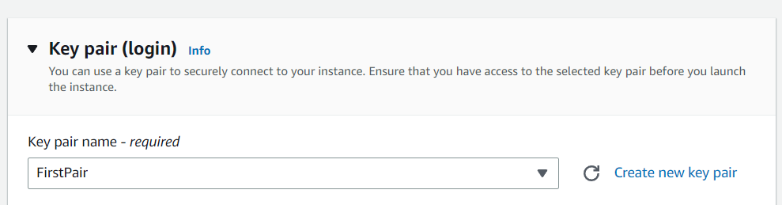

1. One can modify the network setting for the instance.

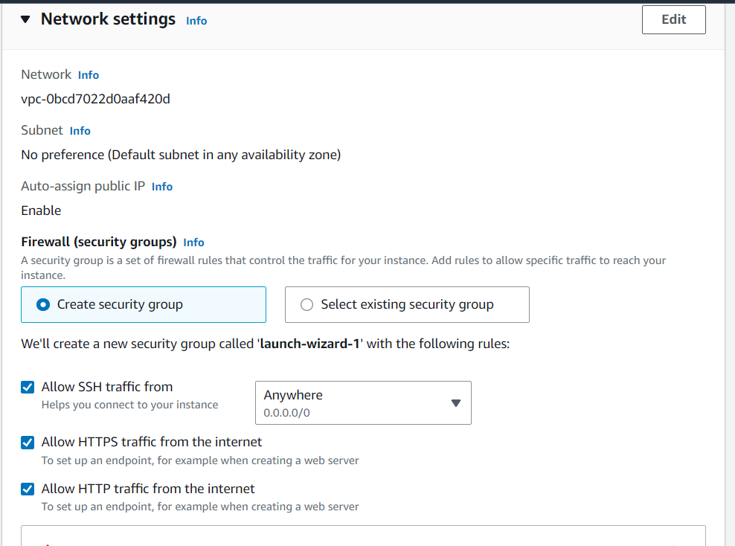 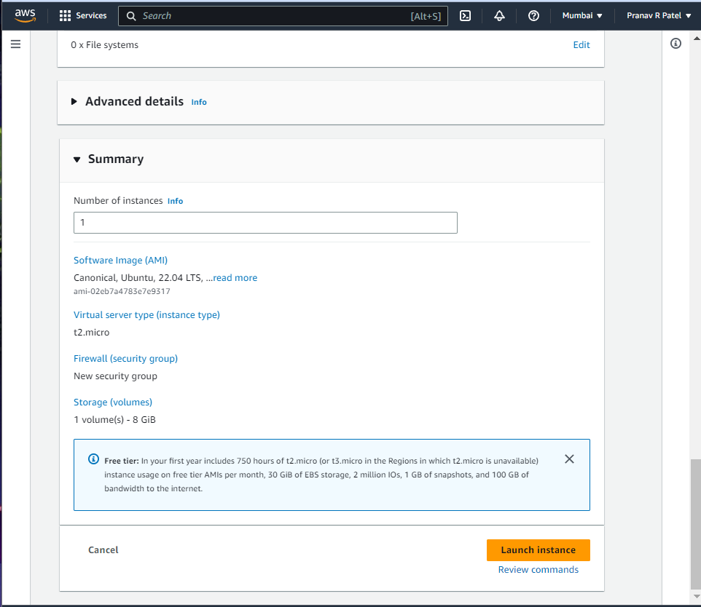

1. Click on “Launch Instance” and check if the instance was successfully launched

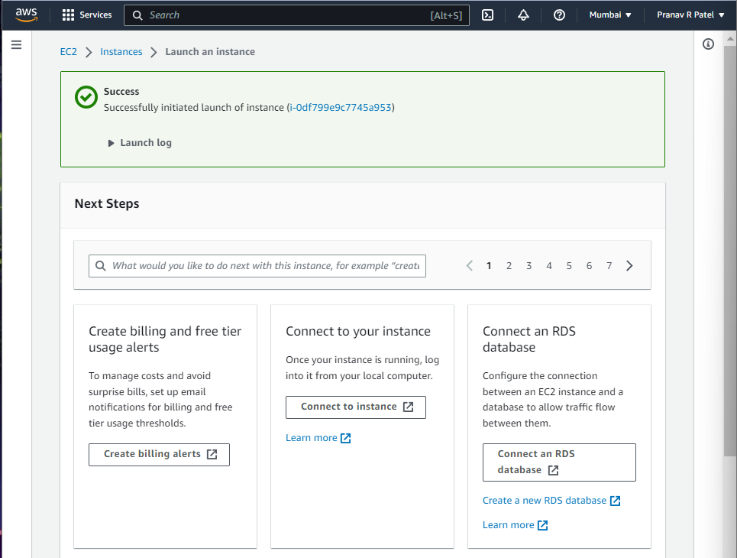

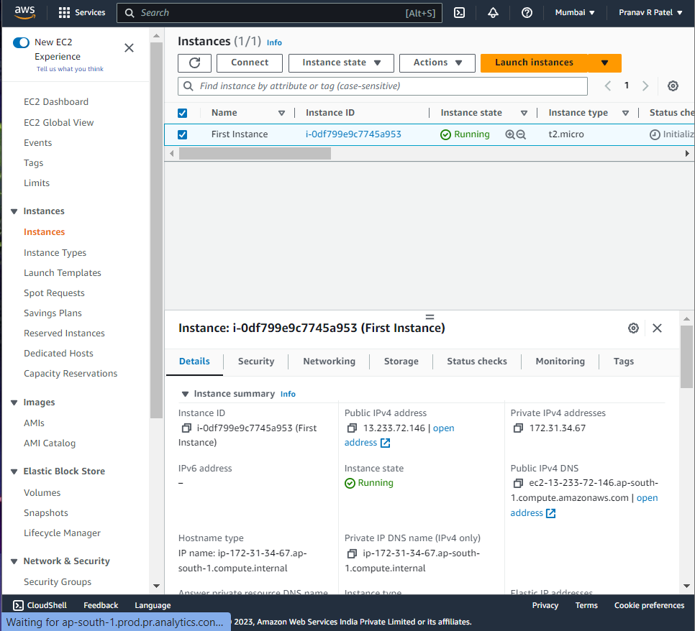

1. Go to “Connect to instance” section

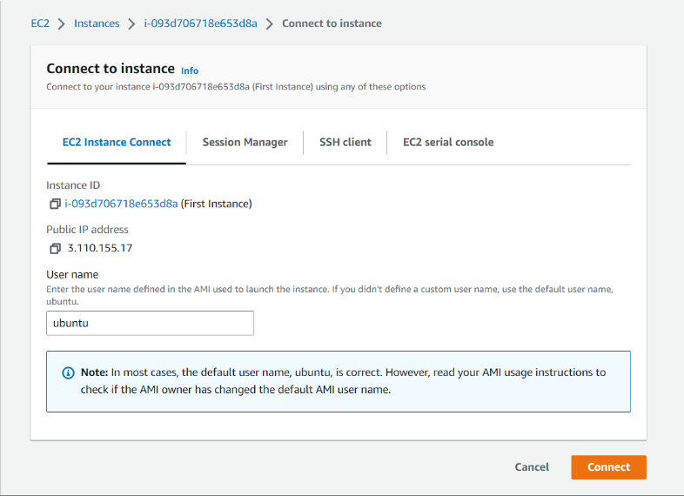

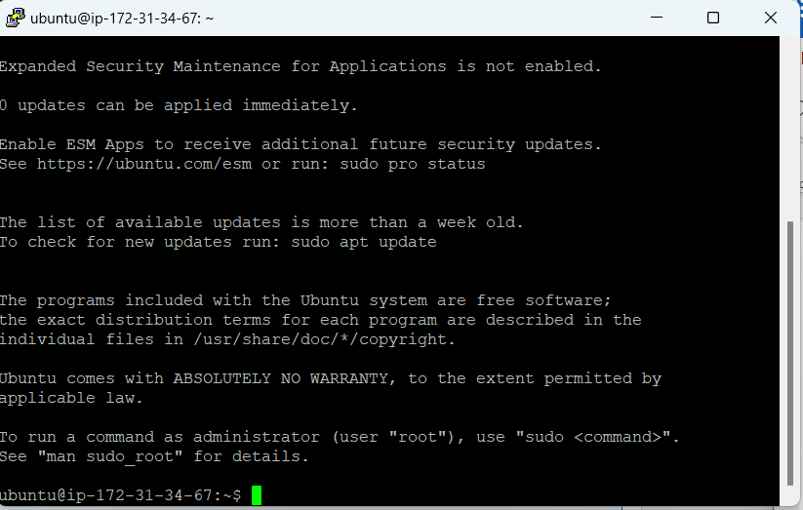

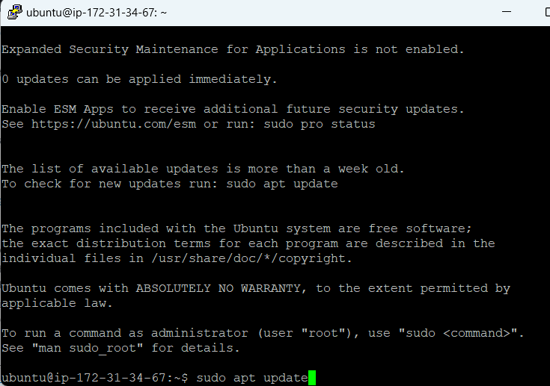

1. Sudo apt-get install apache2

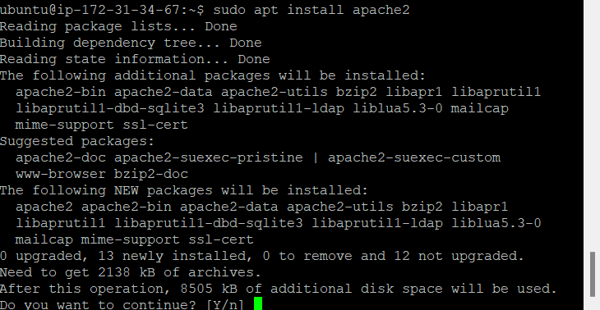

1. Sudo apt install mysql-server

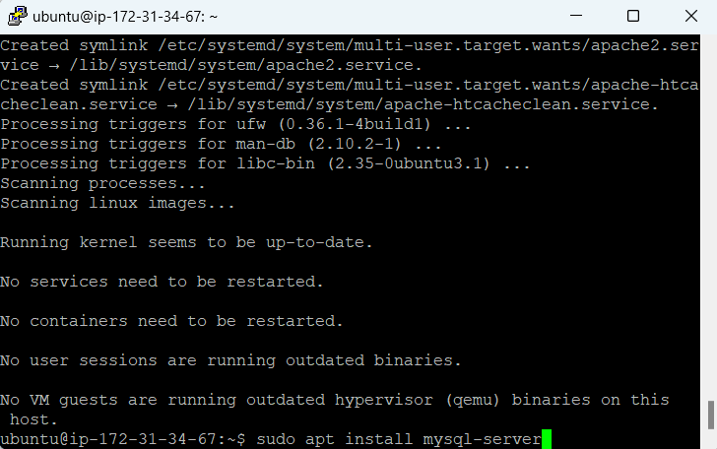

1. Sudo apt-get install php libapache2-mod-php

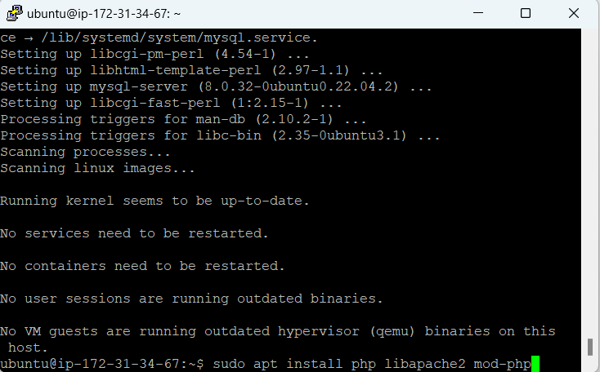

1. Sudo service apache2 restart

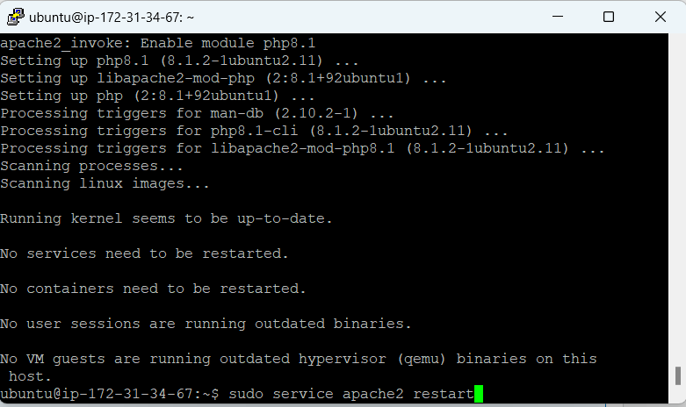

1. Start mysql with “sudo mysql”. This step checks if mysql is working or not

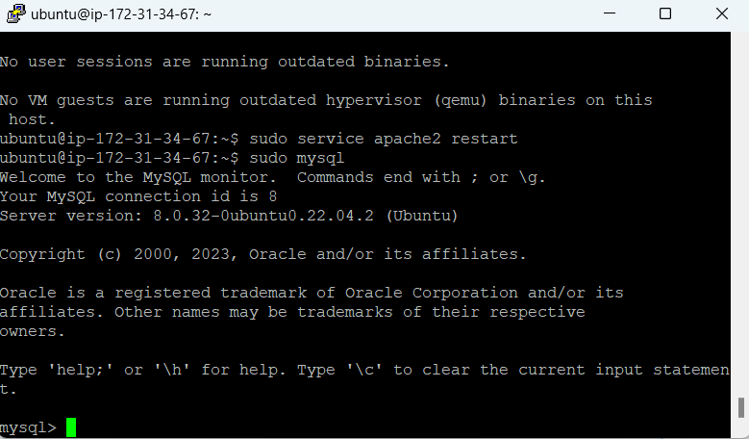

1. Configure the Security group inbound rules to allow traffic on HTTP

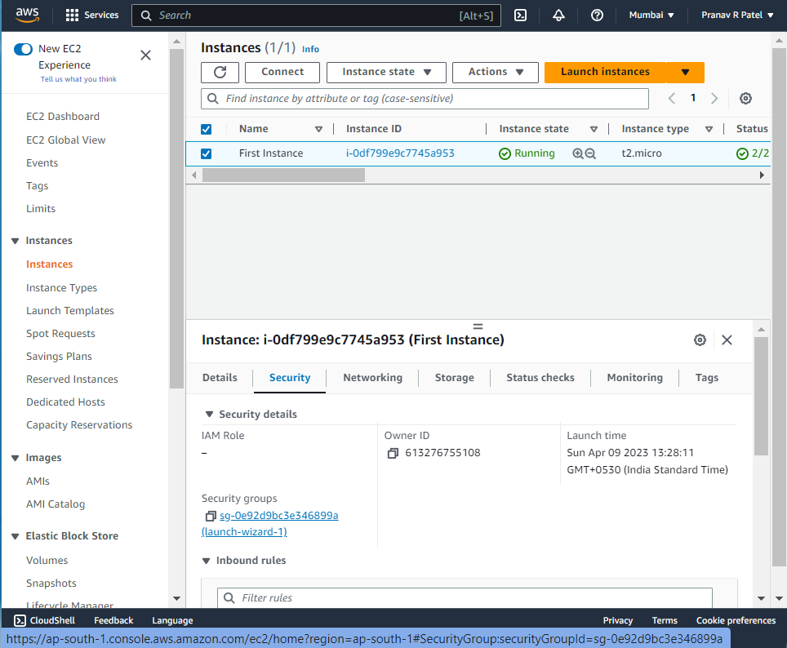

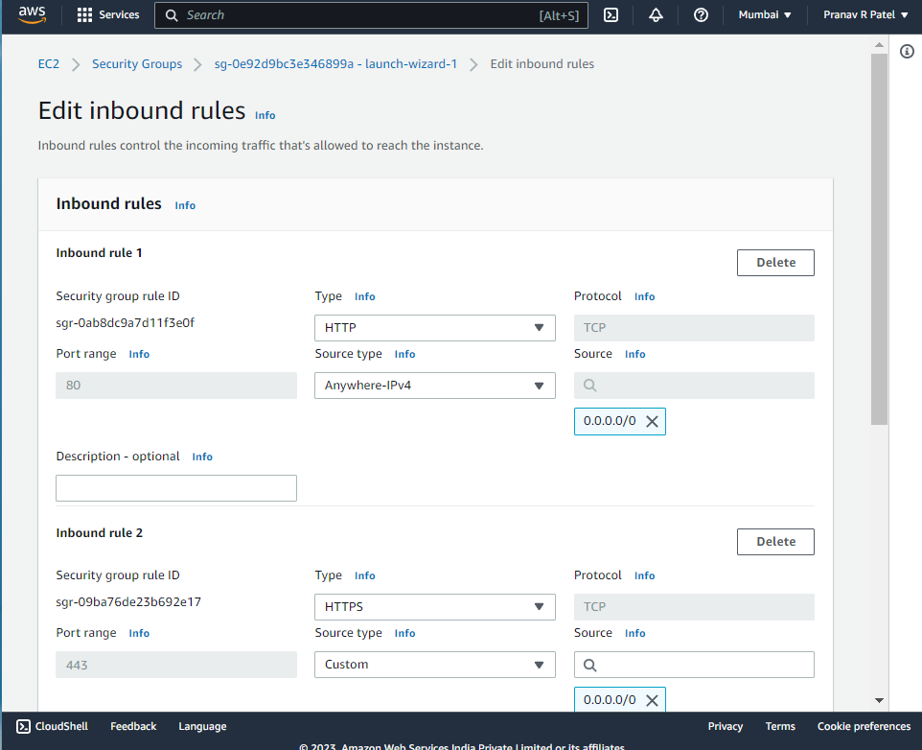

1. Grant permissions to AWS EC2 user as:

Sudo chown –R ubuntu:ubuntu /var/www/html

Sudo chmod –R 755 /var/www/html



1. Open filezilla and enter the public IP address of the EC2 instance in filezilla. Click OK

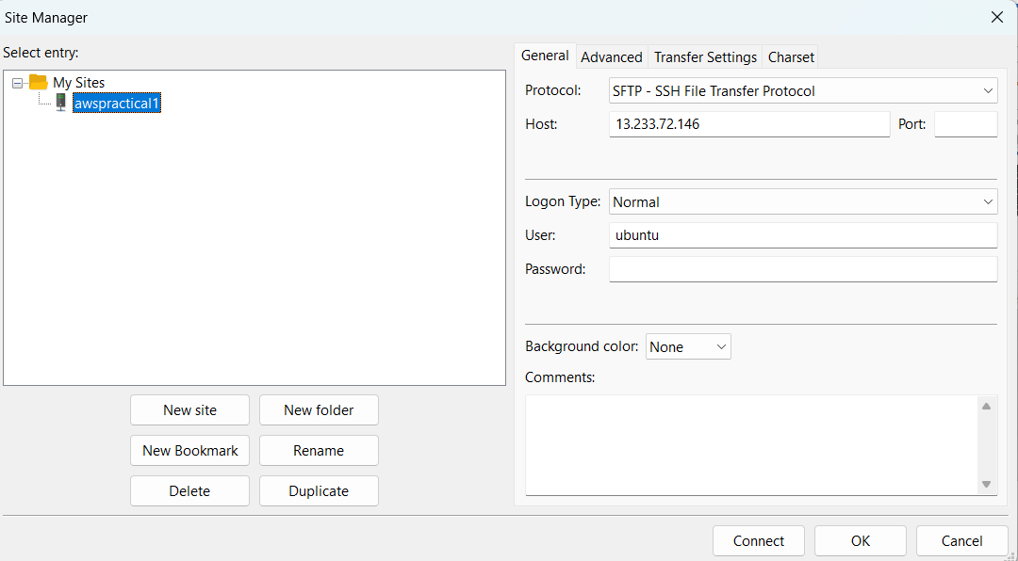

1. Go to the Edit section in Taskbar -> Settings -> SFTP-> Add key file

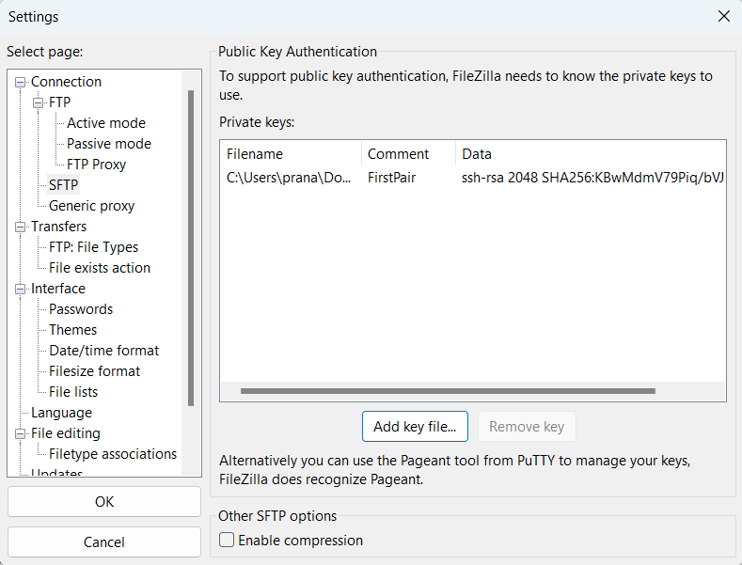

1. Select the connection created in the site manager

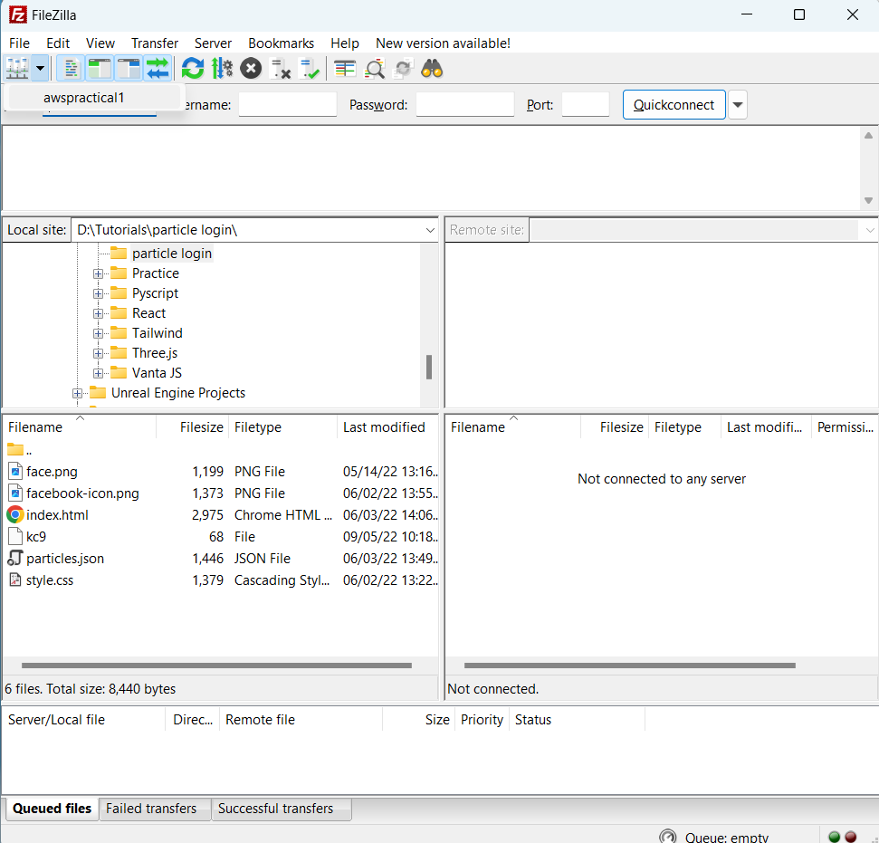 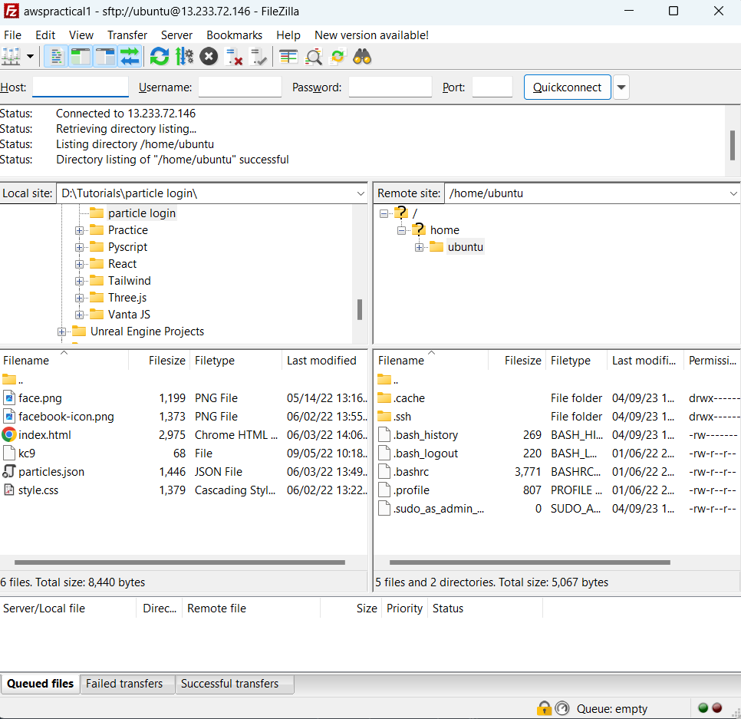

1. After connection is established. Go to the folder /var/www/html in the instance

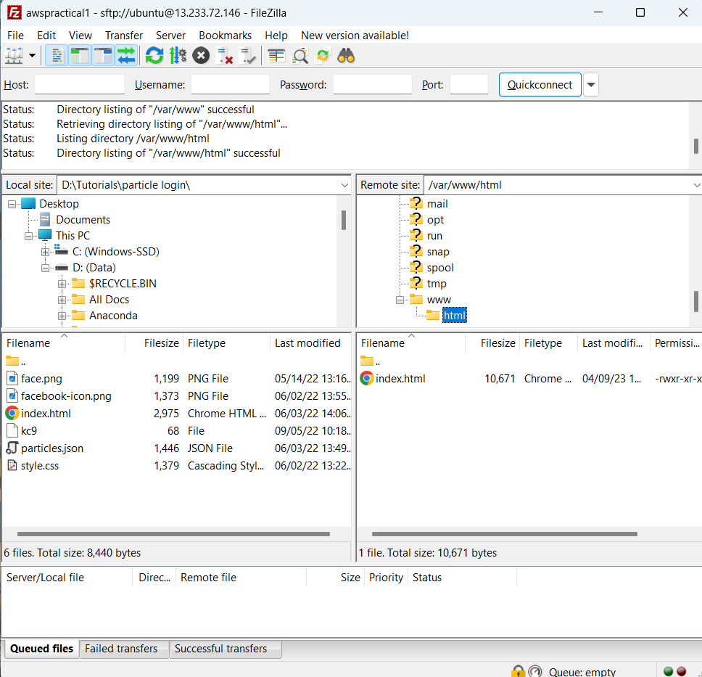

1. Copy the public IP address in the browser and check the html file.

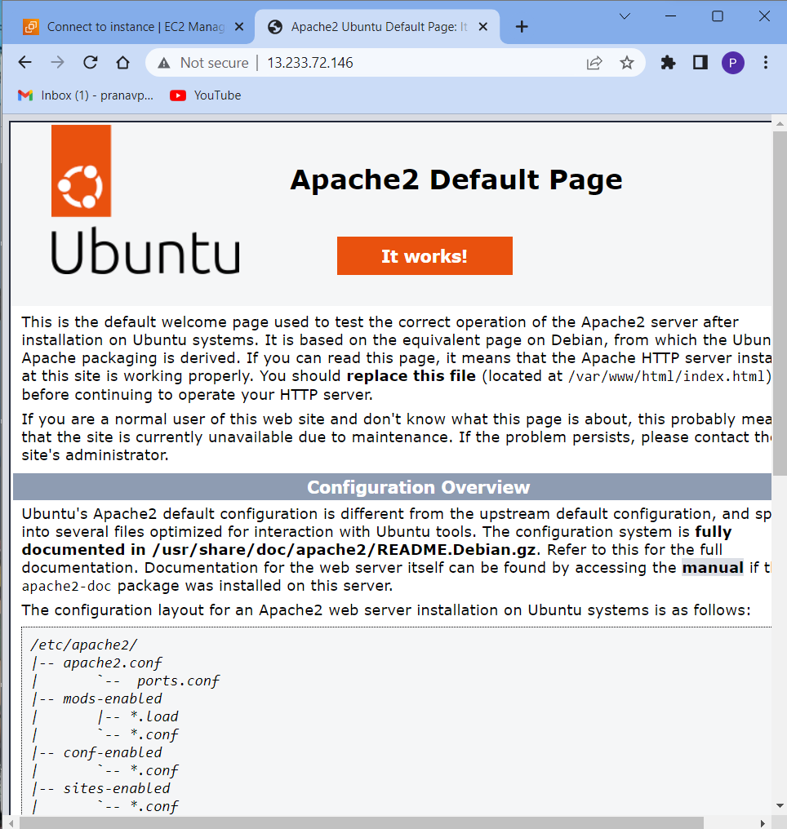

1. Edit the index.html as one deems fit

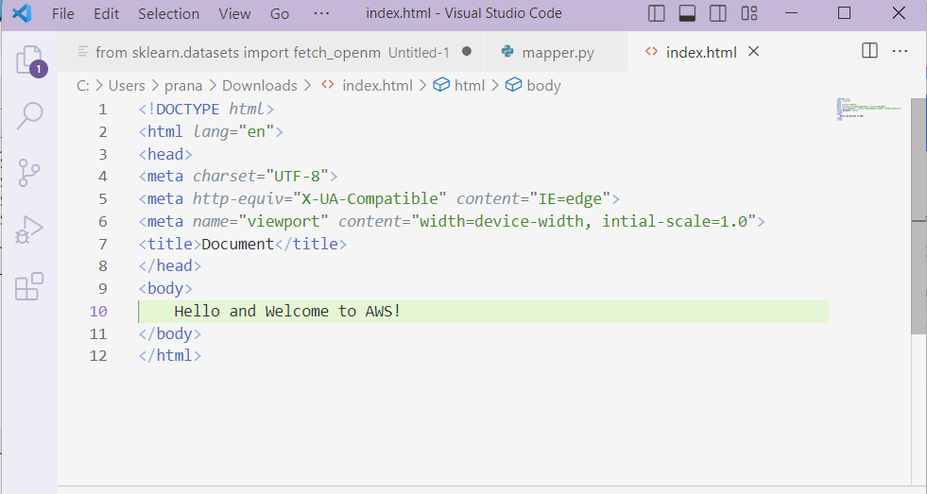

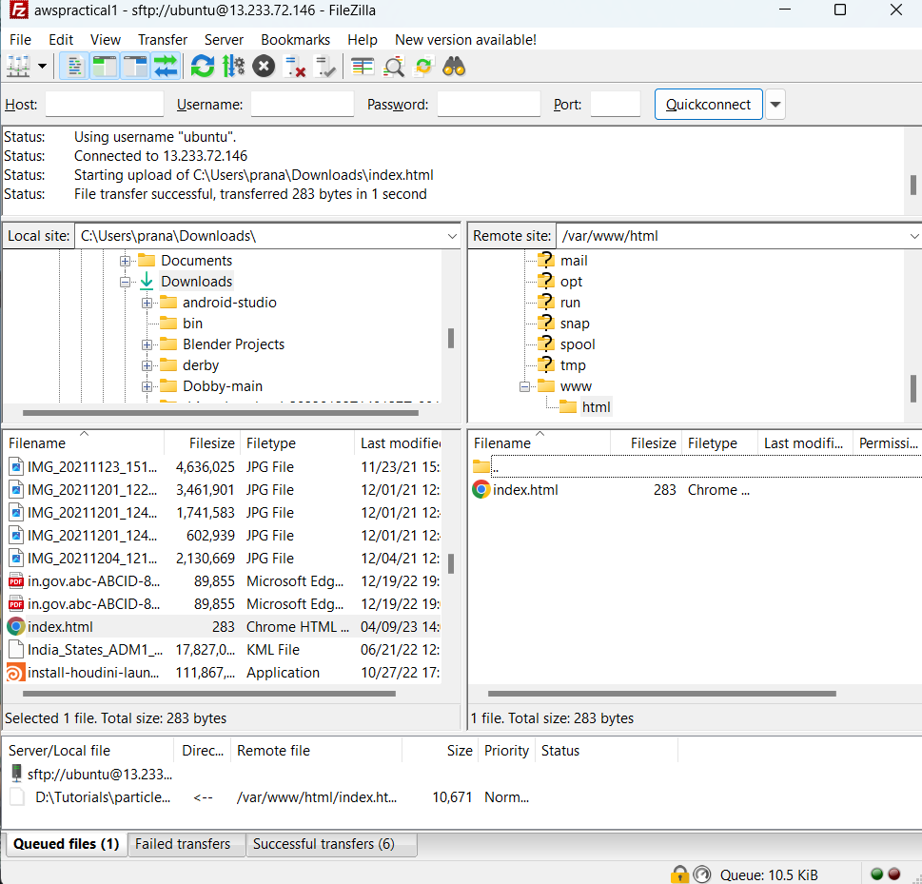

1. Check the public IP address again in the browser and verify if the changes were made

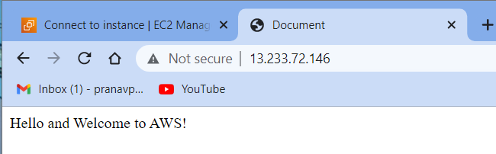

**Name : Treesa Joseph Roll No : KCTYCS(75) Date : 06-03-2023**

# Practical 6 : Write a program for Web Feed

**Steps:**

1. **Start Xampp server**

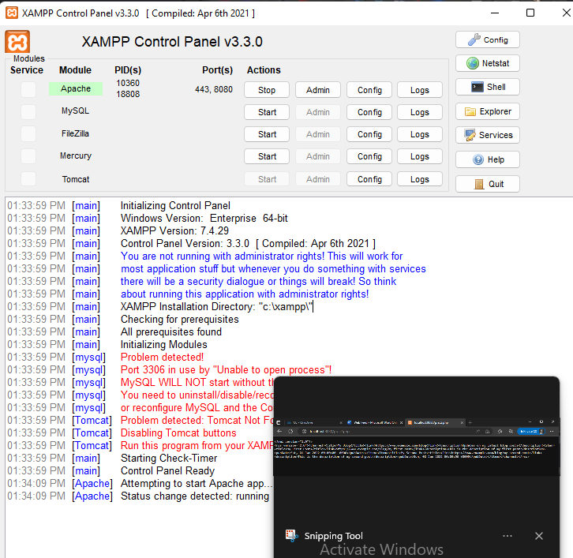

1. **Write the program for Web feed in a php file:**

<?php

$feed = new SimpleXMLElement('<rss></rss>');

$feed->addAttribute('version', '2.0');

$channel = $feed->addChild('channel');

$channel->addChild('title', 'My Blog');

$channel->addChild('link', 'https://www.example.com/blog');

$channel->addChild('description', 'Updates on my latest blog posts');

// add entries to the feed

$entries = array(

array(

'title' => 'My First Post',

'link' => 'https://www.example.com/blog/my-first-post',

'description' => 'This is the description of my first post',

'pubDate' => 'Sat, 01 Jan 2022 00:00:00 +0000'

),

array(

'title' => 'My Second Post',

'link' => 'https://www.example.com/blog/my-second-post',

'description' => 'This is the description of my second post',

'pubDate' => 'Sun, 02 Jan 2022 00:00:00 +0000'

)

);

foreach ($entries as $entry) {

$item = $channel->addChild('item');

$item->addChild('title', $entry['title']);

$item->addChild('link', $entry['link']);

$item->addChild('description', $entry['description']);

$item->addChild('pubDate', $entry['pubDate']);

}

// output the RSS feed

header('Content-Type: application/rss+xml');

echo $feed->asXML();

1. **Check the program in the browser**

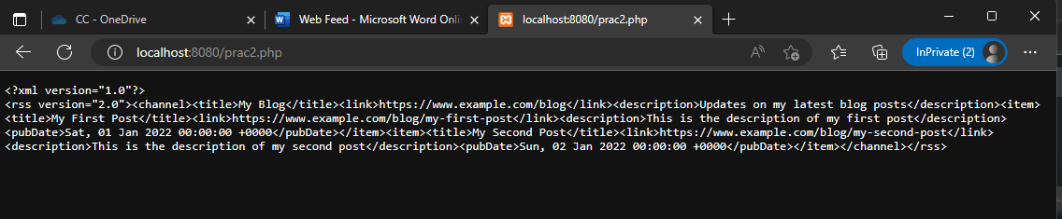

**Name : Treesa Joseph Roll No : KCTYCS(75) Date : 06-03-2023**

# Practical 7 : Installation and Configuration of Virtualization using KVM

**Steps:**

1. Check if your system can use KVM acceleration by typing: sudo kvm-ok

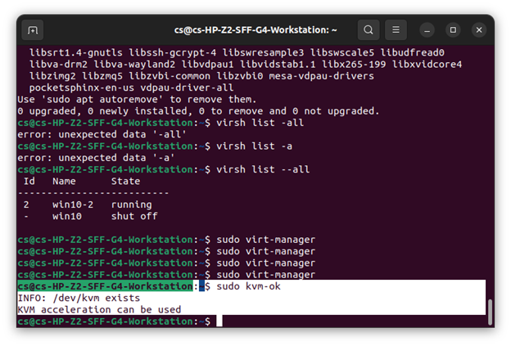

If **kvm-ok** returns an error stating KVM acceleration cannot be used, try solving the problem by installing cpu-checker.

1. To install cpu-checker, run the following command: sudo apt install cpu-checker

When the installation completes, restart the terminal.

You are now ready to start installing KVM.

**Note:** When it is performed for servers, hardware virtualization is referred to as server virtualization.

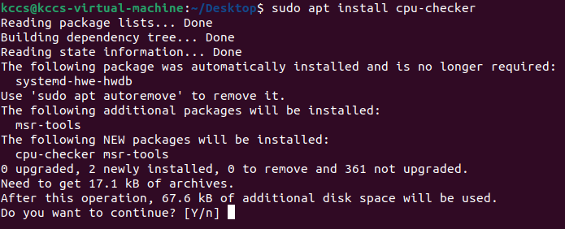

**Install KVM on Ubuntu 20.04**

To enable KVM virtualization on Ubuntu 20.04:

* Install related packages using apt
* Authorize users to run VMs
* Verify that the installation was successful

**Step 1: Install KVM Packages**

1. First, update the repositories: sudo apt update
2. Then, install essential KVM packages with the following command:

sudo apt install qemu-kvm libvirt-daemon-system libvirt-clients bridge-utils

This will start the installation of four KVM packages:  
3. When prompted, type **Y**, press **ENTER**, and wait for the installation to finish.

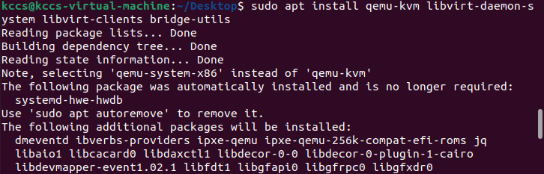

**Step 2: Authorize Users**

1. Only members of the **libvirt** and **kvm** user groups can run virtual machines. Add a user to the libvirt group by typing: sudo adduser ‘username’ libvirt

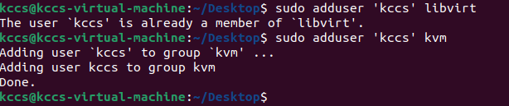

1. Now do the same for the kvm group: sudo adduser ‘[username]’ kvm



**Note:**If you need to remove a user from the libvirt or kvm group, just replace **adduser** with **deluser** in the command above.



**Step 3: Verify the Installation**

1. Confirm the installation was successful by using the **virsh** command: virsh list --all

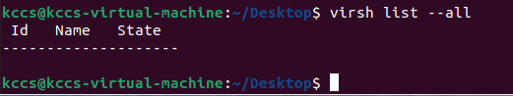

1. If the virtualization daemon is not active, activate it with the following command:

sudo systemctl enable --now libvirtd

Creating a Virtual Machine on Ubuntu 20.04

1. Before you choose one of the two methods listed below, install virt-manager, a tool for creating and managing VMs: sudo apt install virt-manager

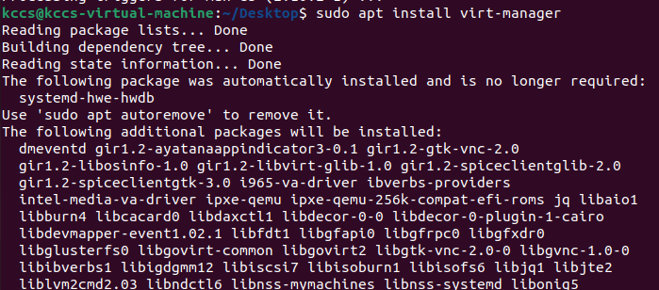

1. Type **Y** and press **ENTER**. Wait for the installation to finish.

Make sure you download an ISO containing the OS you wish to install on a VM and proceed to pick an installation method.

Method 1: Virt Manager GUI

1. Start virt-manager with: sudo virt-manager
2. In the first window, click the computer icon in the upper-left corner.

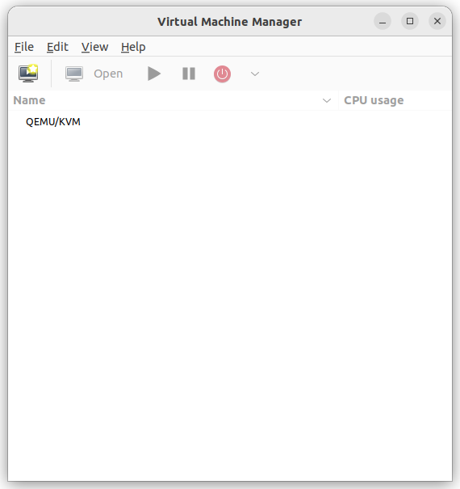

1. In the dialogue box that opens, select the option to install the VM using an ISO image. Then click **Forward**.

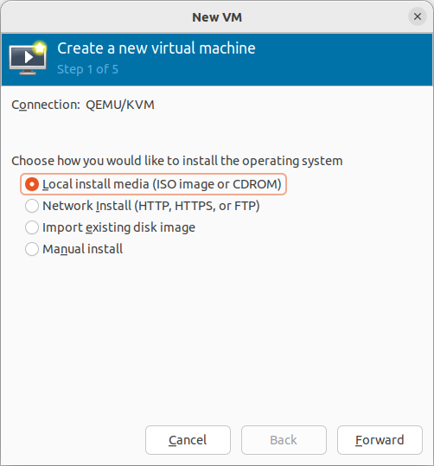

1. In the next dialogue, click **Browse Local** and navigate to the path where you stored the ISO you wish to install.

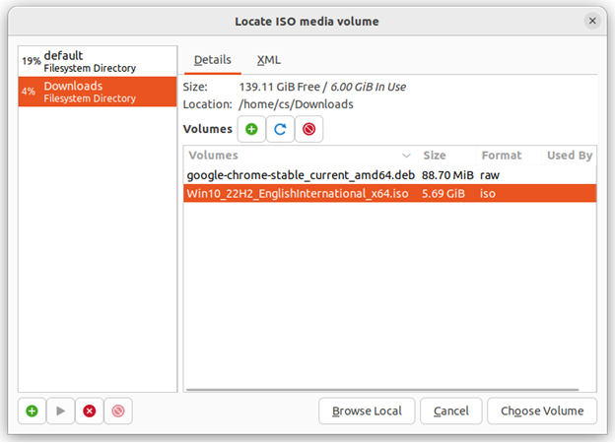

1. The ISO you chose in the previous window populates the field in Step 2. Proceed to Step 3 by clicking **Forward**.

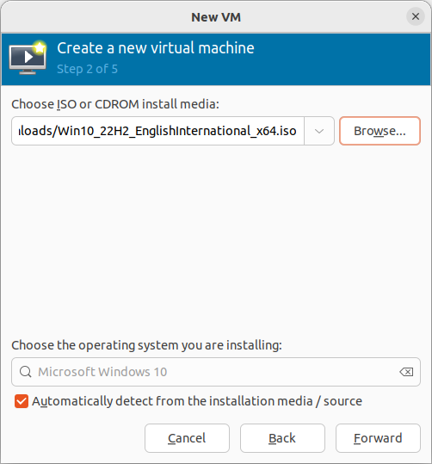

1. Enter the amount of RAM and the number of CPUs you wish to allocate to the VM and proceed to the next step.

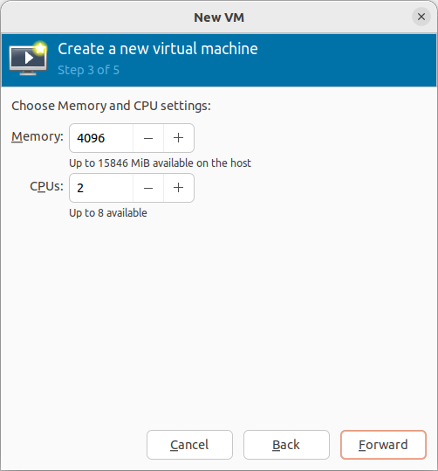

1. Allocate hard disk space to the VM. Click **Forward** to go to the last step.

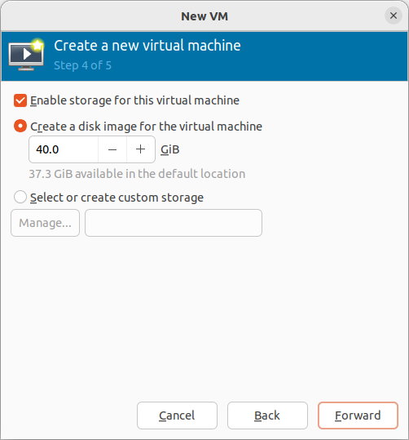

1. Specify the name for your VM and click **Finish** to complete the setup.

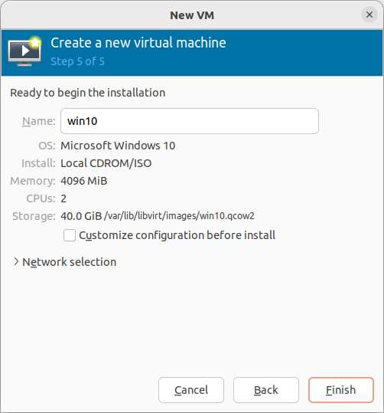

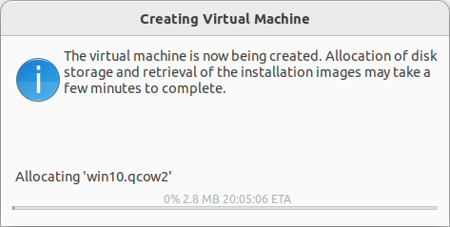

1. The VM starts automatically, prompting you to start installing the OS that’s on the ISO file.

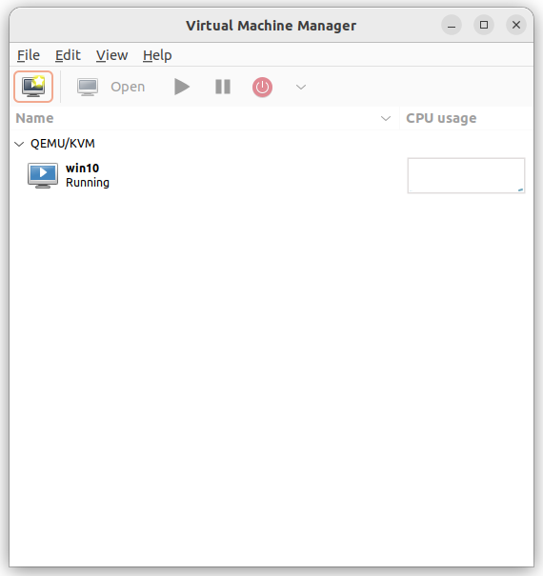

**Name : Treesa Joseph Roll no: KCTYCS075 Date:**

# Practical 08 : Download image from MTOM



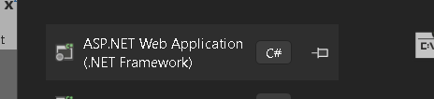

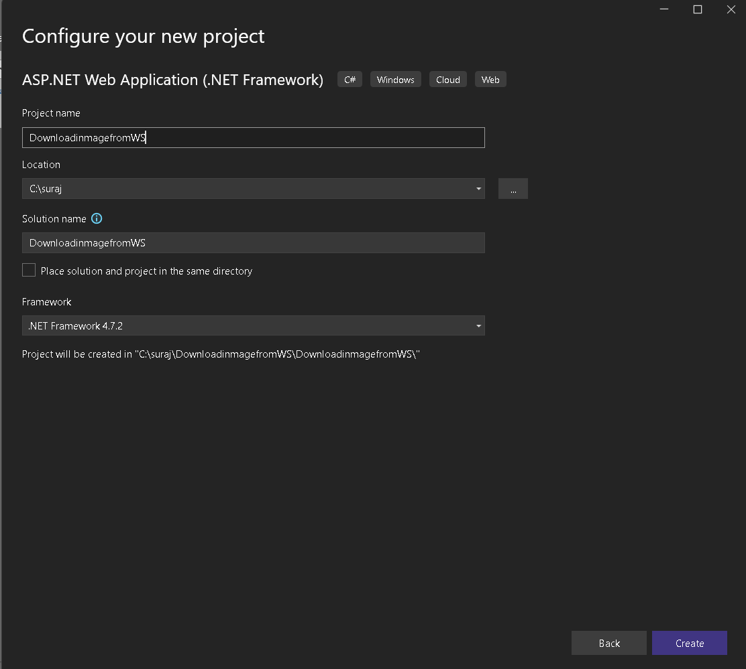

*Click ‘Create’*

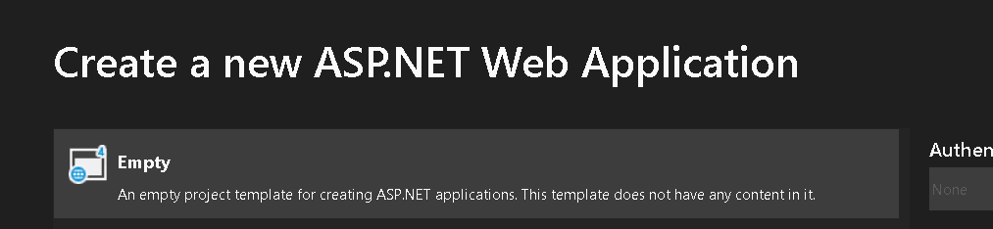

*Choose empty and click ‘Create’*

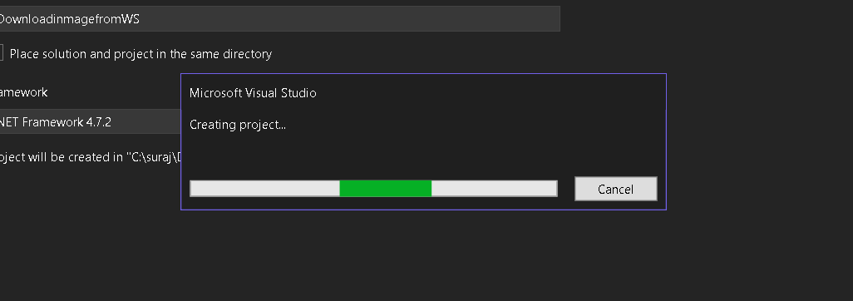

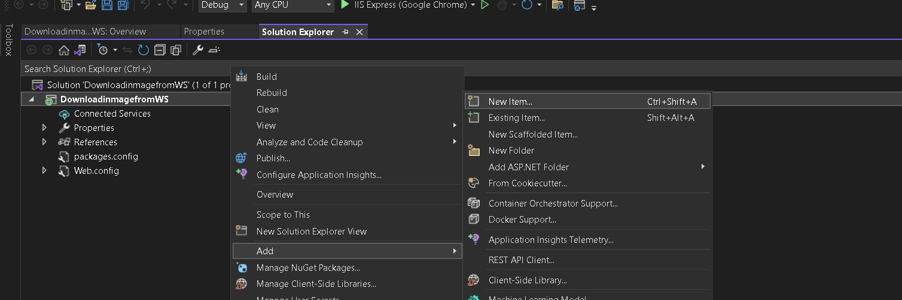

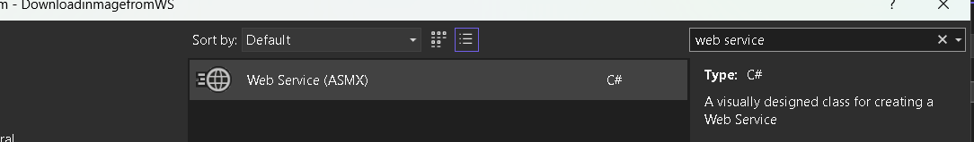



Add this code to the ws file ;

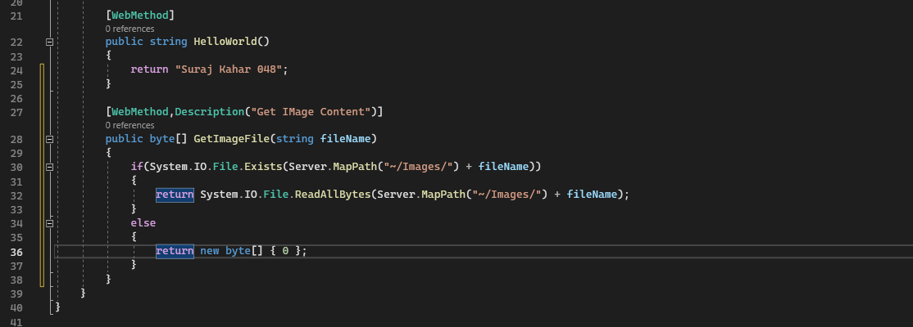

Add handler

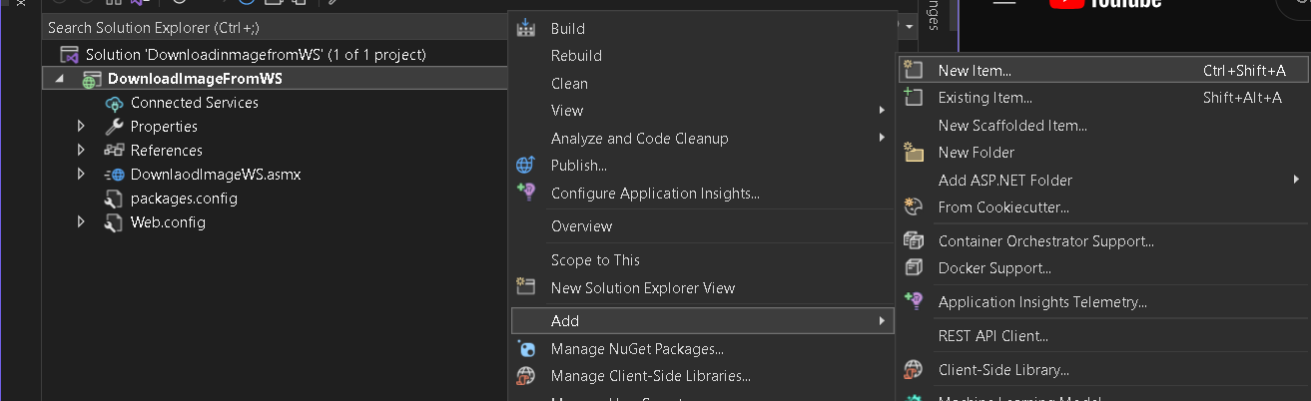

Use Generic Handler

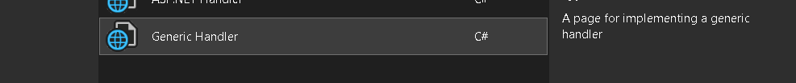

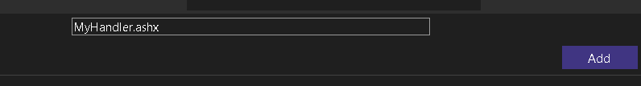

Handler Code

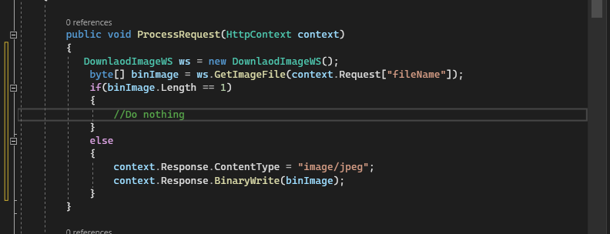

Now Add Web Form

ADD -> NEW ITEM -> Web Form



Add Label and change its properties

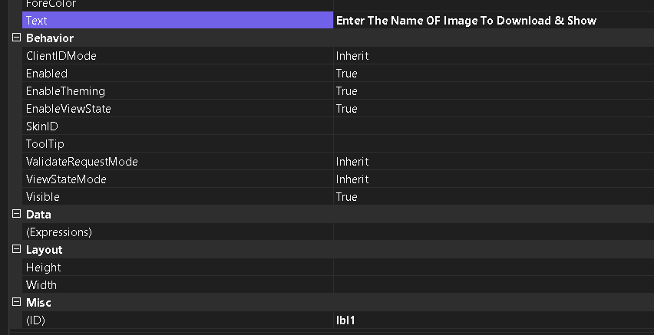

TextBox ID



**Add a Button**

ID – btn1

The Layout

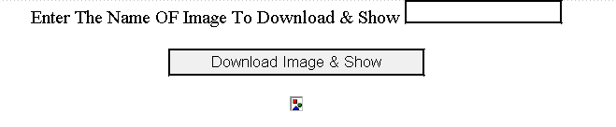

Now Code for Button

Double click on button and code

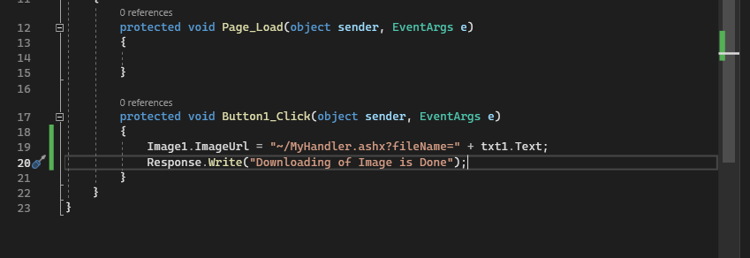

Add new folder for images

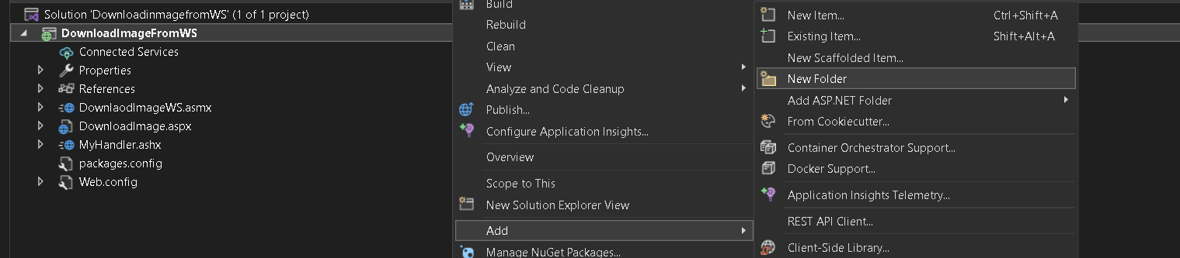

Add Images to the folder

